Technologies offer innovative solutions to water-related problems like clean drinking water & flood management
Innovative technologies by an IIT Kharagpur-based center of technological excellence focusing on water purification have helped deliver clean and safe drinking water and also manage floods in several states across the country.

An efficient, low-cost, nano-filtration-based technology by The Centre for Technological Excellence in Water Purification (CTEWP) housed in IIT Kharagpur has ensured access to safe and clean drinking water free of heavy metals for 25,000 people in three different locations in Telangana and Andhra Pradesh.

The prototype of the highly compact vertical modular nanofiltration membrane system designed for removal of heavy metals from the groundwater was developed by the Membrane Separations Laboratory, CSIR-Indian Institute of Chemical Technology (IICT), with support from the Department of Science and Technology (DST) Water Technology Initiative (WTI). With a capacity of 100 - 300 Litre per hour(L/h), the system based on a membrane technically called hydrophilized polyamide membrane removes heavy metals such as Iron from groundwater. It consists of pumps that force water first through a prefilter assembly to remove suspended solids, color, and odour and then spiral wound membrane modules that separate heavy metals. It gives purified permeate of reasonable total dissolved solids (TDS) devoid of contaminants such as Iron, Arsenic, or excess hardness. Ultraviolet light is provided at the end to disinfect any pathogens that may be present in the tank or pipelines.

The water that children of a primary school in North Guwahati, Assam, drank was highly contaminated with Iron, high COD, and emanated a foul smell. Now with access to clean drinking water from a water treatment plant (300 L/h) developed by IIT Guwahati installed in the school, the students of Lathiabagicha Primary School are relieved. This plant was designed and fabricated based on chemical less electrocoagulation technique. Supported by DST, it is capable of treating Total Soluble Solvent (TSS), Chemical Oxygen Demand (COD), Biological Oxygen Demand (BOD), Iron and Arsenic from contaminated drinking water to below BIS limit. More than 120 students of the school, as well as the villagers of Lathiabagicha (more than 500), are now assured that quenching their thirst will not affect their health. The treated water is also used for cooking mid-day meals in the school.

The CSIR-IICT's team has also developed a simple, inexpensive, hand pump operated hollow fibre ultrafiltration system that is easy to operate, has high mobility, occupies less space, and is lightweight. The technology supported by DST was based on membranes called polyethersulfone hollow fibers. The pressure generated by the hand pump to transport floodwater into the membrane module providing a driving force to facilitate the permeation of clarified and disinfected water through the porous membrane, while a small chlorine cartridge installed at the membrane outlet leaches free chlorine to tackle any secondary contamination.A total of 24 water plants were installed during recent floods in Karnataka, Maharashtra, Kerala, Bihar, Odisha, and West Bengal to provide clean and safe drinking water to 50,000 people.
The solutions by the centre for water-related problems ranging from contamination by heavy metals to flood-related water problems would comprehensively help tackling health and disaster management challenges.

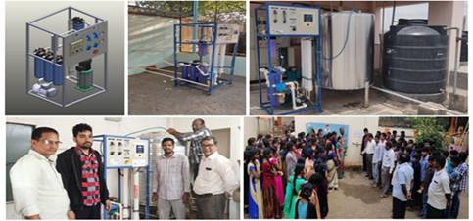
Prototype-1: Design of highly compact, vertical modular Nanofiltration membrane systems for removal of heavy metals from groundwater

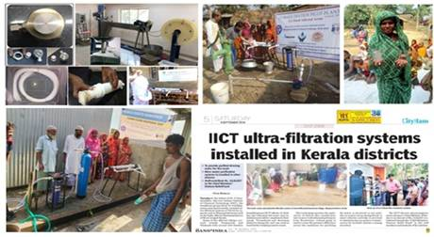
Prototype-2: Development of hand pump operated hollow fiber Ultrafiltration membrane systems for disaster management

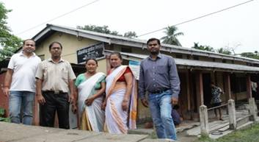
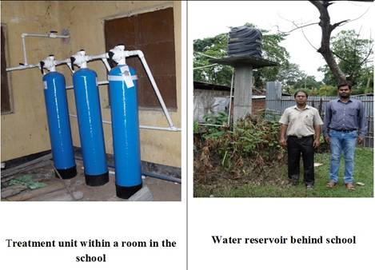
Prototype 3:installed in Lathiabagicha Primary School in North Guwahati, Assam

[For more details, Dr. Sirshendu De, Professor, Department of Chemical Engineering, IIT Kharagpur( 9434017363; sde@che.iitkgp.ac.in);Dr. S. Sridhar, Senior Principal Scientist, IICT Hyderabad (8790748674; email:s_sridhar@iict.res.in); Dr. Mihir Kumar Purkait, Professor, Department of Chemical Engineering, IIT Guwahati, mobile: 9954248807; email:mihir@iitg.ac.in can be contacted.]

Source
Press Information Bureau, 11 March, 2021

