India & Japan deliberate on ways to strengthening health care for elderly
Experts from India and Japan discussed ways in which the two countries can collaborate to strengthening health care for older people and reimagine aging and the research, demonstration, and implementation required for the same at a webinar organised to celebrate International Day of Older Persons.

Prof. A. B. Dey, Former Professor, and Head, Department of Geriatric Medicine, Former Dean (Research) Nodal Officer, National Center for Ageing, AIIMS, New Delhi, suggested that expansion of initiatives like the National Program for Health care of the elderly, Ayushman Bharat and implementation of WHO’s long term care protocol (ICOPE) could help in strengthening health care for older people.

The webinar on ‘India - Japan Celebration of the International Day of Older Persons’ was organized by the Department of Science and Technology (DST), Government of India, jointly with the Embassy of India, Tokyo & and the Ministry of Economy, Trade, and Industry (METI), Government of Japan to celebrate the International Day of Older Persons on 1st October 2020. It was inaugurated by Mr. S K Verma, Ambassador of India to Japan.

“Ensuring people’s health also ensures National Security”, said Dr. Tatsuya Kondo, Chief Executive Officer of Medical Excellence JAPAN (MEJ), Advisor on Health and Medical Strategy for Cabinet Secretariat of Government of Japan. He highlighted the scope of reimagining ageing through education and re-training of the elderly and stressed on the need of strengthening bilateral relations towards achieving universal health care by working together.

Mr. Sanjeev K Varshney, Head, International Cooperation, DST, said that dividing the entire work in two aspects, namely ‘Research’ aspect and ‘Demonstration and application’ aspect, should be the way forward for India and Japan to strengthen their bilateral relations for realising Medical Excellence India (ME-India).

Dr. Usha Dixit, Counsellor (Science &Technology), Embassy of India, Tokyo, Government of India said that a collaborative model will provide an opportunity to explore new directions in research on population ageing as well as the need to design and develop S&T interventions for providing comprehensive health services to elderly at all levels.

Dr. Debapriya Dutta, Head, SEED division, highlighted various initiatives of the Government of India for the health and socio-economic security of elderly people and provided a framework for Indo-Japan collaboration on Geriatric Research and Development, Healthcare, and Assistive technologies for promoting active aging.

The webinar witnessed the presence of Mr. Sanjay Kumar Verma, Ambassador, Embassy of India, Tokyo, Government of India, Mr. Takuma Inamura, Director, Healthcare Industries Division, Ministry of Economy, Trade, and Industry (METI), Government of Japan, Dr. Neena Raina, Senior Advisor, Maternal, Newborn, Child and Adolescent Health at Health and Ageing (MCA), World Health Organization (WHO), Regional Office for South-East Asia, Dr. Hiromasa Okayasu, Coordinator, Healthy Ageing at Western Pacific Regional Office (WPRO), World Health Organization (WHO) and Prof. Y S Rajan, Padma Shri Awardee and Honorary Former Distinguished Professor, Indian Space Research Organisation (ISRO). Several scientists, researchers, policymakers, students, and industry partners from both India and Japan took part in the discussions to explore possibilities of collaboration between groups in Japan and India.

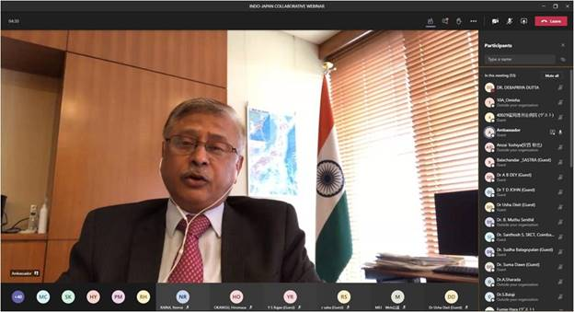
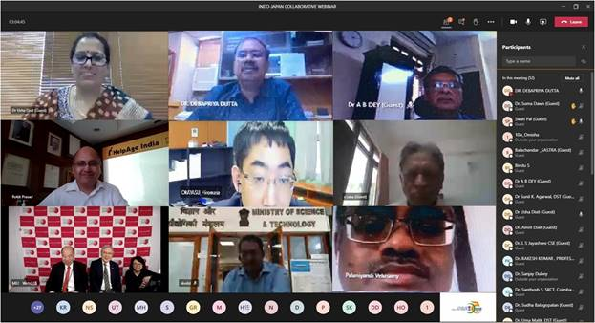

Source
Press Information Bureau, 03 October, 2020

