NRDC and NAL to incubate aerospace engineering start-ups
Start-ups are the initiative to bring innovation in mainstream. The action plan is to focus on simplification and handholding. Another important aspect of start-ups is industry-academia partnership and incubation. Looking at these aspects National Research Development Corporation (NRDC) and Council of Scientific and Industrial Research-National Aerospace Laboratories (CSIR-NAL) joined hands to establish an Innovation cum Incubation Centre with external private funding to promote start-ups in the emerging area of Aerospace technologies.

Under this program start-ups in the area of Aerospace engineering would be incubated, mentored and supported for product and prototype development and their validation. “It is a historical day as NRDC and CSIR-NAL forged an innovative partnership to promote Start-ups in the niche high tech area of Aerospace engineering and this partnership may pave a way for establishing Innovation cum Incubation Centres in other CSIR laboratories which are working in different thematic areas” said Dr. H. Purushotham, Chief Managing Director, NRDC. He also said that this partnership will help to create employment opportunities to the youth of our country as it is the need of the hour.

The agreement was signed by Dr. H. Purushotham and Dr. Jitendra J. Jadhav, Director, CSIR-NAL and was exchanged by the representatives of both the organisations in the presence of Dr. Shekhar C Mande, Secretary Department of Scientific and Industrial Research (DSIR) and Director General CSIR, Shri R Vaidheeswaran, Joint Secretary, DSIR and other senior officials of CSIR and NAL at CSIR Head Quarters, New Delhi.

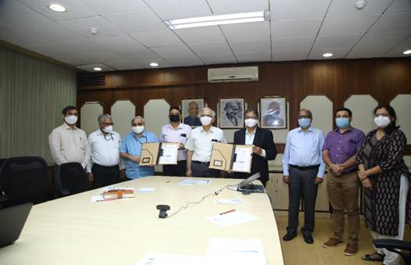

Source
Press Information Bureau, 19 August, 2020

