Experts discuss how STIP 2020 can help country become future-ready & face situations like COVID 19

The STIP 2020 will help democratisation of knowledge, boost research and development to make globally competitive products at greater pace and quality, and empower our industries in research and innovation in creating jobs: Prof Ashutosh Sharma, Secretary, DST
COVID-19 has hugely impacted the world, but it has also shown us the way forward: Dr. V.K. Saraswat, Member, Niti Aayog
Dr. V.K. Saraswat, Member, Niti Aayog highlighted how COVID 19 created opportunities and will have profound long-term consequences while Prof Ashutosh Sharma, Secretary, Department of Science & Technology (DST), underlined how the new Science, Technology and Innovation Policy (STIP) 2020 would make us future-ready to face such situations, at a webinar.
COVID-19 has hugely impacted the world, but it has also shown us the way forward, Dr. Saraswat said at the webinar on DST Golden Jubilee Discourse Series - On the other side of the Pandemic - organised by National Council for Science & Technology Communication and Vigyan Prasa, recently.
“The crisis which has affected everybody through loss of near or dear ones, loss of livelihoods and by bringing the world economy to a halt has also compelled us to re-examine some of our fundamental assumptions about organisational norms, practices one should follow and offered developing countries the opportunity to reinvent and reboot their economy to become self-reliant. The use of science, technology, and innovation will play a pivotal role in dealing with such COVID-19 disruptions,” Dr. Saraswat added.
Emphasising on the role played by STIP 2020 at this critical juncture, Professor Ashutosh Sharma said, “The policy is shaping up well to help us face the challenges of the future and make the country self-reliant.
He said that the policy will help democratisation of knowledge, boost research and development to make globally competitive products at greater pace and quality, and empower our industries in research and innovation in creating jobs.
“We have missed the bus in the past in few sectors, and that this has proved to be an obstacle in being Atmnirbhar in those fields. We cannot miss this opportunity now. STIP 2020 has taken everything into consideration and will greatly help our country to become Atmnirbhar by using science, technology, and innovation”, DST Secretary pointed out.

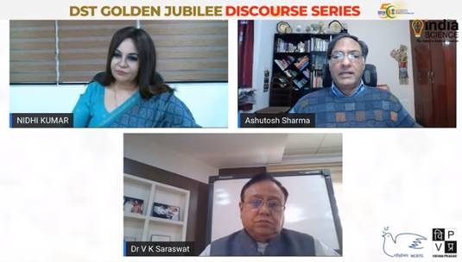

Source
Press Information Bureau, 3 December, 2020

