DST Secretary encourages young scientists to take risks & do profound science

Secretary, Department of Science & Technology, Government of India Professor Ashutosh Sharma encouraged young scientists to do something big to overcome emerging challenges in areas ranging from sustainable development to the rise of intelligent machines at the centenary celebrations of Jamia Milia Islamia (JMI) University recently.

“Challenges and opportunities of doing science are forever emerging and to tackle them young people should take risks, be ambitious and not just carry on regular work just because of the force of habit,” he pointed out while delivering a lecture on the theme ‘Science and Scientist in the New Millennium’ on the occasion.

He stressed on the importance of diversity, inclusion, gender equity, accountability and called for architecture, structure, and processes of doing effective science of quality and direction so that it brings value to the society and is relevant to the society.

Prof. Sharma addressed general misconceptions in academics about segregation of applied and basic science. “The only conflict that matters is about doing work that is either profound or incremental,” he pointed out.

Stressing on the importance of gender equality in science, he talked about ways to get much better representation of women in STEM fields at all levels – researcher, leader, and also culturally empower them.

The celebration was attended by Vice-Chancellor of JMI Professor Najma Akhtar and academics and students from the university.

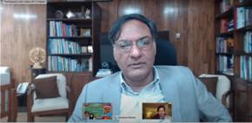

Source
Press Information Bureau, 16 March, 2021

