Dr. Harsh Vardhan calls for public participation in formulating STIP 2020

Inaugurates ‘In Conversation With’ - a series of exclusive interactions with thought leaders from across the country on STIP 2020, which is being formulated
The ‘STIP 2020 Page on ‘MyGov Portal’ along with “popularization Quiz for school children” also launched
“The proposed STI policy must be able to fulfill the dreams and aspirations of millions of young Indian scientists and students”--Dr. Harsh Vardhan
Union Minister for Science &Technology, Earth Sciences, Health& Family Welfare Dr.Harsh Vardhan today invited stakeholders and the public at large in the country and abroad to participate in formulating an evidence-driven, inclusive Science Technology and Innovation Policy (STIP 2020) for the country. He said that it would bring about technology indigenization to become self-reliant, mainstream traditional knowledge systems with conventional R&D, strengthen industry-academia, government interconnectedness and promote equity.

Dr. Harsh Vardhan was speaking at the inauguration of ‘In Conversation With’ - a series of exclusive interactions with thought leaders from across the country and Indian Diaspora on STIP 2020, which is being formulated. He also launched the ‘STIP 2020 Page on MyGov Portal’ along with ‘popularization Quiz for school children’ on 28th August 2020 in a virtual event here.

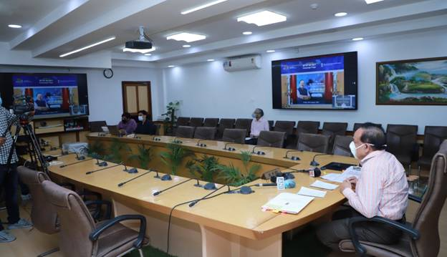
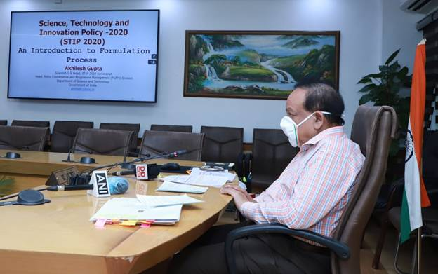

In his address, Dr. Harsh Vardhan said that the entire STI ecosystem has undergone rapid transformation in terms of relevance, scope, and scale in the recent years. These must be captured into a policy to develop a long development trajectory and vision for the country. Moreover, COVID-19 has introduced some new learning and added dimensions to the STI system, he added.

Stating that “Achieving an ‘Atmanirbhar Bharat’ would need greater focus on the development of indigenous technologies and encouragement to grass root level innovation”, the Minister emphasized that “There is an emergence of disruptive and impactful technologies and the country must take advantage of this”.

Dr. Harsh Vardhan outlined, “The proposed STI policy is expected to leverage the astounding progress that the STI system has witnessed in recent years and build a long term pathway which must be able to fulfill the dreams and aspirations of millions of young Indian scientists and students”. “This can be done only when we make policy formulation totally inclusive and participatory”, he stressed.

Elucidating the policy formulation process, the Minister pointed out that “The STIP-2020 process has been divided into 4 interlinked tracks of actions. Track-I involves extended public and expert consultation with 6 activities which aim to reach out to India’s every citizen living in any part of the country to get their ideas, suggestions, or comments for the policy. Track-II action relates to expert consultation, Track-III is for consultation with Ministries and States/UTs, and Track-IV comprises of apex level consultation and advice.”

DST Secretary Professor Ashutosh Sharma highlighted, “As India and the world reorient in the present context of the COVID-19 crisis, a landmark policy initiative STIP 2020 has been initiated at this crucial juncture”. “The formulation process, by design, is envisioned as an inclusive and participative model with interconnectedness among different tracks of activities”, he added.

Later, in a discussion moderated by DST Secretary Professor Ashutosh Sharma, Dr. Harsh Vardhan took up a host of questions on STI ecosystem and STI Policy related issues. The participants too asked questions through live webex platform. He took innovative suggestions from them. Suggestions emerging from these discussions will serve as inputs to the STIP2020 policy process.

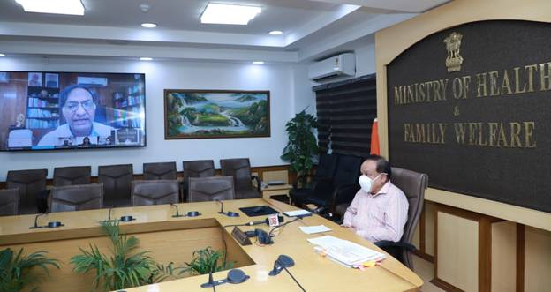

Dr. Akhilesh Gupta, Head - Policy Planning; Mr. Abhishek Singh, CEO, MyGov; Mr. Aditya Kaushik, Co-Founder, Science Policy Forum; Dr. Rabindra Panigrahy, DST Scientist; Dr. Nimita Pandey, DST - STI Policy Fellow; Dr. ChagunBasha, Senior Technical Specialist, Office of the Principal Scientific Advisor to Govt of India; were among various dignitaries who joined the function virtually.
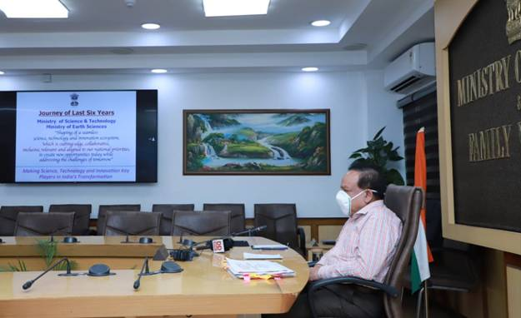

Hyper Links;
- Background Note on STIP-2020
- Introduction to Formulation Process
- Journey of Last Six Years--Ministry of Science & Technology, and Earth Sciences

Source
Press Information Bureau, 28 August, 2020

