DST Secretary highlights digital transformation opportunities that emerged from COVID 19 disruptions
Secretary, Department of Science and Technology, Professor Ashutosh Sharma, has emphasised that the future is all about convergence of digital technologies and that COVID 19 virus has provided the country opportunity to be part of the change rather than resisting it. Professor Sharmawas speaking at webinar on Digital Transformation in COVID-19.

“Use of digital technologies and machines can take the country to new heights and fulfil the dream of our Prime Minister of ‘Atmanirbhar Bharat’,” Professor Sharma pointed out. He added that data is the new Mantra, and we must value data to use it for our progress at the webinar organised by the Standing Conference of Public Enterprises (SCOPE).

Professor Sharma explained that future has been coming to us at a fast pace even before the COVID-19, but the virus has changed everything. It has disrupted every sector and every life beyond imagination. Its’ impact is on all aspects-- whether it is availability of labour, supply chains, or logistics. However, the more disruptive the challenge, the bigger will be the achievement, and this is a very good time to think where we are and where we want to be.

He elucidated that several opportunities have been created in digital, cyber digital areas. “With the youth power we have, this is a great opportunity for all stakeholders to use it to enlarge the scope of business and to reach more people," Prof. Ashutosh Sharma stressed.

The pandemic has created pressures on the business environment, necessitating the adoption of technology and digitalization. Companies across sectors are accelerating investments in Digital Technologies to meet business requirements. SCOPE conducted the Webinar to discuss how various sectors can leverage Digital to operate in the new business environment.

The topics in the webinar included digital economy in COVID, digital disruptions & impact on key sectors, emerging digital themes in the wake of COVID-19, and realigning digital priorities.

The speakers included S.M.Vaidya, Chairman, IOC, Rakesh Kumar, CMD, NLC & Chairman, SCOPE, Sushant Rabra, Partner, KPMG India, and Manas Majumdar, Partner, KPMG India.

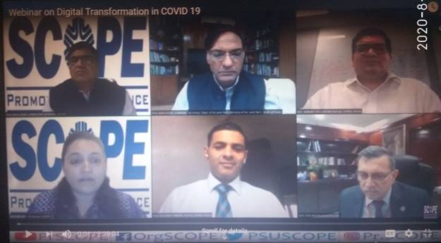

Source
Press Information Bureau, 11 August, 2020

