Kerala Start-ties up with SCTIMST to launch IoT (Internet of Things) based used mask disposal smart bin & UV light-based disinfection device to beat COVID 19

VST Mobility Solutions, a Startup headquartered at Cochin, has launched an automated mask disposal machine as part of efforts to develop products helping to combat the Covid-19. The disposal device, named BIN-19, developed Chitra UV based face mask disposal bin technology from the Sree Chitra Tirunal Institute for Medical Sciences and Technology (SCTIMST), Trivandrum an institute of national importance under Department of Science and Technology (DST), Government of India, was formally launched by Ernakulam District Collector S. Suhas by installing a unit at his office, the administrative headquarters of the district.

The IoT-based BIN-19 (Internet of Things) is used for collecting and disinfecting Used Face-Mask. The device has been subjected to a series of successful microbiological tests by Sree Chitra Lab. Sree Chitra is one of the testing agency for UV based devices in the country as per the guidelines of the Indian Council of Medical Research (ICMR).

Launching the BIN-19 and UV SPOT district collector S Suhas said this is the first time such a facility is available in Kerala. “These products will be assets for beating the COVID19 in the state. The products would also help in preventing environmental damages,” he added.

“The DST and the Institute are very happy to see the successful launch of UV-bin and multipurpose disinfection system by VST. We would like to congratulate the team for converting our technical knowhow and prototype into these devices, which will be very handy in offices, homes, and other public places. It will be an addition to the efforts to break the chain of contagion of COVID-19,” said Dr. Asha Kishore, Director, SCTIMST.

Explaining the functioning of BIN-19, Mr. Alvin George, CEO of VST Mobility Solutions, said that the used masks dropped inside a container of the bin will be first disinfected by a process. The disinfected masks will be transferred to another container inside the Bin. The person dropping the mask can sanitize her hands with the help of the automatic sanitizer dispenser attached to the Bin-19. There is no need to touch or operate any switches in the Bin to do all these. All functions are automated in the hands-free equipment for the safety of users and health workers.

The IoT Features of BIN-19 are Auto Sanitizer Dispenser ( remotely alerts if it's empty), Mobile Application to navigate/find Bin-19, Web Portal for Status Alerts, Power ON/OFF alerts, Box open alerts.

VSL Mobility Solutions has also launched, UV SPOT, a UV light-based multipurpose disinfector, another product in its Covid-19 combat portfolio. It is a multipurpose disinfector device with ultraviolet disinfection lamps. VST Mobility Solutions said that with internal reflective surfaces and UVC Lamp, the device disinfects a board range of microorganisms.

The device is mainly used for disposing of the contaminated or used face-mask and for reusing the UVC stable metallic products. This device is proven under a microbiological test conducted by Sree Chitra Lab.

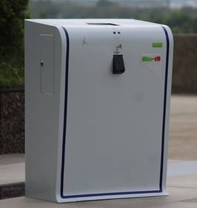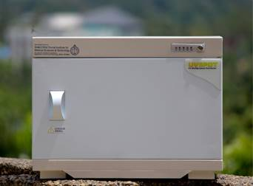
(For more details, please contact: Ms. Swapna Vamadevan, PRO, SCTIMST, Mob: 9656815943, Email: pro@sctimst.ac.in)
Source
Press Information Bureau, 11 June, 2020

