India’s biotechnology industry is built on the 4 core beliefs of entrepreneurship, innovation, development of local talent, and demonstrating high value-based care: Vice President Shri M. Venkaiah Naidu

Shri M. Venkaiah Naidu confers six BIRAC Innovator Awards
The Global BioIndia 2021 showcased India’s strength in the Biotechnology sector: Dr. Harsh Vardhan
Disruptions of supply chains including imports of critical products and raw material brought in realization for India to become Atmanirbhar: Dr. Harsh Vardhan
Dr. Harsh Vardhan releases the Indian Pathogen Priority List
Over 6000 delegates from over 50 countries attended the 24 sessions of the second edition of Global BioIndia 2021: Dr.Renu Swarup, Secretary, DBT

The Vice President, Shri M Venkaiah Naidu today called upon scientists and researchers to be always ready to combat new and emerging diseases as COVID-19 pandemic has reinforced the need to be ever vigilant to tackle an outbreak of sudden and unforeseen epidemics and pandemics.

Virtually addressing the Valedictory and Award Session of Global Bio India-2021, he said that Biotechnology has emerged as the backbone of various industrial sectors in recent times. Built on four core beliefs of entrepreneurship, innovation, development of local talent, and demonstrating high value-based care, India is in a unique position to transition from the biotech industry to a bio-economy, he added.

Lauding the Department of Biotechnology for working relentlessly to mitigate the COVID-19-induced health crisis through the development of diagnostics, vaccines and novel protection equipment, apart from scaling up diagnostic capacity and rapid regulatory response, he expressed happiness that India is at the forefront of fighting the pandemic.

Referring to India’s supply of COVID-19 vaccine to several countries in tune with the spirit of VausudhaivaKutumbakam ( whole world is one family) and our age-old philosophy of ‘share and care’, he pointed that India’s action drew praise from the World Health Organization with its Director-General thanking Prime Minister, Shri Narendra Modi for supporting vaccine equity.

Recognizing the immense potential of the biotech sector, the Vice President said the Government has eased regulatory approvals for the ecopreneurs. “I am pleased to know that these initiatives have resulted in a multifold impact as seen in the number of innovators, technologies and products, incubation space and IPs generated in the last year despite the pandemic”, he added

Referring to the Biotech sector’s ambitious target of becoming a USD 150 billion industry by 2025 and contribute to knowledge and innovation-driven economy, Shri Naidu urged the academia and the industry to join hands and engage pro-actively in imparting training and skills to the youth.
Citing the attractiveness of India’s value proposition and comparative advantage in bio-economy, he said the ‘Make in India’ initiative or Atmanirbhar Bharat will help in achieving the paradigm shift from “biotech” to “bioeconomy”. “I am sure that the new policy actions would result in the growth of a sustainable bio-economy”, he added.

The Vice President also stressed the need to leverage the huge potential of Biotechnology sector to come up with new interventions to address the challenges faced by agriculture and allied sectors.

Union Minister of Science & Technology, Earth Sciences and Health & Family Welfare, Dr. Harsh Vardhan; Secretary, Department of Biotechnology, Dr. RenuSwarup; Director General of CII, ShriChandrajit Banerjee; Chairperson of Biocon, Dr. Kiran Mazumdar Shaw; WHO Representative to India, Dr. Roderico H Ofrin,Head; Strategy Partnership & Entrepreneurship Development, BIRAC Dr. Manish Diwan among others participated in the virtual event.

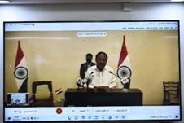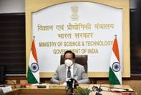

Dr. Harsh Vardhan released the Indian Pathogen Priority List in the presence of Dr. Roderico. Dr Harsh Vardhan stated that the global impact of COVID-19 has brought a greater recognition of biotech sector’s direct influence on innovation and technology adoption for Pharma, Med tech, Agriculture and allied areas, Clean solutions, and Industrial bio-manufacturing. Disruptions of supply chains including imports of critical products and raw material brought in realization for India to become Atmanirbhar.“Prime Minister’s clarion call to make India as a $100 Billion Bio-manufacturing Hub and a USD 150 billion industry by 2025 is a testimony of the nation’s expectations from Biotechnology sector”, he said. The Global BioIndia 2021 showcased India’s strength in this important sector. The Minister also congratulated all the awardees for their exemplary contributions to the biotech innovation ecosystem and also expressed his happiness at the release of Indian Priority PathogenList.

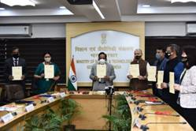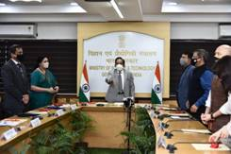
Dr. Renu Swarup Secretary Department of Biotechnology thanked Shri M.Venkaiah Naidu, Vice President and Dr. Harsh Vardhan, for their presence and informed that the Global Bio-India was a success with the participation of over 6000 delegates from over 50 countries who have attended the 24 sessions of the second edition of Global BioIndia2021.

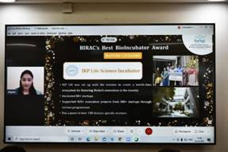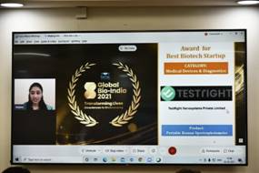

Please CLICK HERE for details of the Best Startup Award .
Please CLICK HERE for details of the Best Bioincubator Award.
Please CLICK HERE for details of the BIRAC Innovator Awards
.

Source
Press Information Bureau, 03 March, 2021

