Youth need to focus on innovation & on creating new jobs: Professor Ashutosh Sharma,DST Secretary
Secretary Department of Science and Technology Professor Ashutosh Sharma underlined that the time for innovation has come and the youth now need not limit themselves to finding jobs, but also focus on creating hundred other jobs.

“There has never been a better time to be in innovation business. It is important to be in the area of innovation and connect with the Nation’s aspirations and priorities,” he said in his keynote address at the KPIT sparkle virtual grand finale.

He spoke about the difference between invention and innovation and the connection between them.

“Invention is something which takes resources and produces knowledge that has both direction and relevance that can be leveraged for innovation. Essentially invention is producing new concepts, new knowledge and innovation starts where invention stops. It takes the new idea, concept or prototype and converts it into new socioeconomic opportunities. For innovation to succeed the idea has to be converted into something that people can use,” he added.

Addressing the audience present at the grand finale event he pointed out that the participants of KPIT challenge are now at a juncture or twilight zone at which they have developed a successful idea or prototype. This is the first step towards innovation consisting of a chain of events starting from scouting of people and ideas, training, mentoring, encouraging and beyond.

He said that the participants should ‘know their problem’ which means they should be have knowledge about the market, competitors, need of the product, as well as market realities.

“DST has increased the budget of startup and innovation by 500% in the last five years and that has led to creation of more technology incubators (TIB) and supported more startups in the last five years than in the previous 50 years. DST is on a journey of doubling startups in every three to five years with thrust from other ministries like, MEITY, DBT and Atal innovation mission of NITI Ayog” he pointed out.

He stressed that there are a lot of opportunities available at every step for starting innovation journeys --- grant of Rs 10 lakhs for prototyping for pre-incubation period, seed money up to 1 crore Rupees per startup from DST. He added it has been found that for every one rupee given by the government as grants to startups boosts the confidence from investors to the tune of 11.5 rupees.
Professor Sharma emphasised that the future is going to be nothing but disruptive and we must build the capacity to learn, relearn and move forward with the understanding and willingness to change.

KPIT Sparkle Virtual Grand Finale was a three day virtual event organized recently by KPIT Sparkle which is a platform that connects budding technology entrepreneurs with the incubation ecosystem. It provides the multidisciplinary outlook required to first-time student entrepreneurs with an objective to spread the culture of innovation at grassroot level and inculcate innovative thinking to identify and solve real-life use-cases/problems by developing a unique solution. It further provides opportunities for realising indigenous solutions to the problems faced by our country within the areas of mobility and energy, encourage students to generate IP and facilitate them to secure their intellectual property, provide faculty of academic institutions a hands-on experience on problem solving and strengthen the student - mentor bond, encourage students to become entrepreneurs and facilitate incubation across India.

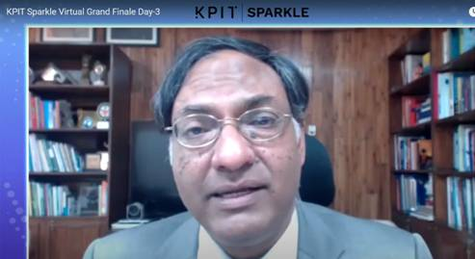

Source
Press Information Bureau, 09 March, 2021

