ARCI scientists develop next-generation biodegradable metal implants

The team is certain that the newly developed alloys are suitable for biodegradable stent and orthopedic implant applications

Scientists at the International Advanced Research Centre for Powder Metallurgy and New Materials (ARCI) and Sree Chitra Tirunal Institute of Medical Sciences, Thiruvananthapuram both autonomous institutes under the Department of Science & Technology (DST) have jointly developed new generation Iron-Manganese based alloys for biodegradable metal implants for use in humans.

Biodegradable materials (Fe, Mg, Zn, and polymer), which can participate in the healing process and then degrade gradually by maintaining the mechanical integrity without leaving any implant residues in the human body are better alternatives to currently used metallic implants which remain permanently in the human body and can cause long-term side effects like systemic toxicity, chronic inflammation, and thrombosis.

The ARCI team employed both conventional melting and powder metallurgy techniques in manufacturing of the new Fe-Mn based biodegradable alloys and stent having dimensions as Diameter: 2 mm, Length: 12 mm and Wall thickness: 175 µm.

Iron-Manganese based alloy Fe-Mn (having Mn composition of more than 29% by weight) is a promising biodegradable metallic implant which exhibits single austenitic phase (non-magnetic form of iron) with MRI compatibility.

The Fe-Mn alloy produced at ARCI exhibited 99% density with impressive mechanical properties and behaved as a nonmagnetic material even under a strong magnetic field of 20 Tesla. These properties are comparable to presently used permanent Titanium (Ti) and stainless-steel metallic implants. The alloy also showed a degradation rate in the range of 0.14-0.026 mm per year in the simulated body fluid, which means that the Fe-Mn alloy exhibits mechanical integrity for 3-6 months and completely disappears from the body in 12-24 months.

During the degradation process, calcium phosphate deposits on the implant due to local alkalization and saturation of calcium and phosphate, allow cells to adhere onto the surface to form tissues.

The team is making further efforts to achieve control in corrosion rates through alloying addition and surface engineering and to employ advanced manufacturing processes like additive manufacturing to realize complicated shapes.

Based on the impressive results, the ARCI team is certain that the newly developed Fe-Mn based alloys are suitable for biodegradable stent and orthopedic implant applications. Invivo and in-vitro studies are being planned at Sri Chitra Tirunal Institute of Medical Sciences by the team.

For more details, contact Dr. Kaliyan Hembram (kaliyan@arci.res.in)
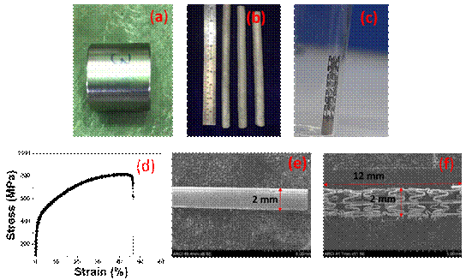

Fig.1: (a) As cast Fe-Mn-Si alloys billet, (b) Extruded and heat-treated rods, (c) Stent made by laser micro-machining, (d) Stress-Strain curve of the alloy, (e) and (f) SEM images of tube and stent

Source
Press Information Bureau, 16 May, 2020

