Dr Harsh Vardhan Launches DBT – AMTZ Mobile Diagnostic Unit for Covid Testing- I-Lab
“This mobile testing facility will be deployed through the DBT testing hubs to remote regions of the country for Covid testing”: Dr Harsh Vardhan
This I-Lab has been created in a record time of 8 days by the Andhra Pradesh Med-tech team with the support of DBT
The unit has biosafety facility and is capable of performing RT-PCR as well as ELISA tests

The Minister for Science & Technology, Earth Sciences and Health & Family Welfare Dr Harsh Vardhan inaugurated and flagged off India’s first I-Lab (Infectious disease diagnostic lab) for Covid testing in rural and inaccessible areas of India, here today. Secretary, Department of Biotechnology Dr. Renu Swarup and other officials were present on the occasion. Dr. Jitendar Sharma, CEO, Andhra Med Tech Zone CEO, and senior officials from NITI Ayog, Ministry of Health & Family Welfare, MeiTY, other ministries, ICMR, DST, CSIR etc joined the function through web online.
Expressing his happiness to launch the I-Lab, infectious disease diagnostic laboratory- a mobile testing facility, Dr. Harsh Vardhan dedicated this facility to provide Covid testing access to rural India. This mobile testing facility will be deployed through the DBT testing hubs to remote regions of the country for Covid testing. He congratulated and appreciated the efforts of the DBT in tackling the Covid pandemic, and added that DBT coordinated in scaling-up testing for Covid by reorienting premiere laboratories as Covid testing centers in a hub and spoke model. There are now over 20 hubs in the country with 100 testing laboratories and these have tested more than 2,60,000 samples.
Dr. Harsh Vardhan said, “This has been possible through the DBT-AMTZ COVID Command Consortia (COVID Medtech Manufacturing Development] Consortia)” to cope-up with the current situation in the country and move progressively towards a stage of self-sufficiency. The I-lab will be deployed through these hubs into remote and interior places”. The Minister appreciated the “Andhra med-tech zone team for building this unique, innovative facility for the country at the period of lock-down through tireless, dedicated and committed efforts”. He informed that AMTZ through the support of DBT has also established manufacturing facility for indigenous manufacturing of kits and reagents for various testing kits which were initially imported thereby helping us realise the vision of Pradhan mantriji on- Make-in India, Make for India”. He pointed out that today there are 953 testing laboratories in all corners of the country and elaborated on “Various steps taken by the ministry and departments towards achieving research components indigenization and their in-house manufacturing.” Dr. Harsh Vardhan emphasised that “In the near future with all these collective and cooperative efforts, India will achieve self-sufficiency in healthcare technologies leading towards Atma Nirbhar Bharat.”
Dr. Renu Swarup said on the occasion that through the concerted efforts Indian scientists, the country has achieved a capacity of producing nearly 5 lakh testing kits per day, exceeding the target of having one lakh test kits by May 31, 2020. She pointed out that this I-Lab has been created in a record time of 8 days by the Andhra Pradesh Med-tech Zone team with the support of DBT under the National Biopharma Mission being implemented by the Public Sector BIRAC. She highlighted that the unit has biosafety facility and is capable of performing RT-PCR as well as ELISA tests.
DBT-AMTZ COMManD
The Department of Biotechnology (DBT), Ministry of Science & Technology along with Andhra Pradesh Med-tech Zone (AMTZ) has initiated the DBT-AMTZ COMManD [COVID Medtech Manufacturing Development] Consortia to address the shortage of critical healthcare technologies in India and move progressively towards a stage of self-sufficiency.
Under this Consortia, India’s first I- lab (infectious disease diagnostic lab) has been built at AMTZ in record time of 8 days from the date of receipt of Automotive Chassis, from Bharat Benz. This is a mobile diagnostic unit with biosafety facility. The I- lab is a BSL-2 facility with on-site ELISA, RT-PCR, Bio chemistry analysers. It can run 50 RT-PCR reactions and about 200 ELISA in a day.Double set of Machines can help increase the capacity to about 500 per day in 8 hours shift
It can be deployed in remote areas and can be lifted from Automotive Chassis and can be put on goods train for sending to any location in the country.The BSL -2 Lab is as per NABL specifications and is being attached to DBT’s certified Testing centres.
The Department of Biotechnology (DBT), under the Ministry of Science & Technology, promotes and accelerates the development of biotechnology in India, including growth and application of biotechnology in the areas of agriculture, healthcare, animal sciences, environment and industry.
AMTZ is Asia's first medical equipment manufacturing ecosystem, uniquely dedicated for Medtech and supported by various Ministries.
INFECTIOUS DISEASE DIAGNOSTIC LABORATORY (I-LAB)
- To promote last mile access of testing to rural India, DBT under the Covid-Command strategy has supported building of mobile testing labs through AMTZ.
- The unique feature of these mobile testing labs is their utility in diagnosing other infectious diseases beyond the Covid period
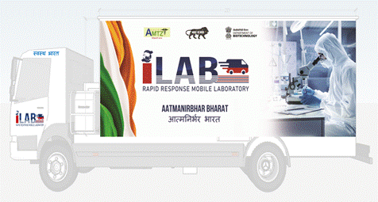

Specifications
- Automotive Chassis, Diagnostic Equipment, Clean Room, BSL-2 lab, bio-safety cabinets
- 25 Tests (RT-PCR) per I-Lab per Day
- 300 ELISA tests/day
- Additional test for other diseases for TB, HIV etc. tol be costed as per CGHS rates.
Deployment

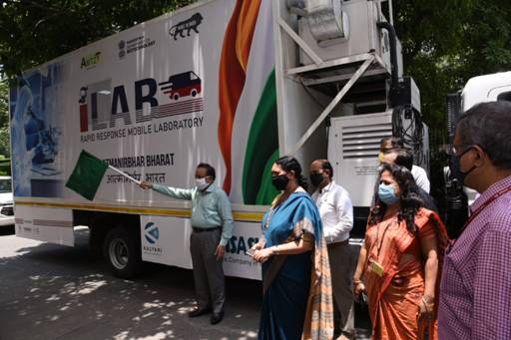
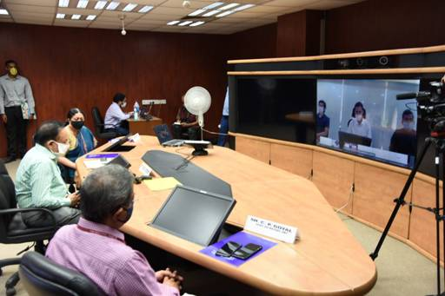
- The first I- lab was launched in New Delhi on 18th Jun, 2020 by Dr Harsh Vardhan, Minister for Science & Technology, Earth Sciences and Health & Family Welfare.
- The labs will be provided to the regional/City hubs and they will deploy it further in the interior, inaccessible parts of the region.
(Pl see more photos and video in this link)

Source
Press Information Bureau, 18 June, 2020

