DST supported startup to make natural, alcohol-free sanitizer to combat COVID 19
“The bio-surfactant based disinfecting solutions are biodegradable, environmentally friendly, and easy on skin", says Professor Ashutosh Sharma, Secretary, DST.

Green Pyramid Biotech (GPB), a company working on Food, Agriculture, and Bio-Technology, located in Pune, Maharashtra, is being funded by the Department of Science & Technology (DST), for manufacturing natural, alcohol-free sanitizer for hands and surfaces with long-lasting antibacterial and antiviral effect.
It can be very effective in India’s fight against COVD 19. Since the disease spreads through contagion, cleaning of hands, as well as commonly used surfaces like tables, computers, chair, mobile phones, and locks, is very essential to slow down the spread. The use of soap or alcohol can destroy the thin outer layer of fat that covers the virus, but in the ready availability of soap and water is a challenge. The access and regulation of usage of the alcohol-water mixture are difficult too.
This sanitizer formulation developed by Green Pyramid Biotech, whose Active Pharmaceutical Ingredient (API) is a biosurfactant that provides long-lasting protection against bacteria and viruses, can be an alternative to significantly reduce the risk of infection. It has been tested against a wide array of pathogenic bacteria, fungi, and yeast. The formulation can provide a convenient and effective way to clean hands and surfaces and is totally biodegradable, natural, and alcohol-free. In addition to sanitization, the API has a unique property of supporting fibroblast activity. Hence it can be used to clean the wounds and prevents dryness and skin irritation. Besides, the product whose technology concept and applications have been formulated is harmless to the skin.
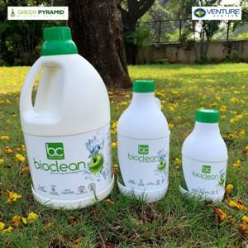
"There are several different approaches to disinfect skin--soap and water, alcohol based formulations, nanoparticle containing media, etc. each of which has strengths and use, depending on the availability, context and circumstances. The bio-surfactant based disinfecting solutions are biodegradable, environmentally friendly, and easy on skin", said Professor Ashutosh Sharma, Secretary, DST.
Green Pyramid Biotech (GPB) is a Pune based company a spinoff from one of the premium research institutes, the CSIR-National Chemical Laboratory (Pune) and funded by Seed Support System of the Technology Development Board (TDB), DST and incubated byEntrepreneurship Development Center (Venture Center), Pune. Dr. Asmita Prabhune, Ph.D. in Microbiology, is its founder and director.
(For further details contact:
Dr. Asmita Prabhune (Founding Director) Green Pyramid Biotech Pvt Ltd, NCL
asmita.prabhune@gmail.com

Source

Press Information Bureau, 10 April, 2020

