S&T based innovative solutions by common people participating in NIF’s Challenge COVID-19 Competition (C3) ready to make adifference

The National Innovation Foundation – India (NIF), an autonomous body of the Department of Science and Technology (DST) has identified several S&T based innovative solutions through the Challenge COVID-19 Competition (C3), a campaign which was running from 31st March to 10th May 2020 for engaging innovative citizens to come up with ideas and innovations to tackle the pandemic.

NIF is providing incubation and mentoring support for further dissemination to the generator of the ideas. A foot-operated device for hand sanitization and washing and an innovative sprayer for sanitizationare the two recently supported innovations under the campaign.

Shri Mupparapu Raju from Warrangal, Telangana, has designed the foot-operated device for hand sanitization and washing, which is a timely solution in response to need for contactless devices in the prevailing COVID-19 environment. It facilitates dispensing of soap and water by way of operating the device by foot, and not hands. As a result, there is no hand-related contact between the user and sanitizer, soap, or water, which are adequately stored in separate containers as a part of the device. Shri Raju has implemented the device at various locations (Warrangal, Mahabubabad, and others) in the State of Telangana. NIF has extended support to the innovator for value addition and in meeting the production commitments.

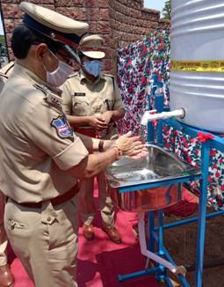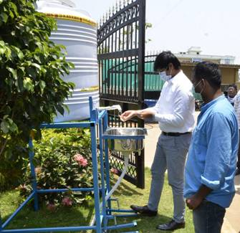

Implementation of Foot-operated device for Hand Sanitization and Washing at Warangal and Mahabubabad districts of Telangana

The other supported innovation is an innovative sprayer capable of sanitizing or washing large areas like roads, societies, doors, compounds, walls, etc. The sprayer consists of two radial fans of aluminum moving opposite to each other. In terms of mechanism, each fan sucks air from two opposite directions, which is released through nozzles at high pressure with minute droplets sizes. As the panel rotates 180 degrees, it can cover from the ground upto 15 feet tall walls. Any tractor of power more than 15 horsepower(hp) can be used to operate this through Power Take-Off (PTO). By deploying this sprayer, one can sanitize the societies, roads, and so on at a maximum distance of 30 feet from the center of machine and upto 15 feet height. Which means the machine will sanitise 30 feet horizontally and 15 feet vertically. As a result, compounds, doors can easily be sanitized with this sprayer. Nozzles in the sprayer are such that during operation of the device, the required area can be sanitized at ease, be it a spacious location or a congested location.

"Unleashing the partnership, ownership and creativity potential of our citizens in COVID-19 solutions and actions is a huge opportunity which is made visible by the NIF challenge. This is empowering our grass-roots innovators and entrepreneurs by recognition, prototyping help and thus translation of their relevant ideas into products.", said Prof Ashutosh Sharma, Secretary, DST.

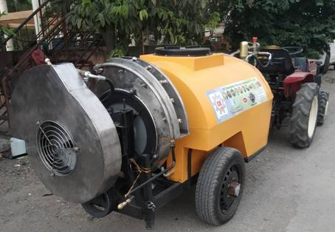
The Innovative sprayer for sanitization

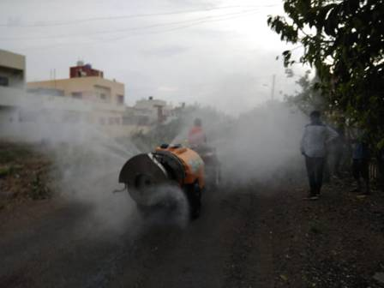
The Sprayer is being deployed for sanitization on the streets of various locations in Maharashtra

The sprayer has been actively used at various locations in the State of Maharashtra viz. Satana, Nashik, etc.

A large number of citizens have participated in the Challenge COVID-19 Competition (C3) and helping the country come out of this crisis through Science and Technology based innovative solutions. The relevance of technologies to COVID-19 and the pace at which these have been designed, prototyped and eventually made available for social and commercial dissemination establishes the fact that Challenge COVID-19 Competition (C3) of NIF has been accepted very well by common people who believe that Innovation can indeed help the nation conquer crisis.
[For further details, contact Mr. Tushar Garg, tusharg@nifindia.org, Mob: +91-9632776780.]

Source
Press Information Bureau, 17 May, 2020

