Webinar on Scientific & Technological Interventions by CSIR-CMERI combating COVID-19 under Jigyasa programme
“We must have a common goal, shared vision and direct link between science and society to harness better results in whatever solution we expect from science” -- Prof. (Dr.) Harish Hirani

Prof. (Dr.) Harish Hirani, Director, CSIR-CMERI, Durgapur has said that “science is the key to progress for socio-economic development and as the present pandemic has posed a challenge to combat it in a united spirit, we must also have a common goal, shared vision and direct link between science and society to harness better results in whatever solution we expect from science. He highlighted the need of effective local level administration to provide an efficient result at global standards”.

Prof. (Dr.) Harish Hirani was addressing a webinar,hosted by CSIR-CMERI Durgapur in association with Samagra Siksha, Department of School Education, Jammu & Kashmir on 08.09.2020 on Scientific & Technological Interventions by CSIR-CMERI combating COVID-19 as a part of the ‘Jigyasa’ programme. The event had the following keynote speakers: 1) Prof. (Dr.) Harish Hirani, Director, CSIR-CMERI, Durgapur 2) Dr. Asgar Samoon, IAS, Principal Secretary, School Education, Technical Education & Skill Development, Jammu & Kashmir, 3) Dr. Anjali Chatterjee, Chief Scientist, CSIR-CMERI, 4) Dr. Himadri Roy, Principal Scientist, CSIR-CMERI, 5) Mr. Avinash Yadav, Senior Scientist, CSIR-CMERI, 6) Dr. Nasir ul Rasheed, Senior Scientist, CSIR-CMERI and 7) Mr. Sanjay Hansdah, Scientist, CSIR-CMERI. The webinar was attended by more than 3,500 participants.
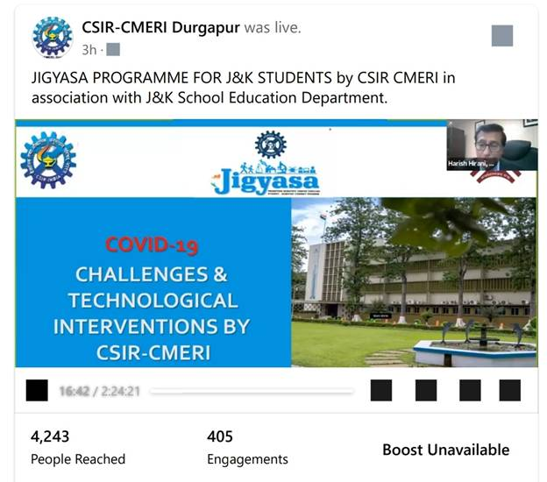

Opening the above webinar, Prof. (Dr.) Hirani, highlighted the importance of such ‘Jigyasa’ programmes for the students and stated that CSIR-CMERI is contributing in this direction through providing skill development opportunities to the students starting from school level i.e. Higher Secondary, ITI, Diploma, Undergraduate level and help them imbibe a scientific temper and entrepreneurship mindset. Prof. Hirani said that the present crisis of the pandemic COVID-19 is expected to continue for a longer period of time. In this regard he signified the importance of science which has the capability to do anything comparing science with magic.

Prof. Hirani emphasized about the technological interventions and solutions developed by CSIR-CMERI such as Face Masks, Basic Liquid Soap, Hand Sanitizers, Sprayers, Ventilators etc. and its contributions in containing the spread of the pandemic as well as providing the employment opportunities to many households. He also emphasized on the requirement of clean water, clean air and environment with proper waste management system together with the need of an improved immune system for us to fight the coronavirus and even in post COVID era also.

Dr. Asgar Samoon, IAS, Principal Secretary, School Education, Technical Education & Skill Development, Jammu & Kashmir while addressing the participants discussed in details the proposed education Policy as well as the previous policies of the Government. He underlined the contributions of CSIR Labs throughout the country and particularly in Jammu & Kashmir in creating higher scientific & technical outputs and providing the youngsters an opportunity in their S&T pursuits. He also suggested to come forward further so that our country can compete with the developed nations.

During the webinar Dr Anjali Chatterjee, Chief Scientist, CSIR-CMERI presented in detail about the COVID Protection System (COPS) for Workplace & Hospitals like Solar based IntelliMAST, Touchless Faucet, 360º Car Flusher, Dry Fogging Shoe Disinfector and Hospital Care Assistive Robotic Device (HCARD) developed by CSIR-CMERI. Dr. Himadri Roy, Principal Scientist discussed about the importance of Masks & sanitizers as 1st level of defense in COVID-19. Mr Avinash Yadav, Sr. Scientist presented in detail the Disinfection Units developed by the Institute for Workplace, Schools, Hospitals & Roads like Hydraulic and Pneumatic Variants of Disinfection Walkway, Road Sanitizer Unit, Pneumatically Operated Mobile Indoor Disinfection (POMID) Unit, Battery Powered Disinfectant Sprayer (BPDS). Dr. Nasir ul Rasheed, Senior Scientist presented on the versions of Touch free Soap-cum-Water Dispensing Systems developed by the Institute. Mr. Sanjay Hansdah, Scientist made an in depth presentation on Ventilators developed by CSIR-CMERI as Life Supporting System in COVID-19.
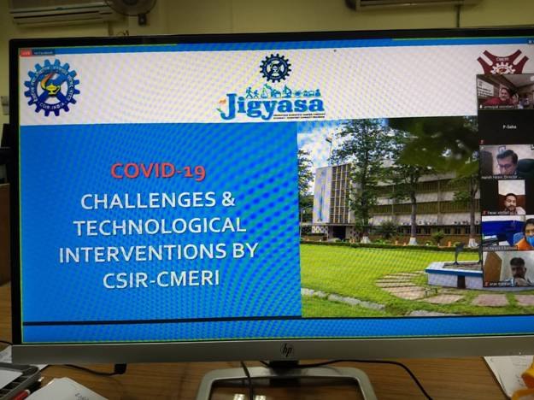

Dr. Arun Manhas, Director of School Education, Jammu & Kashmir acknowledged the role and contributions of CSIR-CMERI in dissemination of S&T to the society. He also thanked Dr. Asgar Samoon, Principal Secretary, School Education, Technical Education & Skill Development, Jammu & Kashmir and other Education Officers and students participating in the webinar.

Source
Press Information Bureau, 9 September, 2020

