Vigyan Jyoti programme spreads to 100 districts in 2nd phase

DST is working proactively to bring gender parity in Science & Technology (S&T) domain through various women-centric programmes
The New Education Policy and the Science, Technology and Innovation Policy could make use of the demographic dividend to progress long in short time to help increase number of women in science:Prof Ashutosh Sharma, Secretary, DST
The second phase of Vigyan Jyoti programme commenced on the occasion of International Day of Women and Girls in Science on February 11, 2021, which will spread the programme for encouraging girls to take interest in science and build a career in STEM to 50 more districts adding to the existing 50 districts across the country.

Speaking on the occasion, Prof Ashutosh Sharma, Secretary, DST hoped that this programme would improve by learnings of the past one year and expand to more and more districts of the country to empower women and help increase number of women in top science institutes.

“Under-representation of women is a multi-dimensional problem, and we need to see the problems from all angles and give a little push to get the desired result. The New Education Policy and the Science, Technology and Innovation Policy could remove the constraints and make use of the demographic dividend to progress long in short time to help increase number of women in science,” he added.

He suggested that interaction with girls should increase with all sort of role models, especially women achievers.
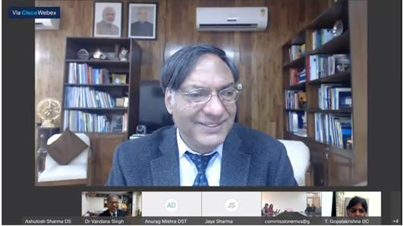

Vigyan Jyoti programme, a new initiative to encourage girls to take interest in science and build career, was launched by the Department of Science & Technology (DST) to create a level-playing field for the meritorious girls to pursue STEM. It had been running successfully in 50 Jawahar Navodaya Vidyalayas (JNV) since December 2019 and has now been expanded to 50 more JNVs for the year 2021-22.

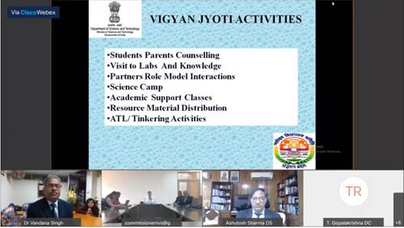
The programme addresses the under-representation of women in certain areas of STEM. As a first step, the programme has been started at school level for meritorious girls of Class IX to Class XII to encourage and empower them to pursue STEM courses in reputed institutions of the country.

Vigyan Jyoti activities include student-parent counselling, visit to labs and knowledge centres, partners role model interactions, science camps, academic support classes, resource material distribution and tinkering activities. Online academic support to students includes streaming of video classes, study materials, daily practice problems and doubt clearing sessions.

Dr Sanjay Mishra, Adviser, DST and head of KIRAN programmes, including Vigyan Jyoti, said that there are plans to add more and more districts for this programme in the near future and the impact of this programme would be visible in 100 districts to encourage girls in STEM.

Vinayak Garg, Commissioner, Navodaya Vidyalaya Samiti (NVS), said that it is very important to provide a conducive environment for girls and this programme is a huge step in the direction to encourage girls taking interest in science.

DST is working proactively to bring gender parity in Science & Technology (S&T) domain through various women-centric programmes. Apart from Vigyan Jyoti, it runs other women-oriented programmes like Women Scientists Scheme to help women with career-break, Indo-US Fellowship for Women in STEMM (WISTEMM) program where women scientists can work in research labs of USA, Consolidation of University Research for Innovation and Excellence in Women Universities (CURIE) programme for improving R&D infrastructure and establishing state-of-the-art research facilities in order to create excellence in S&T in women universities and Gender Advancement for Transforming Institutions (GATI) program in pilot mode. Further, DST has also additionally established Artificial Intelligence (AI) labs in women universities with the goal to foster AI innovations and to prepare skilled manpower for AI-based jobs in future.

Source
Press Information Bureau, 12 February, 2021

