CSIR-CMERI Transfers COVID related technologies of Oxygen Enrichment Unit, UVC LED Sterilizer Unit and Safe Disposal of Solid Waste

CSIR-Central Mechanical Engineering Research Institute, Durgapur transferred its COVID related technologies namely Integrated Municipal Solid Waste Disposal System in modular form, Oxygen Enrichment Unit and Intelligent UVC LED Sterilizer Unit to M/s. Sai Enviro Engineers Pvt. Ltd. (SEEPL), Tuticorin Tamil Nadu, M/s. Zen Medical Technologies Pvt. Ltd., Ranga Reddy, Telangana and M/s.Trinity Microsystems Pvt Ltd, New Delhi respectively on 24.03.2021.

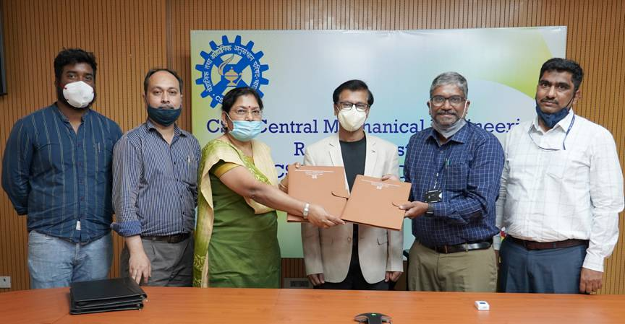

Prof. (Dr.) Harish Hirani, Director, CSIR-CMERI on the occasion shared that there has been a substantial recurrence of the COVID-19 menace in the recent times. At the same time there is an urgent need to strengthen the Indian Economy through a multi-pronged strategy, which aims towards Atma Nirbharta or Self-Reliance. CSIR-CMERI is dedicated towards the goal of Atma Nirbharta through technology innovations & transfers, which reflects the latest technology advancements for societal intervention, to the MSMEs, small entrepreneurs and start-ups. In the last few days CSIR-CMERI has conducted a number of skill development programs on specialisations ranging from additive manufacturing to applied statistical design and has benefitted around 300 young minds. CSIR-CMERI ought to immediately reach the beneficiaries to ensure its comprehensive impact on the society. This can be achieved when MSMEs, Entrepreneurs and Start-Ups join hands with CSIR-CMERI. Another aspect of achieving Atma Nirbharta is through skilling the national human resource and keeping them attuned to the latest technological advancements for operations & maintenance (O&M). Boosting of indigenous technology and capacity building will address the root causes of import dependence and help in promotion of exports for the nation.
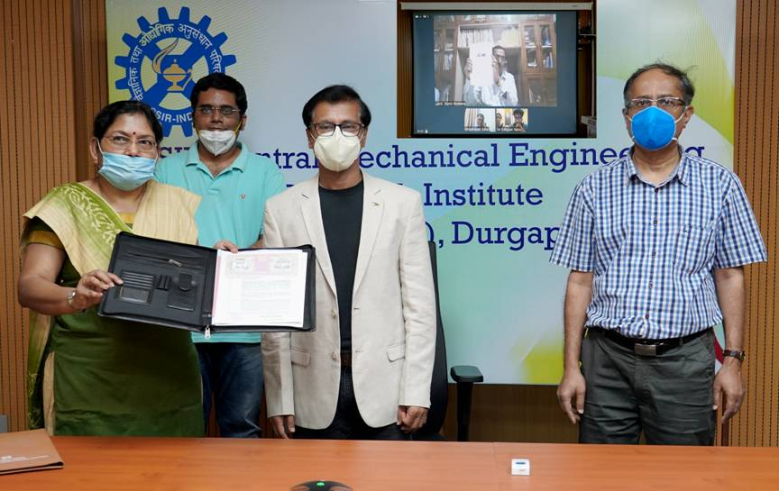

It may be noted that CSIR- CMERI has developed technology for Integrated Municipal Solid Waste Disposal System in modular form depending on the requirement of the end user. The different modules of technology transfer consists of separation of solid component from liquid waste utilizing screw based press, regenerative hot air drying system from hot flue gas of pyrolysis plant, briquetting machine, composting of separated solid. CSIR-CMERI has transferred five modules of technology to Sai Enviro Engineers Pvt Ltd. for utilization of solid component of liquid waste from sewage treatment plant/effluent treatment plant.

The official of Sai Enviro called that CSIR-CMERI developed Waste Management technology shall not only help in achieving decentralized decimation of solid wastes, but shall also help in creating value-added end-products from abundantly available redundant stuffs such as dry leaves, dry grass etc. He added that, “The MSW Processing Facility by CSIR-CMERI is developed for disposal of solid waste in a scientific way following the Solid Waste Management Rules (SWM) 2016 prescribed by Union Ministry of Environment, Forests and Climate Change (MoEF&CC), Govt. of India and we are proposing to introduce it in our projects at Vijayawada (Andhra Pradesh), Paradip & Trivandrum (Kerala).” He also added that the technology would be instrumental in breaking the chain of COVID.
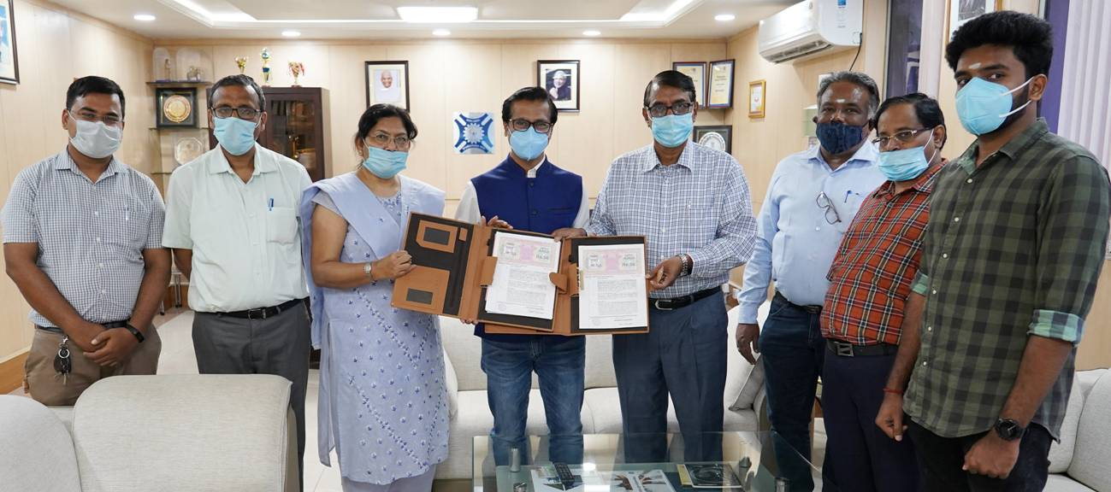

The Oxygen Enrichment Unit developed by the Institute is a device, which concentrates the Oxygen from the air around us by selectively removing nitrogen to supply an oxygen-enriched air. The concentrated oxygen is delivered to the patient with breathing-related problems through oxygen mask or nasal cannula to improve oxygenation in the blood. The device may be used in Homes or Hospital type facilities for patients with chronic obstructive pulmonary diseases (COPD), chronic hypoxemia and pulmonary edema. It may be used as an adjunct treatment for severe sleep apnea (in conjunction with a continuous positive airway pressure unit). During the Transfer of Technology, the representative of Zen Medical Technologies Pvt. Ltd. hailed the efforts of the Institute in developing the system and stated that the technology would be useful for the households due to the rise in pollution and at the hospitals for providing the enriched oxygen for the pulmonary diseases. He stated that it would also be equally effective for high altitude terrain soldiers for their contingency purposes due to its smooth portability.

In the context of the present pandemic, the Intelligent UVC LED Sterilizer Unit brings an extra protection. This is because hand washing and use of mask may not be enough if objects of regular usage like mobile, wallet or key chains are budding with germs. Inspite of our best preventive measures, it calls for one tainted object to make entry of infection inside the house. CSIR CMERI brings an intelligent, ultra-portable, safe UVC Led based disinfection technology, designed to sterilize germs, right to your doorstep for you and your dear ones to be safe at the touch of a button, either at home or while enjoying a long ride. The design facilitates wireless and sensor based operation with added features for safety of users. While taking the technology the people from Trinity Microsystems Pvt Ltd, New Delhi appreciated the Institute for coming out with such technology and said that the deployment of this Sterilizer Unit at Schools and Industrial units would bevery vital for continuing their businesses during the resurgence of the pandemic.

Source
Press Information Bureau, 25 March, 2021

