CSIR-CMERI develops Affordable Solar Powered Battery based Sprayers to tackle Water Crisis in Agriculture
Water is a precious resource and water scarcity is looming large over the entire Nation. Agriculture, which consumes around 70% of Water, for irrigation purpose, is the most vulnerable sector of the Economy owing to this crisis. To address this issue there has been discussion on implementing solar pump in almost every farmland.

Apart from solar pumps, CSIR-CMERI isworking on methods to reduce water consumption required for irrigation. Initially, Drip irrigation was considered but later it was realised that Drip irrigation is not affordable for marginal to small farmers, who are the major stake holders in Indian Agrarian scenario. Those farmers use manual sprayers costing a few thousand rupees.

As per the available knowledge, pesticides play very big role in increasing crop productivity, but large amount of pesticide sprays is wasted due to lack of appropriate machinery, and soil, water and air become polluted. Due to such harmful effects of pesticides, there is an increasing pressure to reduce their use and make their spraying more efficient. To make efficient sprayer, there is need to understand science of surface tension, viscosity, wettability, air drag, dynamic pressure, particle size, etc. CSIR-CMERI developed two variants of battery operated spray systems one for “marginal famers” and other for “small farmers”. Back Pack Sprayer, having capacity of 5 litres, is made for “marginal farmers”, while the Compact Trolley Sprayer having capacity of 10 litres, is made for “small farmers”. These sprayers are equipped with two separate tanks, flow control and pressure regulator to handle different water requirements of the crops, target/site specific irrigation, maintaining appropriate dilution of pesticide/fungicide to control the pest (on foliage, under the leaves, at root zone etc.), creating water based micro-roughness of leaf surface, maintaining soil moisture levels in a narrow range, and weed control. The systems functions on Solar-Powered batteries, thus enabling its usage even in energy and power deprived agricultural regions of the Nation, thus reducing dependence on price volatile fossil fuels. The sprayers are simple to develop, easy to learn and implement, therefore will help to overcome water crisis faced by Indian farmers.

The flow control feature of the Sprayers helps achieve multiple levels of Water/Pesticide flow thereby enhancing the flexibility and dynamicity of the coverage area as well as the intensity of the application. The Dual-Chamber design of the Sprayers helps achieve a degree of resource versatility as it allows the system to carry two variants of liquids at any particular instant. As per experiments conducted at CSIR-CMERI, the engaged farmers have informed that it helps save 75% of Water and 25% time-consumption while using the CSIR-CMERI developed sprayers. This design element might also help reduce the time consumption for Spray based Agricultural applications, as the farmer need not empty the contents of a single vessel completely before using a different content.

Prof. (Dr.) Harish Hirani, Director, CSIR-CMERI, elaborated, “These couple of variants can bring about a revolution in the sphere of Precision Agriculture by reducing usage of Water in Agriculture. This revolutionary technology will help in creating agricultural avenues even in arid and semi-arid regions, as the Water scarcity will no longer be feared by the farming community. The CSIR-CMERI developed sprayers provide a cost-effective socio-economic solution for both marginalised and small-scale farmers. The affordable pricing profile helps to provide opportunities to cottage and micro-industries in furthering the outreach factor of the technology widely.”

CSIR-CMERI has already developed solar tree of capacity 1 Kwp, 3 kwp, 5 kwp, 6 kwp, 7.5 kwp and 11.5 kwp,(which is now the Largest Solar Tree in the world).

 | Back Pack Sprayer | Compact Trolley Sprayer
Overall Dimension | H 300mm W220mm B 120mm | H 650mm W400mm B 200mm
Weight | 16Kg | 23 kg
No of Container | 2 | 2
Each Container Capacity | 2.5Kg | 5Kg
Battery life | 4 to 5 hr | 4 to 5 hr
Nozzle spray angle | 80 degree | 80 degree
Sprayer distance | 1 to 1.5 m | 1 to 1.5 m
Max. Flow Rate | 0.7L/min | 0.7L/min
Key Features | Flow regulator, Easy Switching option for tank, Extenable hose up to 12feet, Easy Handling | Flow regulator, Easy Switching option for tank, Extenable hose up to 12feet, Easy Handling

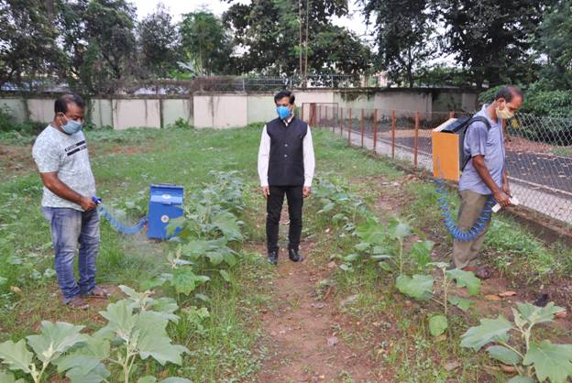

Source
Press Information Bureau, 4 September, 2020

