Uttarakhand State Level Consultation Meet on STIP 2020 harps on promoting indigenous & traditional technologies
Chief Minister of Uttarakhand, Shri Trivendra Singh Rawat, has stressed that the STIP 2020 should promote the indigenous and traditional technologies of every state and support them with the new age innovations, in a message for the Uttarakhand State Level Consultation Meet on the National Science, Technology and Innovation Policy-2020 (STIP 2020).

Chief Minister of Uttarakhand conveyed in a message through Prof. Narendra Singh, Science & Technology Advisor to the CM, that “Harnessing of rural technologies with innovations, ruralisation of economy, creating a rural-based economy with support of technology and innovation at local level will boost the national economy and make the country self-reliant”.

The State Level Consultation Meet On the National ‘Science, Technology and Innovation Policy-2020’ was organized by the Dev Bhoomi Vigyan Samiti Uttarakhand, State Unit of Vijnana Bharati (VIBHA) on 11th October 2020 in virtual mode as part of the elaborate consultation process for the new Science, Technology and Innovation Policy-2020 that is being formulated.

Prof. Narendra Singh also spoke about the Bagheshwari Charkha and Lohaghat Kadhai, which have become important sources of livelihood for rural people, by transforming these rural technologies with the help of innovations. He underlined the need of complementing traditional technologies and manpower with new-age innovative technology to solve the specific issues of states and creating a skilled workforce.
Dr. Akhilesh Gupta, Adviser & Head, STIP-2020, DST highlighted the important features of the policy and its decentralized, bottom-up, and inclusive design process with focus on indigenous technology, grassroot level innovations, disruptive technology like Artificial Intelligence, machine learning, Internet of Things. He stressed on taking forward the triple helix structure of government, industry, and academia for larger socio-economic welfare and emphasized the role of States in the national STI ecosystem and policy formulation.

Er. Jayant Sahasrabuddhe, National Organising Secretary, Vinjana Bharti (Vibha), appreciated the efforts of the Science, Technology, and Innovation Policy Secretariat especially Dr Akhilesh Gupta to bring together the views of all stakeholders as inputs in the policy drafting process.

Prof. Ajit K Chaturvedi, Director, IIT Roorkee, emphasized that academia and research institutions should reach beyond the recognition from peer groups and focus on seeking recognition from the market place by commercializing their technologies and innovations. He stressed on creating a culture of startups as a great platform to bring academia and industry closer.
Dr. Rajendra Dobhal DG, Uttarakhand S &T Council (UCOST), Dehradun suggested that STIP 2020 should focus on generating quality human resource in states through state S&T councils, creating inter-ministerial high power committees for encouraging academia and industry collaboration, ensuring coordination and networking among central and-state universities as well as laboratories.

The State Level Consultation Meet was attended by a large number of experts and thought leaders that include; Prof. Shyam Lal Soni , Director, NIT Sringar (Garhwal); Dr. Mahendra Kunwar , Chief Functionary, HARC, Dehradun; Prof. Roopkishore Shastri,VC, GKV, Haridwar; Dr. Dipankar Banerjee, Director, ARIES, Nainital; Prof. Devi P. Tripathi,;; Dr. Narendra S. Chaudhari, VC, UTU Dehradun; Dr. Vijay Dhasmana, VC, SRHU,; Prof Rakesh Sharma, VC, Graphic Era University, Dehradun; Shri Pankaj Gupta, President, Industries Association of UK; Dr Kalachand Sain, Director, WIHG, Dehradun; Dr RS Rawal, Director GBPIHE, Almora, and many others . The recommendations from these experts, and the discussion that emerges, will serve as inputs to the policy drafting process.

The Meet was organized under the guidance of Dr KD Purohit, President and Dr. Hemwati Nandan, Secretary Vibha Uttarakhand.

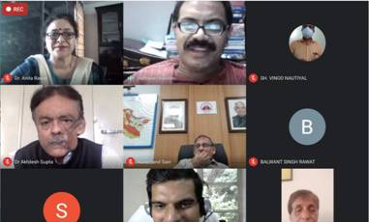
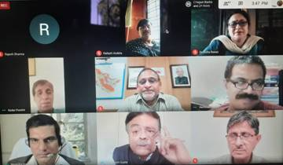

Source
Press Information Bureau, 12 October, 2020

