SCTIMST scientists develop disinfected barrier-examination booth for examining COVID-19 patients
The examination booth is closed like a telephone booth for examining the patient without direct contact with the doctor to prevent transmission of infection
Installed UV light in the booth disinfects the chamber after each patient leaves
“A thoughtfully designed protective booth with clinician inputs is a good step in preventing transmission of infection”, says Professor Ashutosh Sharma, Secretary, DST

Scientists at Sree Chitra Tirunal Institute for Medical Sciences and Technology(SCTIMST), an autonomous institute of the Department of Science and Technology (DST),Govt. of India, have designed and developed a disinfected barrier-examination booth for examining COVID-19 patients.
The innovative disinfected examination booth is closed like a telephone booth for examining the patient without direct contact with the doctor to prevent transmission of infection. It is equipped with a lamp, table fan, rack, and Ultraviolet (UV) light.
The installed UV light in the booth disinfects the chamber after each patient leaves.The UV light installed has a wavelength of 254nmwith a 15 watts rating, which effectively removes most of the viral load within 3 minutes of exposure. A pair of gloves provided in the examination booth allows the patient’s physical examination.Additionally, an entry tunnel onthe side frame is provided to pass a Stethoscope within the chamber. This feature would help the doctor to place stethoscope on the patient and listen to heart and breath sounds.
After the examination, the patient is requested to vacate the chamber, and UV light will be turned on for 3minutes. When UV exposure in the chamber is completed, the next patient is examined, and the sequence is repeated. The Examination Booth hasdimensions of 210 cm(H)X 150cm(D)X 120cm(W), which provides enough space for thepatient.
"Providing the highest standards of safety to the doctors and the front-line medical workers while interacting with the carriers of a highly contagious virus is clearly a critical priority. A thoughtfully designed protective booth with clinician inputs is a good step in that direction”, said Professor Ashutosh Sharma, Secretary, DST.
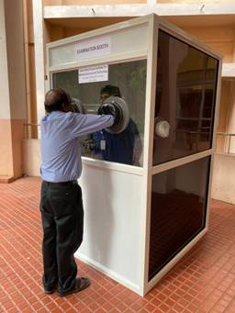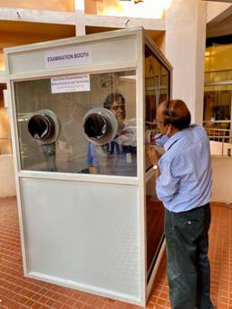

The team of innovatorsfrom SCTIMST comprises of Mr. Muraleedharan C. V,Mr. Ramesh Babu V.,Mr. D. S. Nagesh, Er. Saurabh S. Nair, Er. Arvind Kumar Prajapati, Dr. Sivakumar K. G. V., and theteam of Artificial Internal Organ (AIO)& Division Of Extra Corporeal Devices (ECD), SCTIMST.The technical know-how of the Examination Booth has already been transferred to FlyTechIndustries, Trivandrum.

(For more details please contact: Ms. Swapna Vamadevan, PRO, SCTIMST, Mob: 9656815943, Email: pro@sctimst.ac.in)

Source

Press Information Bureau, 08 April, 2020

