NIDHI-EIR Brochure featuring Entrepreneurs in Residence launched
A brochure featuring Entrepreneurs in Residence (EIR) under the National Initiative for Developing and Harnessing Innovations (NIDHI) programme was launched by DST Secretary Professor Ashutosh Sharma at the National Get-Together of NIDHI-EIR Family.

“NIDHI-EIR program is an example of innovative tweaking of the fellowship processes that make it possible to be effective,” said Professor Ashutosh Sharma, Secretary, Department of Science and Technology at the event organized by Venture Centre, the National Implementation Partner for NIDHI- Entrepreneurs-in-Residence (EIR) program of the Department of Science & Technology (DST).

“The goal of achieving Atmanirbharta starts with translation of knowledge, innovation, capacity building, workforce, Industries, and markets. It is a whole chain starting from the knowledge and goes on to markets. The NIDHI-EIR Program conceived to inspire the S&T qualified youth in India to take up entrepreneurship as a viable career and help shape India's future and the economy,” he added.

Dr. Anita Gupta, Head NSTEDB, elaborated on the success of the NIDHI-EIR program highlighting that the two editions of the EIR program has shown overwhelming impacts and has resulted in 65% conversion into startups.

She added that EIR happens to be the very starting component in the bouquet of programmes offered under NIDHI. In the years to come, it will have a much more fruitful impact. “The current COVID situation has further given us time to facilitate the kind of offering and connect needed with industry to scale up the startup ecosystem,” she pointed out.

The brochure brought out by Venture Center, details what the EIRs are working on and some highlights about them. It is also meant to be a directory of all EIRs. All contributing project execution partners are also featured in the brochure. The brochure also has a summary number of results and impact.

In Round 1 and 2 editions of the NIDHI-EIR program has coordinated with roughly 12 Project Execution Partners (incubators) that host EIR fellows. These 2 rounds of EIR calls had representation from 225 EIR fellows from 22 states of India, 68% of the fellows were below 30 years of age. A total of 146 companies have been formed with 65% conversion to startups, 711 jobs created, 65 patents, 45 trademarks, 19 copyrights created,146 initial prototypes developed. DST’s investment in Round 1 and 2 of the calls amounted to Rs 874 lakhs and follow on funding raised by EIR fellows from non-NIDHI programs is Rs 2300 lakhs.
Entrepreneurs-in-Residence (EIR) Programme under National Initiative for Developing and Harnessing innovations (NIDHI) of Department of Science and Technology supports aspiring or budding entrepreneur of considerable potential for pursuing a promising technology business idea over a period up to 18 months with a subsistence grant up to Rs 30000 per month with a maximum cap for total support of Rs 3.6 lakh to each EIR over a maximum of 18 months. The programme aims to provide guidance to these aspiring entrepreneurs from experienced, innovative and highly successful entrepreneurs on the business concept strategy and insight into specific industries or markets, inspire the best talents to be entrepreneurs, to minimise the risk involved in pursuing start-ups, and to partially set off their opportunity costs of high paying jobs. The NIDHI-EIR programme provides tremendous opportunities for innovative entrepreneurs to expand their networks and get critical feedback on their ventures in order to promote their entrepreneurial career goals and aspirations. This program is important in that it creates a pipeline of startups with a focus on young budding entrepreneurs.
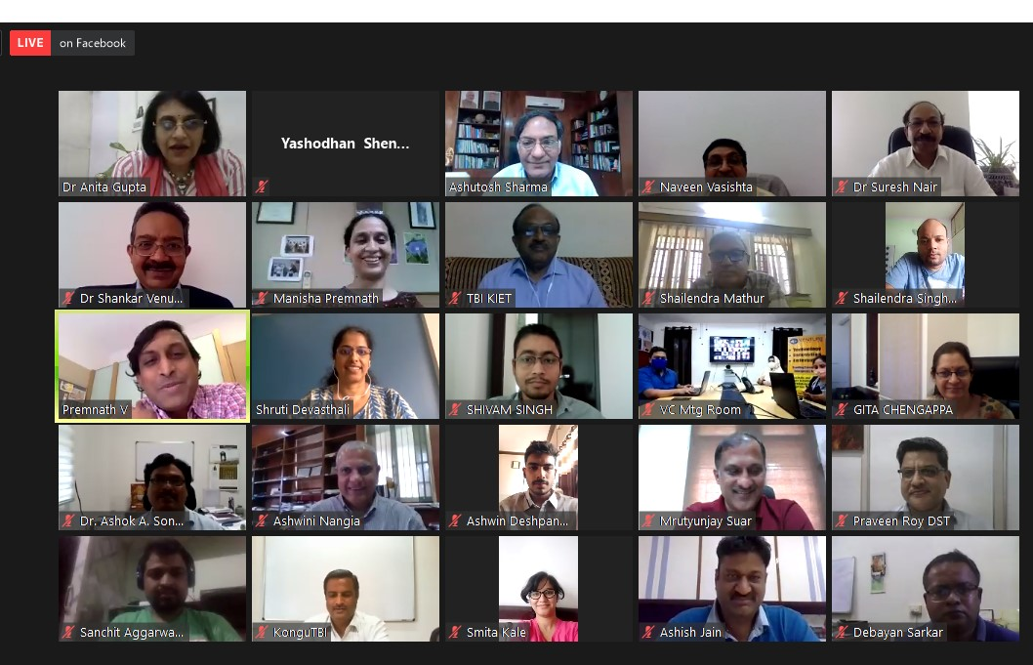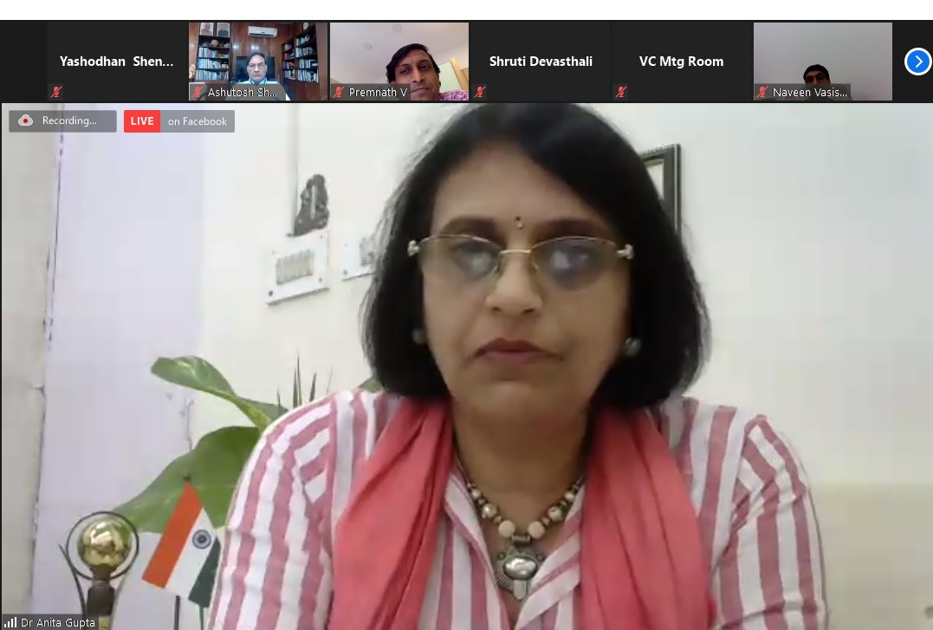

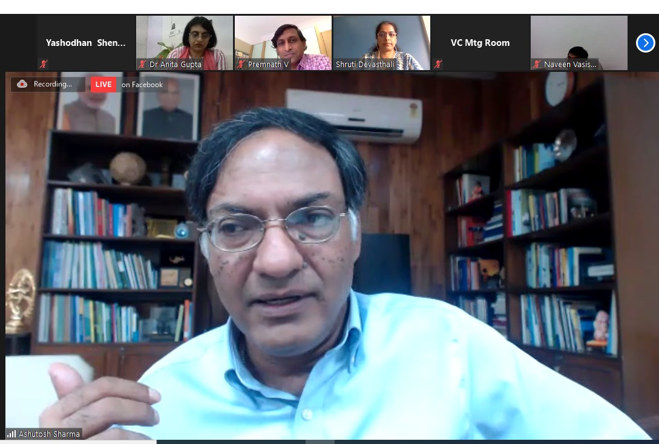
(For details please contact:
1. Program officer in Charge: Dr Naveen Vasishta, Director / Scientist F, NSTEDB, DST
Email: nvasishta@nic.in
2. National Implementation Partner of NIDHI-EIR: Venture Center, National Chemical Lab ( NCL), Pune website : www.nidhi-eir.in )

Source
Press Information Bureau, 2 September, 2020

