Geo-research scholars discuss Geo science for Society at NGRSM

Geo-research scholars came together in a webinar to discuss Geosciences for Society focusing on areas like natural resources, water management, earthquake, monsoon, climate change, natural disaster, river systems and so on at the 4th National Geo-research Scholars Meet (NGRSM) organised by the Wadia Institute of Himalayan Geology (WIHG), Dehradun an autonomous institute under the Department of Science & Technology (DST), Government of India.

Prof. Ashutosh Sharma, Secretary DST, Chief Guest and Patron of the event in his inaugural address spoke about various aspects of geo-research like mapping of springs, geosciences for civil engineers, the study of climate change with respect to crop and water, convergence of various technologies in the field, use of solar energy in agriculture and sustainable development.

The two-day webinar held last week included 20 invited talks from distinguished speakers from all around the nation.

Prof. Ashok Sahani, Chairman of Governing Body of WIHG, motivated young scholars to carry out research for the benefit of society. Dr. KalachandSain, Director WIHG, and senior scientists from the institute also gave presentations on current trends and societal relevance of geoscience research.

The NGRSM started in 2016 as a regular event of WIHG to encourage young researchers and students to improve their research interests, providing them a platform to share their research work, receive feedback from the peers and refine their ideas. The event also provides them an opportunity for interaction with the eminent geoscientists and for understanding the latest trends in Geo-science research.

This year, due to the global COVID-19 pandemic, the 4th NGRSM was organized through webinar, a first one of this kind from WIHG. A total of 657 scholars participated in this event from around 82 different universities, institutes, and other organizations of India.

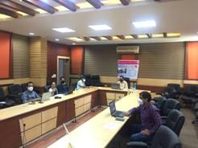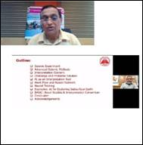

Source
Press Information Bureau, 29 June, 2020

