COVID-19 testing laboratory inaugurated in CSIR-NEIST, Jorhat

A COVID-19 testing laboratory has been established in the Jorhat campus of the North East Institute of Science and Technology (NEIST). Dr Himanta Biswa Sarma, Minister of Health and Family Welfare, Finance, Education (Higher, Secondary and Elementary), Transformation and Development, PWD, Govt. of Assam, inaugurated the laboratory. The Director of CSIR-NEIST, Dr G. Narahari Sastry, described this momentous event as an important milestone in the annals of CSIR-NEIST history.

Appreciating the fact that NEIST is the first research and development institute in Assam to open up a testing facility, Dr. Himanta Biswa Sarma congratulated the scientists and staff of the institute for making it happen.

Dr Sastry mentioned that a team of 10 scientists of the institute are actively involved in isolation of RNA from the virus besides 40 other staff members are acting as a support system. The institute’s Biotechnology Division is playing a pivotal role in carrying out RT-PCR-based COVID-19 testing. Besides, the Govt. of Assam and the district administration of Jorhat are actively cooperating and facilitating the efforts put in by the institute.

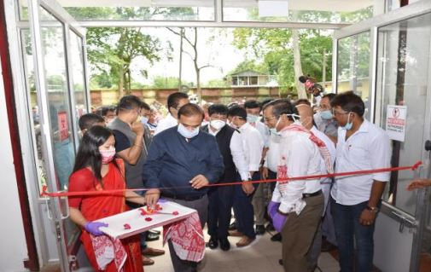
Dr Himanta Biswa Sarma inaugurating the COVID-19 testing laboratory at CSIRNEIST in the presence of director of the institute Dr G. Narahari Sastry

A microbiologist from the Department of Health and Family Welfare, Govt. of Assam has been engaged with the institute’s COVID-19 testing laboratory to certify the testing. The samples for the testing are expected to be obtained in coordination with the state government and the district administration of Jorhat. The institute has also contractually engaged a project scientist and a research scholar for the testing purpose.

Dr Sarma also took stock of the kind of scientific programs, research, technologies and products of the institute. He was quite happy to learn about the technologies that were patented and commercialized by NEIST. Some of the noteworthy achievements that have been commercially translated include the herbal anti-arthritis ointment, anti-fungal ointment, new varieties of aromatic plants.

“Establishment of the COVID-19 testing laboratory here is the demand of the hour, as it is the most effective and globally successful approach to test, trace, isolate the virus before it gets dispersed to community transmission level. Assam is at the threshold point of crossing over to stage 3 which is the community level transmission stage”, said Dr Sastry.

He further added that the only way to mitigate and contain the situation is to carry forward with extensive testing, and the ray of hope is the will of lakhs of people to fight the pandemic. At the same time, the challenge is that the capacity to do so lies in the hands of only a few people. Thus, the paramount task of the scientific community is to carry out as many tests as possible to keep a tab on the virus and to develop effective drugs and vaccines for a sure shot cure.

Source
Press Information Bureau, 02 June, 2020

