Multilateral cooperation is the key to overcoming global challenges such as COVID-19: Dr. Harsh Vardhan

Calls upon SCO young scientists to come forward and join hands for developing solutions for common societal challenges including current pandemic of Corona

“Our premier institution – the Indian Council of Medical Research (ICMR) - is involved in the trial of COVID-19 vaccines’ executions. India is also hosting clinical trials for all the major vaccine contenders. About 30 vaccines are in different stages of development in India. Two of them are in the most advanced stage of development - COVAXIN developed through ICMR-Bharat Biotech collaboration and COVISHIELD from the Serum Institute of India. The
Institute, world’s largest vaccine manufacturer, is conducting trials for the vaccine developed by Oxford University. Both are in Phase-III clinical trial stage. One of our pharma giants, Dr Reddy’s Laboratories, will distribute the Russian vaccine in India after conducting final-stage human trials and receiving regulatory approval”. Dr. Harsh Vardhan, Minister for Health and Family Welfare, Science & Technology and Earth Sciences said this in his inaugural Speech at the First Virtual SCO Young Scientist Conclave, held virtually here today. He said, “The broad aim of this conclave is to bring brightest young mindsfrom SCO (Shanghai Cooperation Organization) on a common platformto harness their knowledge for addressing common societal challenges through research and innovation”.
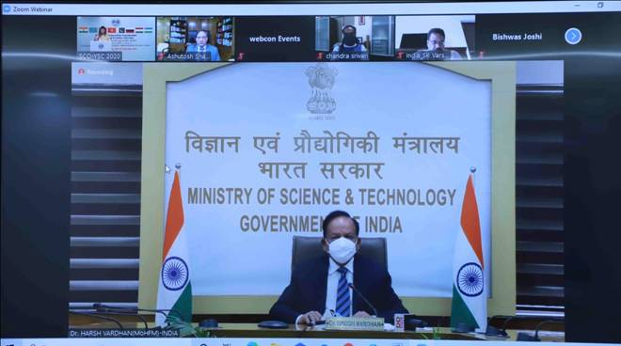
Dr. Harsh Vardhan said, “In response to COVID-19, India has put to use its significant scientific calibre. From the development of indigenous vaccines, novel point-of-care diagnostics and therapeutic formulations based on traditional knowledge, to establishing research resources, Indian R&D entities both public and private, have been working relentlessly to develop effective interventions for combating the pandemic”. “With the help of Government support, More than 100startups have provided innovative products & solutions to tackle COVID-19”, he pointed out.
The Minister extended“a special request to the young scientists of SCO” that for the welfare of the world, for human welfare, “they should come forward and join hands for developing solutions for our common societal challenges including current pandemic of Corona”. Saying that “The COVID-19 pandemic is a test”, he emphasised, “It demonstrated that multilateral cooperation is the key to overcoming such globalchallenges”.
Dr. Harsh Vardhan informed that Indian Government had announced a US Dollars 12Croregrant for COVID-19 vaccine research. “This is being provided for COVIDSuraksha Mission (mission for protection from COVID) and is to be used purely for research and development in this field”, he said. Stating that “Innovation is the key driver for enhancing productivity and prosperity”, he told the audience,"India has emerged a hub for start-ups and innovation. Indian youngsters have distinguished themselves due to their futuristic and out-of-the-box thinking”.
He also pointed out, “To give young talent opportunities and leadership in challenging areas of science, India has established five specialised research laboratories. Each laboratory deals with a focussed area of science - artificial intelligence, quantum technologies, cognitive technologies, asymmetric technologies and smart materials”. “As per the norms laid out, everyone, including Director at these laboratories is under 35 years of age”, he said.
Dr. Harsh Vardhan recalled that at the recently held SCO heads of States Summit Meeting on 10th November,2020, India had proposed creating a Special Working Group on Innovation and Startups to share our rich experience in the startup ecosystem. “We have also proposed a Working Group on Traditional Medicine, so that the knowledge of traditional and ancient medicine is spread across SCO countries and the headway in contemporary medicine can complement each other”, the Minister added. “The growth of SCO depends on its success in science, technology and innovation sector. There is a need to transform this landscape”, emphasised Dr. Harsh Vardhan.
The Science & Technology Minister congratulated all the young scientists who have been nominated for this first ever SCO Young Scientists Conclave, hosted by India, and expressed his thanksto “My own organizations Department of Science and Technology and Indian Institute of Chemical Technology and Ministry of External Affairs for hosting this Conclave despite the challenges and obstacles posed by the COVID-19 pandemic”. He underlined, “The motto for the young scientists should be -to Innovate, Patent, Produce and Prosper. These four steps will lead our countries towards faster development”.
Mr. Vladimir Norov, Secretary General,Shanghai Cooperation Organization; Dr. S. Chandrasekhar, Director, CSIR-Indian Institute of Chemical Technology, Hyderabad, India;Mr.VikasSwarup, Secretary (WEST), Ministry of External Affairs,Government of India; Prof. Ashutosh Sharma, Secretary, Dept. of Science and Technology,Government of India; Mr.Sanjeev Kumar Varshney; Head, International Cooperation Division, DST; nominated young scientist from SCO Member states; Senior experts/mentors from SCO Member states; Representatives from SCO member states scientific ministries; India’s Heads of Missions/Ambassadors, Science Counsellor in SCO Countries,were among the dignitaries who joined the event virtually.
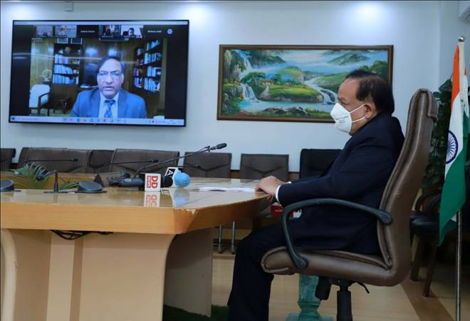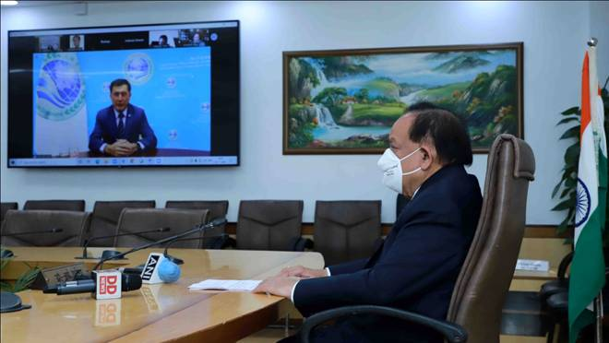
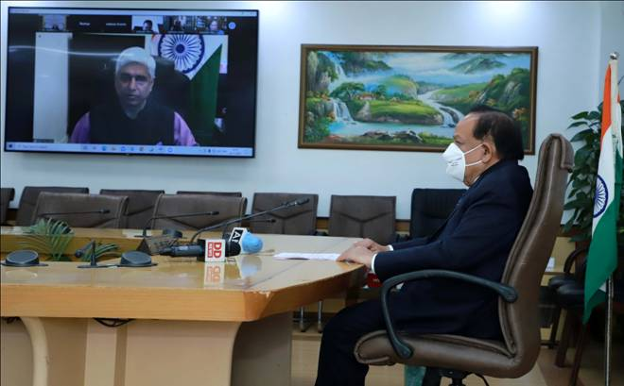
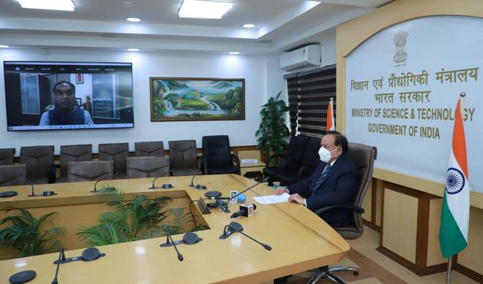
"Click here for SCO backgrounder".
Source
Press Information Bureau, 24 November, 2020

