CSIR observes World TB Day=-- Holds a panel discussion on “Lessons from Covid-19 Pandemic for TB”

On the occasion of World TB Day on 24th March 2021, the Minister of S&T, ES and MoHFW, Dr Harsh Vardhan delivered a key note lecture at the World TB Day Event organized by MoHFW and at the panel discussion on “Lessons from Covid-19 Pandemic for TB”. Every year world TB day is observed to commemorate the day in 1882 when Dr Robert Koch discovered the bacterium that causes TB.

Dr Harsh Vardhan in his address highlighted that the government has set an ambitious target of ending TB by 2025, five years ahead of the global ‘End TB’target. He highlighted that the rapid strides made by the country while addressing the current Covid19 pandemic is exemplary with vaccines being administered in about a year’s time and also being shared with other countries. Dr Harsh Vardhan observed that India has capacity and capability to achieve the TB target as demonstrated during the Covid-19 pandemic and in the case of polio eradication. He further noted that the scourge of Tuberculosis could be eliminated with strong resolve, cooperation, enthusiasm and extraordinary commitment and contribution from each and every stakeholder.

Speaking at the panel discussion on “Lessons from Covid-19 Pandemic for TB” DG-CSIR, Dr Shekhar C Mande, who is an expert in infectious diseases observed that while TB caused by Mycobacterium tuberculosis is a rather complex disease, lessons learnt from Covid19 in cooperation and collaboration can help us guide the strategy for ending TB.

Dr T. Balganesh a leading TB expert and President Gangagen Biotechnologies, in his remarks emphasized on the need for non-invasive diagnostics for TB as a game changer in surveillance and rapid control of infection. Other TB experts from the country who participated in the panel discussion included Dr Anurag Agrawal, Director, CSIR-IGIB, Dr Rajesh Gokhale, Staff Scientist VII, NII, Prof Jaya Tyagi, Dept. of Biotechnology, AIIMS, New Delhi, Dr Chandra Shekhar S, Director, CSIR-IICT, Dr Anil Koul: Vice President, Research, J&J. Dr Geetha Vani Rayasam, Sr. Pr. Scientist and Head-SCDD at CSIR and Dr Anshu Bhardwaj, Senior Scientist at CSIR-IMTECH moderated the discussion towards identification of disruptive ideas as well as identification of critical gaps in our current strategies and how they can be addressed from the recent experience with Covid-19.

The entire panel of experts highlighted that despite the complexity of infection in case of Tuberculosis, where the Mycobacterium has co evolved with humans for thousands of years, it can be addressed the way collective wisdom and efforts of the scientific and healthcare community is addressing COVID-19. They all recommended that an open mindset is imperative to challenge our existing approaches to address TB as the existing scenarios can offer only incremental success and strategies need to be evolved for short duration therapy, effective vaccines and rapid point of care diagnostics. The experts also recommended that new technologies, disruptive ideas and data driven holistic approaches must be attempted boldly for TB as seen during Covid-19 pandemic. Engagement and coordination of all stake holders, including public, is vital to generate a critical mass to address Tuberculosis and other infections which are leading to ever increasing rate of antimicrobial resistance throughout the world.

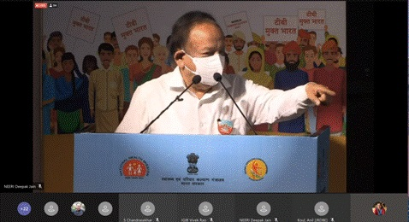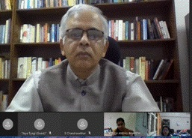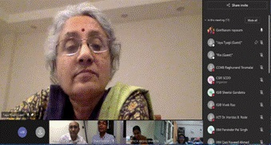

Source
Press Information Bureau, 25 March, 2021

