CSIR-CMERI, Durgapur along with MSME-DI, Ahmedabad organises Webinar on Water Purification Technologies for MSMEs

CSIR-CMERI Focuses upon Development of Green Water Purification Innovations, Decentralised in Nature and is Effective in Outcome: Prof. (Dr.) Harish Hirani
Director, MSME-DI, Ahmedabad Assures to Provide all Assistance for MSMEs

“CSIR-CMERI has made a substantial societal impact with its Water Purification Technologies, amongst other things. The organisation in the recent years has been steadily developing Technologies for affordable and effective Purification of Water and has created a substantial interest among the MSME community”, said Sjri K H Shah, Director, MSME-DI, Ahmedabad today, while inaugurating a webinar on ‘Water Purification Technologies for MSMEs’, jointly organised by CSIR-CMERI, Durgapur and MSME-DI, Ahmedabad. He assured the business community to provide all coordination and assistance required by the MSMEs of the region for getting access to the Technology Advancements of Institutions of Excellence such as CSIR-CMERI.

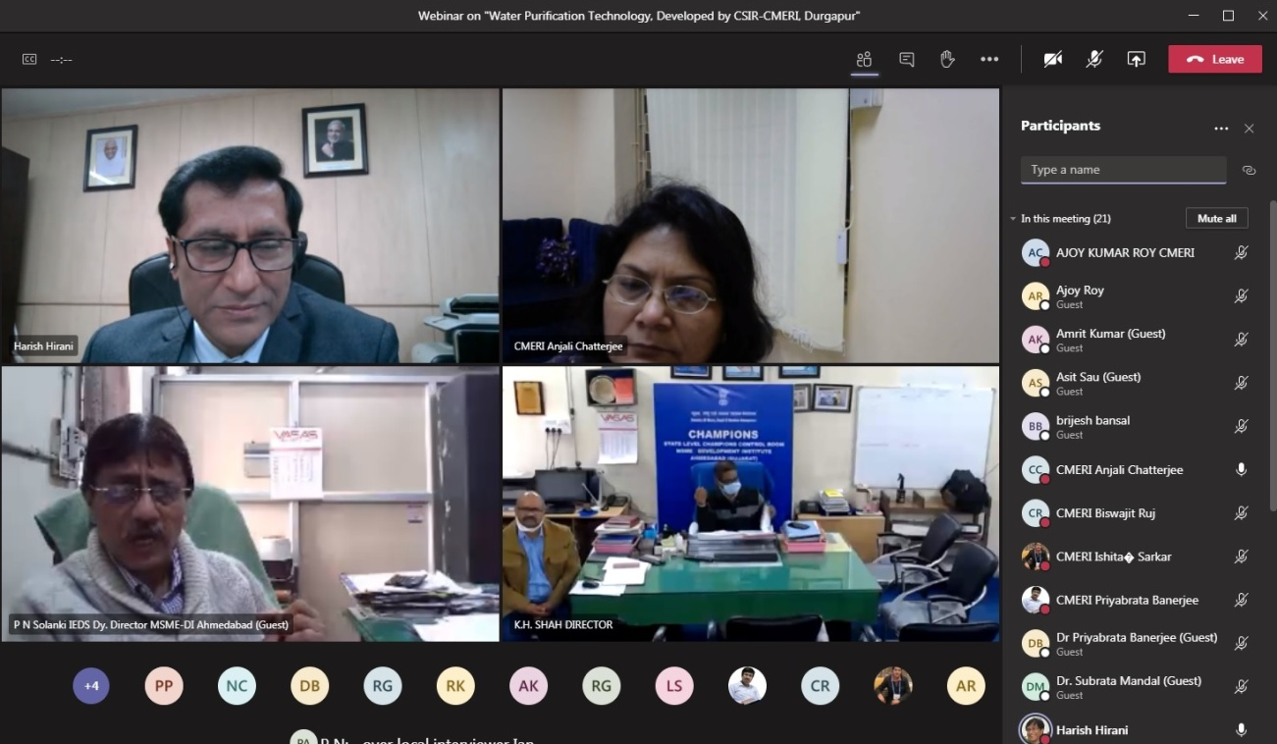

Prof. (Dr.) Harish Hirani, Director, CSIR-CMERI, Durgapur, as the Chief Speaker stated, “Sixty per cent of India’s Population is dependent upon Agriculture as its primary occupation. Thus, Water has tremendous Impact Factor as an Agricultural Resource. CSIR-CMERI completely focuses upon development of Green Water Purification/Treatment Innovations which is decentralised in Nature and is Effective in Outcome. The Water Purification Technologies have been incrementally developed steadily widening its Purification Profile as well boosting its Energy Sufficiency character. The innovative Biological-Chemical-Physical Filtration Media is also easily and locally source able. The technologies are modular in character and have steadily incorporated Multi-Stage Filtration Characteristics. Since 54% of India faces Extremely High Water Stress and over a 100 million lives are affected by Water Scarcity. The cost of Water Purification through the CMERI technologies ranges from 1paise/litre to 10 paise per litre and has tremendous scaling up potential. The Purification Costs are almost 1/10th compared to its predecessors. The CSIR-CMERI developed Water Purification technologies have already been transferred to 56 business entities. These technologies have received overwhelming feedback from the MSME partners and as per this feedback they have already influenced the lives of over a million Indians and are an effective and economic Water Purification option. There are substantial Financial Resources available for Water Purification/Treatment and Flood Management in the form of assistance from World Bank, New Development Bank, Asian Development Bank etc. and it needs to be effectively banked upon by the MSMEs.”
It is to be noted that the CSIR-CMERI developed Mechanized Drain Cleaning System is utilising Self-Propelling Nozzle and Robots and a Mobile Filtration Unit for Effective and Immediate Cleaning of Drainage Chokages. The Effluent Treatment Plant developed recently has an Innovative multi-layer Filtration System which Recycles Waste Water generated from the CMERI Residential Colony for Agricultural Purposes. CSIR-CMERI has also developed a Solar Powered High Flow-Rate Arsenic Removal Filter for easy deployment in far-flung areas.
Among the other speakers were Shri P.N. Solanki, Dy. Director, IEDS, MSME-DI, Ahmedabad. He urged all the MSMEs to actively participate in promoting and working with CSIR-CMERI for solving the Water Woes of the nation. Shri Solanki also shared that owing to the existence of Industrial Water Pollution in Gujarat, the CSIR-CMERI Water Technologies can be harnessed by the MSMEs for partnering in creating a healthy regional ecology.

Source
Press Information Bureau, 05 January, 2021

