Kisan Sabha App to Connect Farmers to Supply Chain and Freight Transportation Management System Launched by CSIR

Kisan Sabha has 6 major modules taking care of Farmers, Mandi Dealers, Transporters, Mandi Board Members, Service Providers and Consumers
In present situation of COVID 19, farmers are looking for help in their harvest reaching the market, seed/ fertilizer procurement, etc. A robust supply chain management is urgently required to facilitate the timely delivery of the produce at the best possible prices.
Kisan Sabha App developed by CSIR-Central Road Research Institute (CSIR-CRRI), New Delhi to connect farmers to supply chain and freight transportation management system was remotely launched today, by DG, ICAR and Secretary DARE, Dr. TrilochanMohapatra. Dr Mohapatra complimented CSIR on developing this portal as a one stop solution for farmers, transporters and other entities engaged in the agriculture Industry and offered that ICAR can work together with CSIR and use the Krishi Vigyan Kendra’s (KVK) networks for implementation.
DG CSIR and Secretary DSIR, Dr Shekar C Mande, present on the occasion, noted that “The development and launch of the App reiterates the commitment of CSIR in supporting the farmers in these critical times in the country. We look forward to partnering with ICAR, Industry, MSMEs, the trucker and farming community and all stakeholders to take this initiative forward”, he said.
The launch of the app was witnessed remotely by representatives of industry, farmers, team of CSIR-CRRI and other senior scientists of CSIR. Dr Satish Chandra, Director of CSIR-CRRI highlighted that as the overall agriculture market is not well organized and lot of produce gets wasted or is being sold at a very low rates, a detailed primary study was undertaken wherein 500+ farmers, were interviewed and 6-day long survey with dealers, transporters and farmers was conducted in Asia’s biggest AzadpurMandi to understand the various issues and gaps in the current environment. Based on this study and the current prevailing situation, the Kisan Sabha App was developed.
Ø The portal connects the farmers, transporters, Service providers (like pesticides/ fertilizer/ dealers, cold store and warehouse owner), mandi dealers, customers (like big retail outlets, online stores, institutional buyers) and other related entities for timely and effective solution.
Ø The portal acts as a single stop for every entity related to agriculture, be they a farmer who needs better price for the crops or mandi dealer who wants to connect to more farmers or truckers who invariably go empty from the mandis.
Ø KisanSabha also works for people in agriculture services sector such as dealers of fertilizers/ pesticides,who can reach out to more farmers for their services.
Ø It would also prove to be useful for those associated with cold store(s) or godown(s). KisanSabha also provides a platform for people who want to buy directly from the farmers.
Ø Kisan Sabha has 6 major modules taking care of Farmers/Mandi Dealers/Transporters/Mandi Board Members/ Service Providers/Consumers.
Kisan Sabha aims to provide the most economical and timely logistics support to the farmers and increase their profit margins by minimizing interference of middlemen and directly connecting with the institutional buyers. It will also help in providing best market rates of crops by comparing nearest mandis, booking of freight vehicle at cheapest cost thereby giving maximum benefit to the farmers.
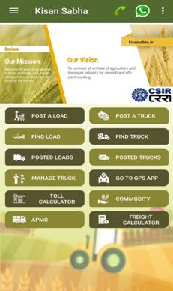

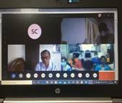

[Contact for further information:
Director,CSIR- CENTRAL ROAD RESEARCH INSTITUTE, Delhi - Mathura Road,New Delhi 110025
Telephone:+91-11-26848917 (Director)
director.crri@nic.in]

Source
Press Information Bureau, 1 May, 2020

