Global Indian Scientists & Technocrats (GIST) meet begins at IISF2020

No country can achieve global solutions in isolation; Such challenges can be addressed through cooperation, particularly seamless scientific and technological cooperation: Dr. Harsh Vardhan
“There is enormous untapped potential in connecting and engaging with the Indian scientific diaspora - not only for the benefit of our national development but also for the global good”: Dr. Harsh Vardhan
IISF-2020
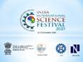

Union Minister for S&T, ES and MoHFW, Dr Harsh Vardhan inaugurated the Global Indian Scientists & Technocrats (GIST) meet which is being organized as a part of the Indian International Science Festival (IISF) 2020. Speaking on the occasion, Dr Harsh Vardhan observed, “India is blessed with a large S&T Diaspora spread across the globe who are not only contributing to the progress of the countries they reside in, but are eager to share their knowledge and experiences for accelerating the pace of development of India using appropriate engagement opportunities”. “There is enormous untapped potential in connecting and engaging with the Indian scientific diaspora - not only for the benefit of our national development but also for the global good”, he added.

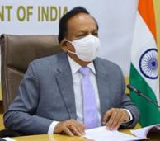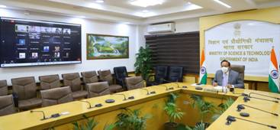
Dr Harsh Vardhan expressed satisfaction that the GIST Meet would enable developing long term linkages for creating and effectively applying S&T tools for sustainable development particularly in the rural sector. “We all are aware that science and technology are a propellant for building a thriving country and are the key drivers for empowering nations and the mankind at large”, he noted and stressed that “Scientific inventions ensuring technologies that enable development in all its dimensions and enhance human capabilities are of particular importance”.
The Minister pointed out that many of the challenges that the world is facing today - from climate change, food security, energy to poverty reduction have scientific dimensions that can be only effectively addressed through S&T. He emphasized, “No country can achieve these in isolation; Such challenges can be addressed through cooperation, particularly seamless scientific and technological cooperation”.
Dr Harsh Vardhan highlighted the various initiatives by Government to strengthen the connect with the Indian S&T diaspora such as the Vaishvik Bhartiya Vaigyanik (VAIBHAV) Summit, which was collectively organized by several scientific departments/ministries/councils wherein many of the Diaspora experts enthusiastically deliberated on several topics and priority areas. In another initiative from CSIR to engage with diaspora more extensively and in a structured fashion, an interactive National Digital Platform named “Pravasi Bharatiya Academic and Scientific Sampark (PRABHASS)” has been developed.
Dr Harsh Vardhan pointed out the exceptional role played by scientific community in addressing the problems and developing solutions during Covid-19 pandemic. He emphasized that the spirit of collaboration should continue even in post Covid world and the Indian scientific community in partnership with diaspora can play a vital role in addressing the global challenges such as climate change and help achieve sustainable development in India and the world. “A key step would be partnering with research and academic institutions to address specific societal challenges particularly for the benefit of rural India”, he pointed out.
DR. Harsh Vardhan expressed his satisfaction that application of advanced technologies for imparting education and skilling for better employability is another area being discussed at this meet. “This is absolutely an important aspect and an area where the diaspora can make immense contribution”, he said.
Dr Vijay Bhatkar, President, Vijnana Bharati, speaking on the occasion complimented the organizers and highlighted that the virtual platform has made global collaborations easier and faster and India must capitalize this opportunity to engage with diaspora and utilize their expertise in developing innovative solutions for various challenges.
GIST Meet has participants from several countries including USA, UK, Qatar, Angola, Anguilla, Australia, Switzerland and ofcourse India. The meeting involves Students, Teachers, Professors, Engineers, Physicians, Researchers, Scientists, Doctors and many others. Deliberations and presentations in the area of Agriculture, Water, AI applications, Healthcare, Education and Skilling for better employability are some of the key topics that would be deliberated upon. There are open interactive sessions, where diaspora and their Indian counterparts would share their collaboration experiences and recommendations for implementation.

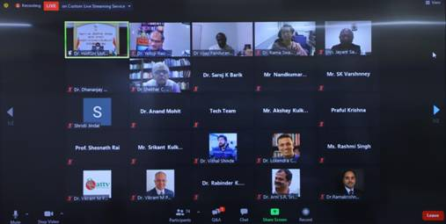

Source
Press Information Bureau, 23 December, 2020

