First-ever Farmer’s Meet of CSIR-CMERI
CSIR-CMERI organized its first-ever Farmer’s Meet on 25th February, 2021. The event was graced by the Chief Guest, Dr.Shekhar C Mande, Hon’ble Director-General, CSIR and Secretary, DSIR, Government of India, Prof. Harish Hirani, Director, CSIR-CMERI& Special Guests Dr. Sanjay Kumar, Director, CSIR-IHBT, Palampur, Dr.Vibha Malhotra Sawhney, Head, TMD, Socio-Economic Industry Interface, CSIR, Shri Sagar Bandopadhyay, Dy. Director, Agriculture Department, Govt. of West Bengal, Shri Partha Mandal, DGM, NABARD, Burdwan, Dr.Azizur Rahaman, Head, KVK, Burdwan and Prof. Subrata Karmakar, Bidhan Chandra Krishi Vishwavidyalaya, Mohanpur, among others.

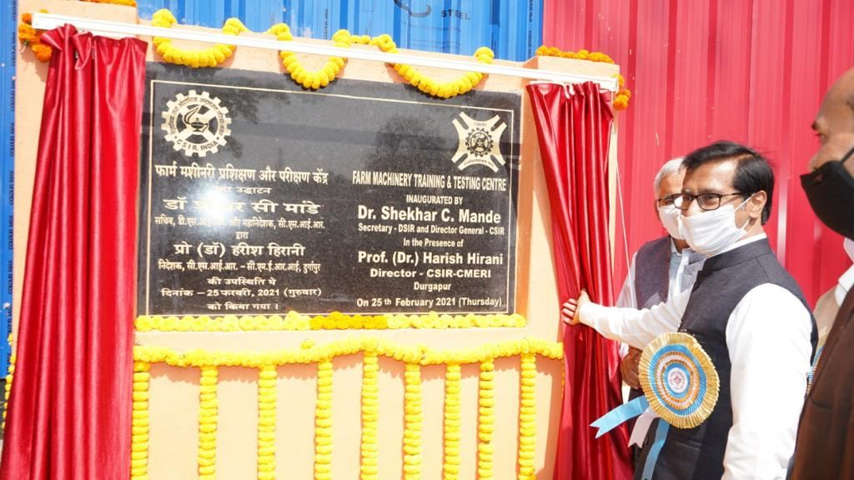

The first-ever CSIR-CMERI Farmer’s Meet witnessed the inauguration of the Farm Machinery Training & Testing Centre, Compact Tractor and the CSIR-CMERI Football Complex by Dr.Shekhar C Mande in the presence of Prof. Harish Hirani. Demonstration of e-Tractor, Farm Power & Farm Machineries, Waste Water treatment for Agricultural Usage, Smart Lighting and Smart Parking, World’s Largest Solar Tree and Bio-Char production from waste Bio-Mass were also done to the participating Farmers.

Dr.Mande, while delivering his Chief Guest address and responding to the Press shared, that all the efforts of CSIR Laboratories are intended for the society. The CSIR-CMERI technologies can expedite the pace of Farm Mechanization in multiple ways to help create an India for AtmaNirbharKrishi and realize the dream of our Hon’ble Prime Minister to double the income of the Farmers. The CSIR-CMERI developed Solar Powered Electric Tractor is a complete Technology Ecosystem which can provide renewable energy solutions in the domain Agro-Mechanisation. He urged all the 23 Krishi Vigyan Kendras in West Bengal to partner CSIR-CMERI in promoting its Farm Mechanisation Technologies for ensuring its outreach to the targeted farming groups.

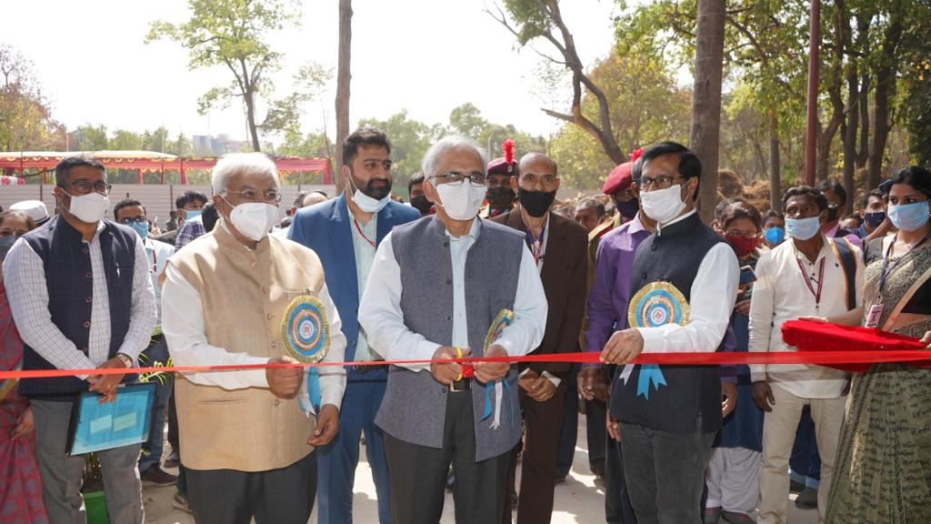

Prof. Harish Hirani, Director, CSIR-CMERI, while addressing the Farmers and the Press expressed his gratitude to the Farmers for attending the first-ever Farmer’s Meet. CSIR-CMERI through its technology innovations has helped convert arid and barren tracts of lands fit for Agriculture. The same is also being promoted in an Organic manner. The weeds that grow along in the farms are also being innovatively converted into Carbon for fertilising the soil. CSIR-CMERI has given Swaraj, Sonalika, Krishi-Shakti and now it is slowly transitioning towards a new domain in the form of e-Tractors, Compact Tractors and e-Power Tillers. CSIR-CMERI envisions a Diesel Free India through Electric Farm Mechanisation using Renewable Sources of Energy.
Dr. Sanjay Kumar, Director, CSIR-IHBT, Palampur, on the occasion shared Farmer’s Conclave such as this provides a chance for the Scientists to comprehend the challenges of the Farmers,and thereafter deliver Sustainable and Effective Technology Solutions for mitigating these challenges.

Shri Sagar Bandopadhyay, Dy. Director, Agriculture Department, Govt. of West Bengal, said that Farmers are the best Scientists of the Society as through their efforts they continuously improvise their practice.

Dr.Vibha Malhotra Sawhney, Head, TMD, Socio-Economic Industry Interface, CSIR, stated that CSIR-CMERI has made tremendous contributions to the society in the form of various Tractor variants with manifold utility.
Dr.Azizur Rahaman, Head, KVK, Burdwan, stated that West Bengal is one of the most income deprived Agro-Economies in the Nation. There would be no agricultural progress possible without Farm Mechanization to the maximum extent, as sought by CSIR-CMERI.
Shri Partha Mandal, DGM, NABARD, Burdwan, shared that since 96% of the farmers of West Bengal are Small or Marginal Farmers. The Decentralised and Renewable Energy based Farm Mechanisation initiatives of CSIR-CMERI are the perfect solutions for these Small and Marginal Farmers, as they are comparatively Affordable.

Source
Press Information Bureau, 25 February, 2021

