CSIR-CMERI Demonstrates three Variants of advanced indigenous design and featured Mob Control Vehicle prototypes

Operational units are height adjustable front shovel, retractable protective front shield, all round irritant spray system, foam spray system and tear smoke munitions system
Other capabilities are cabin pressurization system, retractable multi barrel tear gas launcher with appropriate electronic vision systems, wide angle surveillance, multi-channel video transmission system, GPS tracker and GPS navigator
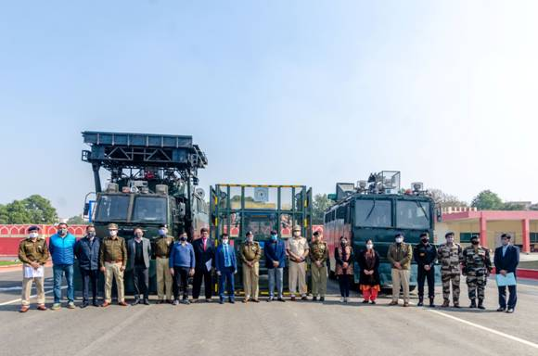
Team MCV during Demonstration

In a view to elevate modern technical support to paramilitary forces engaged in maintaining law and order situation; train and equip them with advanced options, CSIR has demonstrated its three innovative variants ‘Compact, Medium, Heavy’ category of Mob Control Vehicles (MCVs) to a team of MHA recommended members under leadership of IG (RAF), CRPF. The demonstration was successfully carried out at Parade Ground, CRPF Group Centre, Gurugram recently. This is a first of its kind advanced indigenous design and featured development in the country.
The MCVs have been designed, developed and demonstrated by one of the CSIR’s constituent laboratory ‘Central Mechanical Engineering Research Institute’ (CMERI) based in Durgapur, which had brought indigenous tractor revolution in India. The Heavy category of these MCV prototypes has a 7.5-ton payload capacity. While, the Medium category is of 2.5-ton payload capacity, the compact one is a tractor-based vehicle for easy maneuvering. The key requirement and followed specifications have been evolved, formulated with involvement of various designated stakeholders.
The prototypes consist of several independent operational units unified as per vehicle category and operational requirement during mob control. Few example, the operational units are height adjustable front shovel, retractable protective front shield, all round irritant spray system, foam spray system and tear smoke munitions system. The other capabilities are cabin pressurization system, retractable multi barrel tear gas launcher with appropriate electronic vision systems, wide angle surveillance, multi-channel video transmission system, GPS tracker and GPS navigator. The design architecture allows easy and fast customization in downstream products. The production versions of the MCVs can be tailor-made as per the actual requirements and functional priorities of the users so that their effectiveness in mob/riot control scenario can be augmented.Other than IG (RAF) CRPF, DIG RAF, Comdtt RAF, DIG BSF, Director ODC VHF, 2-I/C Assam Riffles, DC CISF, DC ITBP, DC SSB, T Cmdr NSG, SSP JKPS, DCPs from Haryana Police, DIG, Comdtt and DCP from Maharashtra police, Scientists, Technical and Senior Officials from CSIR-CMERI and CSIR HQ also participated in the demonstration.
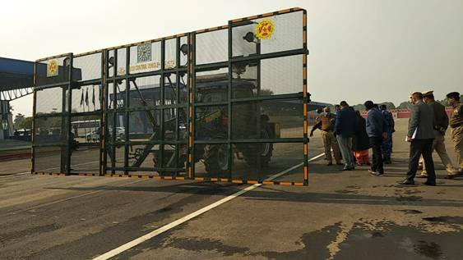
Tractor based MCV in Operation
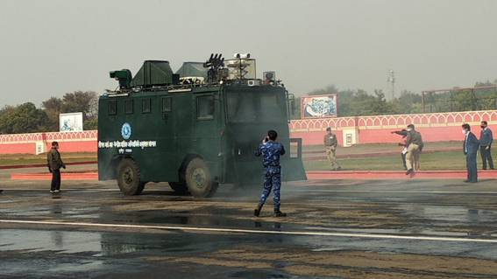
Compact Medium Category Vehicle in Operation
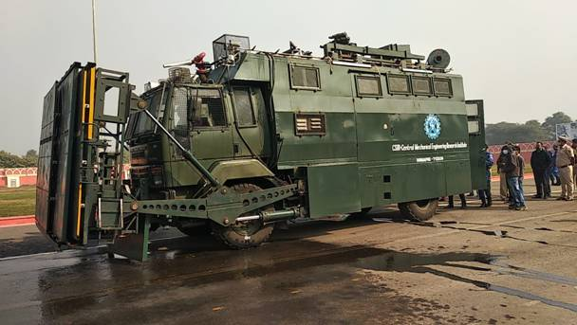
Heavy Category Vehicle in Operation

Source
Press Information Bureau, 01 February, 2021

