CSIR-NAL develop Personal Protective Coverall Suit to Combat COVID-19

CSIR constituent Lab in Bengaluru, CSIR-National Aerospace Laboratories (CSIR-NAL), along with MAF Clothing Pvt. Ltd., Bengaluru has developed and certified the overall protective coverall suit. The polyproplylene spun laminated multi-layered non-woven fabric based coverall can be used to ensure the safety of Doctors, Nurses, Paramedical staff and Health Care workers working round the clock on COVID-19 mitigation.

CSIR-NAL team lead by Dr. Harish C Barshilia, Dr. Hemant Kumar Shukla, and Mr. M J Viju of MAF have worked quickly to find the solution to the problem by identifying suitable indigenous materials and innovative manufacturing processes.

The Coveralls have gone through stringent testing at SITRA, Coimbatore and have been qualified for use. CSIR-NAL and MAF have plans to augment the production capacity to about 30,000 units per day within four weeks’ time.

Shri Jitendra J Jadhav, Director, CSIR-NAL has stated that the major advantages of these Coveralls are that they are highly competitive in price as compared to other manufacturers and the import content is negligible. He appreciated the efforts of NAL, MAF Clothing Pvt Ltd and SITRA team who have worked round the clock for this national cause by accelerating the development and certification process.

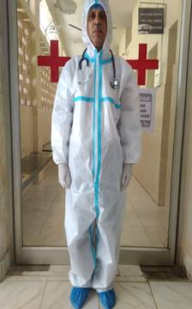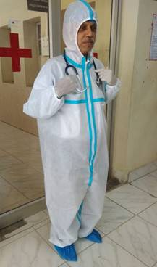

Source
Press Information Bureau, 18 April 2020

