Science & Technology Media Conclave

Responsible Science Communication Fights with Infodemic: Dr. Harsh Vardhan
Short videos are an Exciting Medium to Take Science to the Masses: CEO,
Prasar Bharati

IISF-2020
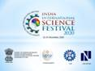

The ‘Science and Technology Media Conclave’ is a prominent event of the India International Science Festival2020. This conclave looks at the soaring emergence of digital media and its various avatars. The power of responsible science communication to cope with disasters such as pandemic was also one of the focal points of discussion at the conclave. The inaugural session of the S&T Media Conclave was attended byScience communicators, journalists, scientists and policymakers to discuss various facets of science and media engagement.
In his message to the Science and Technology Media Conclave, Dr. Harsh Vardhan, Union Minister of Science & Technology, Earth Sciences and Health &Family welfare, said that the pandemic-ridden year had been the coming-of-age year for science communication through digital means. The conclave will emphasize the power of responsible science communication and which can help to fight with ‘infodemic’arising during the pandemic, he hoped.

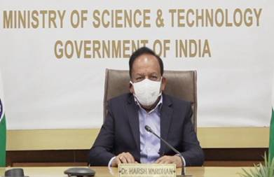

In his keynote address, Shri Shashi S.Vempati, Chief Executive Officer, PrasarBharati, said that short videos are an exciting medium to take science to the masses. Highlighting the recent Saturn-Jupiter great conjunction, Shri Vempati said that the celestial event telecast on the national television had over a million views. He said that the media focus on the celestial event triggered a mass curiosity about this specific happening and also on general aspects of astronomy.

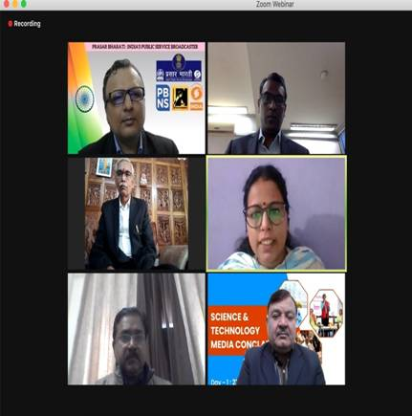

Prof. Baldeo Bhai Sharma, Vice-Chancellor, Kushabhau Thakare Patrakarita Avam Jansanchar Vishwavidyalaya and Guest of Honour said that science communicators and science journalists have the responsibility of taking science to the masses in the languages that public understands.
A Science Media Virtual Exhibition showcasing cover pages of popular science magazines and science newspapers was also inaugurated on this occasion.
Dr.Manoj Kumar Patairiya, Scientist-G &Adviser, Department of Science and Technology and the Principal Coordinator of the S&T Media Conclave, said that the media's science coverage needs to increase. He said that communication from land to lab is as important as communication from lab to land.
In a panel discussion on "Science News in the Media: Past, Present and Future", speakers highlighted that combating fake news has become a challenge, especially in the backdrop of lots of misinformation shared on social media about COVID-19.
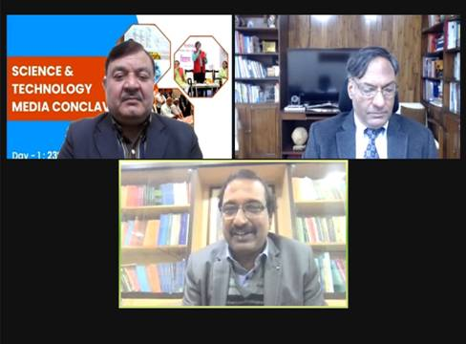

After the panel discussion, there was a freewheeling conversation between Prof. Ashutosh Sharma, Secretary, Department of Science & Technology and Prof. K.G. Suresh, Vice-Chancellor of the MakhanlalChaturvedi National University of Journalism and Communication. Discussing the topic, "Strengthening Science & Media Engagement", the eminent scientist and the noted journalist and media specialists discussed augmenting communication skills among science students.
Traditional Crafts and Artisan Meet and Expo
The Traditional Crafts and Artisan Meet and Expoprogramme aims at showcasing the Indian scientific achievements and innovations for students, young researchers and general public and to display India’s contribution in the field of S&T and to motivate young scientists to find solutions to the burning issues of our society. CSIR-AMPRI, Bhopal is the Principal Organizing Institute for the event.
Dr. Sunil Kumar, Vice Chancellor, Rajiv Gandhi Proudyogiki Vishwavidyalaya, Bhopal was the Chief Guest of the inaugural session and Dr.Sharada Srinivasan, Professor, NIAS, Bengaluru was the Guest of Honour for the event.
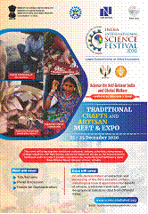

Dr. A. K. Srivastava, Director, CSIR-AMPRI welcomed the guests and provided a brief overview over the origin of IISF and also highlighted the importance of this fest.
This is a unique event of this kind. In this event, a National level virtual Meet and Expo are being organised, which emphasize the science behind the traditional Indian Arts and Crafts, their history, technological and policy interventions to improve the quality of handicrafts and the life of the artisans, future prospects, etc. The event throws light on implementation and development activities of primitive tribes of the country like Agaria, Bharia, and many more. The Expo has live streaming and demonstration for extraction and processing of the fibre, yarn and rope making, handicrafts and other products. This program brings together traditional craftsmen and artisans, researchers, scientists, entrepreneurs, cottage industries, self-help-groups, policy makers and students to discuss about the improvement in traditional crafts to make them competitive at global level and augmenting self-reliance (Atmanirbharta).

Source
Press Information Bureau, 24 December, 2020

