Dr. Harsh Vardhan: “A robust Climate Risk management framework calls for a multi- level approach across the country to determine various climate change risks likely to impact the country while also providing a broad understanding of the loss and damage likely to be caused due to these risks”

“Science and technology has a critical role to play in the climate adaptive planning to help building disaster resilience and sustainability contributing to our journey towards self-reliance”--- Dr. Harsh Vardhan
The Conference aims at all-inclusive roadmap development through discussion & dialogue on experiences and lessons, gaps, and opportunities to utilize the range of S&T disciplines and innovations, including traditional and local science and role of institutions for promoting the same.
“India not part of Climate Change problem but have to be part of solution”: Prof Ashutosh Sharma

The Minister Science and Technology, Earth Sciences and Health and Family Welfare, Dr Harsh Vardhan today said that “A robust Climate Risk management framework calls for a multi- level approach across the country (national, sub-national, regional and local) to determine the various climate change risks likely to impact the country while also providing a broad understanding of the loss and damage likely to be caused due to these risks”. He was delivering a special address as the Chief Guest at the three-day Conference on “S&T Research- Policy-Practice Interface for Climate Risk Management” jointly organized by National Institute of Disaster Management (NIDM) through video conferencing in New Delhi.

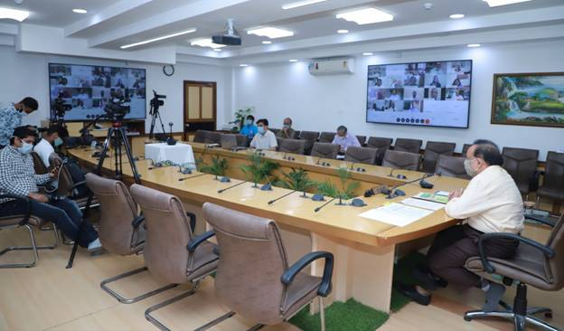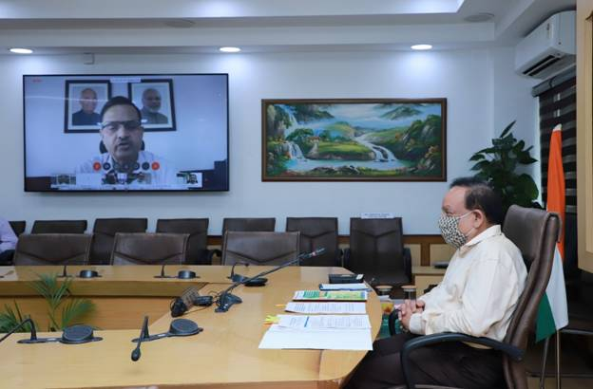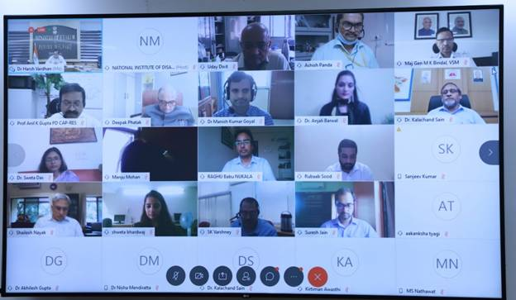
Stating that “Science and technology has a critical role to play in the climate adaptive planning to help building disaster resilience and sustainability contributing to our journey towards self-reliance as part of PM’s clarion call for an Aatmnirbhar Bharat”, the Minister said that “Department of Science and Technology (DST) has made some major achievements in the implementation of two national missions on CC as part of National Action Plan on Climate Change (NAPCC). Under the two missions, as many as 200 projects of different sizes have been supported which include 15 Centres of Excellence, 30 Major R&D programs, 14 Network programs which comprise of nearly 100 projects, 6 Task Forces; 25 State CC Centres, etc. During last 6 years, as many as 1500 research papers in high impact factor journals were published. More than 100 new techniques have been developed and nearly 50,000 people are trained as part of these missions. More than 1200 scientists and students are working in these mission projects.” He underlined that “In a changing time with onset of new technologies but also the new challenges and social-behavioural changes, a new paradigm of science policy practice is much warranted.”

Dr. Harsh Vardhan pointed out that “According to a survey made by independent agencies like Globe Scan and National Geographics for 18 countries in the world, India ranks one in terms of a parameter called Greendex which is a measure of sustainability and life style. Despite so much of contribution to sustainability and environment, India is one of the worst impacted countries in the world in terms of extreme events. India is among few countries which witnesses almost all types of disasters like earthquake, tropical cyclones, flood, tsunami, thunder storms, hail storms, lightening, heat wave, etc. Improved warning systems have greatly helped reducing loss of lives but the loss of property continues to increase as more and more infrastructure due to economic development is getting exposed to disasters.”

Dr. Harsh Vardhan said that “There has been an increasing trend in the frequency and severity of climate change inflicted extreme weather events. Growing risks are pushing vulnerable people, communities and countries to their physical and socio economic adaptation levels”, and added that “there are needs for proper strategies not only to save people from disasters but also to build resilience towards disasters, educating people about the types and nature of disaster and ways to build resilience are of great importance. This would need building capacity of the communities to face these disasters.”
In his keynote address, Prof Ashutosh Sharma, Secretary, DST, said that “Climate Change is a global problem. But per capita emissions (accumulative emissions that drive climate change) in India is less, and we are not part of the problem. However, we need to develop efficient use of technology to be part of the solution.”

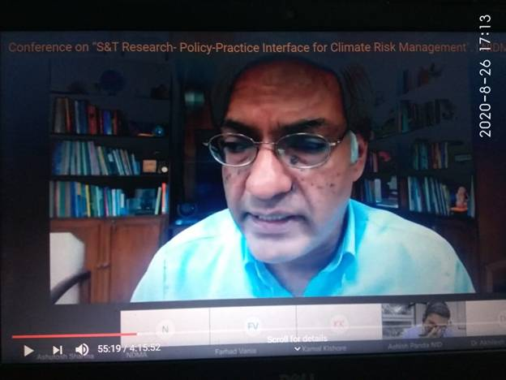

He added that it is evident that disasters are linked to climate, and we have to be atmanirbhar in dealing with disaster preparedness. Likewise, self-reliance is needed in tackling climate change, sustainable development, and anti-bacterial resistance. “For this to happen, connecting our systems and community participation are important. Knowledge creators and knowledge consumers need to work together. The role of industry and private sector and disruptive technology is significant”, he pointed out.
Dr. Akhilesh Gupta, Advisor & Head-SPLICE & Climate Change Programme, DST, GoI (Chair), highlighted how DST is supporting climate change programmes across the country. “We have difficult situations like flood, cyclone. Additionally, with the pandemic COVID-19, it is crucial at this juncture to have disaster preparedness. We should work on disaster management with Science & Technology solutions,” he stressed.
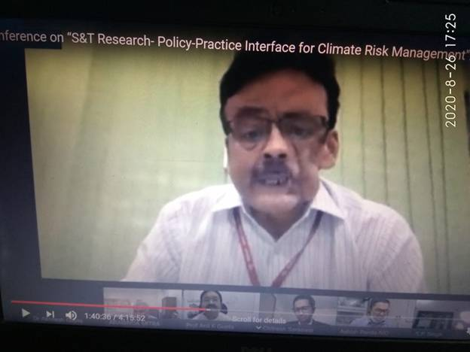

The Conference was organised by the National Institute of Disaster Management (NIDM), Ministry of Home Affairs, & Department of Science & Technology, Govt. of India, in collaboration with Deutsche Gesellschaft für Internationale Zusammenarbeit (GIZ) GmbH.

It was organized in the context that India is already prone to multiple disasters due to its wide range of environmental, geological, and developmental variations, and people’s vulnerability of disasters is aggravated with climate and associated environmental changes.

The three-day conference aims at all-inclusive roadmap development through discussion & dialogue on experiences and lessons, gaps, and opportunities to utilize the range of S&T disciplines and innovations, including traditional and local science and role of institutions for promoting the same.

Other notable speakers at the conference included Maj Gen Manoj K Bindal, Executive Director, NIDM, GVV Sarma, Member Secretary, NDMA, Farhad Vania, Senior Portfolio Manager, GIZ India, and Kamal Kishore, Member, NDMA. Prof. Anil K Gupta, Head-ECDRM NIDM & PD-CAPRES DST Project (Convener), and Mr Ashish K Panda, Faculty, NIDM were facilitators. Experts, researchers, professionals, officials, and academicians from related Government organizations/department/Ministries, institutions, NGOs, and field professionals also attended the conference.

Source
Press Information Bureau, 26 August, 2020

