CSIR- National Chemical Laboratory (NCL) Pune ties up with Bharat Electronics Ltd (BEL) for production of medical devices

Mass manufacturing ready hardware and software design will be available to manufacturers across India for free

CSIR’s constituent Lab, CSIR-NCL Pune, has been leading the way in promoting innovation and entrepreneurship through its Venture Centre for the past decade and new innovations from there are helping in fight against the Corona outbreak. Two of the recent innovations that can help in the mitigation of the Corona outbreak are featured:
1) Digital IR Thermometer: CSIR-NCL’s Venture Centre’s incubatee BMEK headed by Mr. Pratik Kulkarni has developed hand held digital IR thermometer which is an important component of measures to mitigate Coronavirus outbreak. Mobile phone or power banks can be used as a power source. The design of IR thermometers is available open source where in the complete know-how with mass manufacturing ready hardware and software design will be available to manufacturers across India for free. This is an effort to enable a large number of manufacturers to manufacture the thermometers and cater to their local demands. Now it is being scaled up in partnership with BEL (Bharat Electronics Ltd, Pune). About 100 prototype units will be made for pilot distribution and testing at TUV Rheinland India Pvt Ltd Bangalore.

2) The second innovation is the oxygen enrichment unit (OEU): One of the critical needs of COVID-19 patients is the need to meet the oxygen requirements due to their lungs being compromised. Oxygen enrichment unit (OEUs) to increase the oxygen concentration from the ambient air of 21-22% to 38-40% have been developed by CSIR-NCL and Genrich Membranes, a start-up innovation venture founded by Dr. Ulhas Kharul, Head of Polymer Science & Engineering Divsion at NCL. OEU is hollow fiber membrane bundles for separation and filtration of ambient air to produce enriched oxygen for patients in home and hospital settings. The prototype units are ready at Pune and will be sent to TUV Rheinland India Pvt Ltd Bangalore for testing/validation. About 10 OEU machines will be assembled by NCL BEL in Pune and after the trials, scale up will be done.

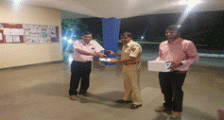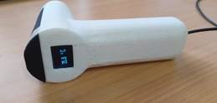
Five, infrared non-contact thermometers were handed over to Deputy Commissioner of Police, Pune.
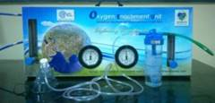
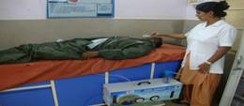
Genrich-NCL Oxygen enrichment unit machine connected to a patient’s breathing mask in medical center during prototype testing near Pune.

Source

Press Information Bureau, 09 April, 2020

