Multiple options for COVID 19 detection kits by start-ups on the cards through support of CAWACH Initiative of NSTEDB, DST
India will soon have the option of choosing from several COVID 19 rapid detection technologies that start-ups are working on currently.

A technology to conduct rapid molecular tests at small clinics, points of entry like airports, or small laboratories, a lab on palm platform for Rapid Antibody Test and a test kit with a reader enabling direct antigen testing in suspected COVID samples are some of them.

The technologies developed by some start-ups have been repurposed and extended for COVID19 with support from the Centre for Augmenting WAR with COVID-19 Health Crisis (CAWACH) an initiative by National Science & Technology Entrepreneurship Development Board (NSTEDB), Department of Science and Technology (DST), implemented by Society for Innovation and Entrepreneurship (SINE), IIT Bombay.

Among 51 companies shortlisted for developing various COVID 19 solutions, 10 have been supported for manufacturing and widescale deployment of diagnostic kits and therapy solutions. Most of the technologies are under validation from ICMR and can be made functional once the validation and approval processes are completed and are granted.

OmiX Research and Diagnostics Laboratories extended their OmiX-AMP platform making it suitable for carrying out low cost molecular COVID 19 tests rapidly with the help of a technology called Loop-mediated isothermalamplification(LAMP), with support from DST. The LAMP tests are run in a colour detection device with in-built machine learning algorithms that correctly identify samples as positives or negatives. It can be deployed in small clinics, points of entry like airports, or small laboratories.

The OmiX-AMP platform and 5 of the LAMP based, easy to use kits are currently under validation by ICMR. The LAMP technique offers a simpler and easier alternative to RT-PCR in molecular testing and allows deployment of the more accurate molecular testing widely.

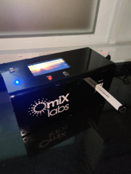
The single tube kits which come pre-loaded with all the reagents, in room temperature stable format. The device and in-built machine learning algorithm further provide a low-cost detection system (less than Rs 50,000) with automated identification of positive and negative cases.

A Lab on palm platform called ‘anuPath’ by PathShodh Healthcare, incubated in 2015, at the Society for Innovation and & Development, IISc Bangalore, has been repurposed for COVID-19 Rapid Antibody Test.

PathShodh a one of its kind unique solution, uses an electronic reader in conjunction with disposable test strips, thus eliminating human errors in interpreting results. It is a total antibody test (both IgM and IgG) unlike most of the tests which are only IgG tests. It is a quantitative test, as opposed to the qualitative tests in the market, which is very important in assessing the immunity level. The limit of detection goes down to 10 nanomolar concentration. The test results can be linked to Aadhar number, and ArogyaSetu app.

They have received the CDSCO Test License for manufacturing CODID-19. The test assay has been fully validated on COVID-19 recombinant antibodies spiked in blood samples. Initial results on actual patient samples have been very encouraging and more tests will be completed in the next few days. They plan to submit the test kit for ICMR validation and approval by 30th September.

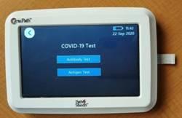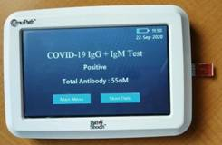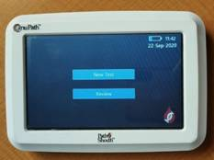

Prantae Solutions OPC has developeda test kit with a reader enabled direct antigen testing in suspected COVID samples. It is based on the technology called Localized Surface Plasmon Resonance Enhancement which enables quantifiable measurement of proteins at less than 100pg concentrations. The technology is a rapid alternate to RT-PCR and can be deployed at Point-of-care.

The COVID-19 Detection KIT V2.0 Huwelcontains three ready to use Oligo mix for detection of Corona Virus, along with Reverse Transcriptase Enzyme for single tube RT qPCR amplification having a shelf life of about a year.

Chimera Translational Research Fraternity has developed a technology for delivering a standardised therapeutic dosage of plasma for treatment of COVID 19 patientsso that just the right amount of dose is administered to the patient. TheLyophilised - COVID Antibody Rich Product (L-CARP) they have developed, provides a safe therapy and avoids transmission of infections by a strategic donor with the help of a screening process. They have developed a bank of L-CARP, to avoid the delay and hassle of finding, screening and withdrawing the plasma at the last minute.

Incubators like SINE IIT Bombay FIIT, IIT Delhi, SIIC, IIT Kanpur, HTIC, IIT Madras, Venture Centre, Pune, IKP Knowledge Park, Hyderabad, KIIT-TBI, Bhubaneswar,provided timely advice on technical progress, guided the start ups to follow all necessary guidelines, signing of MoUs and so on.

Source
Press Information Bureau, 06 October, 2020

