Dr. Harsh Vardhan inaugurates the “DBT-BIRAC Clean Tech Demo Park” at Barapullah drain site
“The novel indigenous technologies developed for the treatment of sewage and industrial waste waters should be promoted for achieving Swachh Bharat and Atmanirbhar Bharat goals”: Dr. Harsh Vardhan
Dr. Harsh Vardhan, Minister for Science & Technology, Health & Family Welfare and Earth Sciences, today inaugurated the “DBT-BIRAC Clean Tech Demo Park” at Barapullah drain site, near Sundial Park, Sarai Kale Khan, New Delhi in a virtual event in the presence of Lt. Governor of Delhi, Shri. Anil Baijal. Dr. Renu Swarup, Secretary, DBT and other Officials, Scientists and Innovators were present on the occasion.
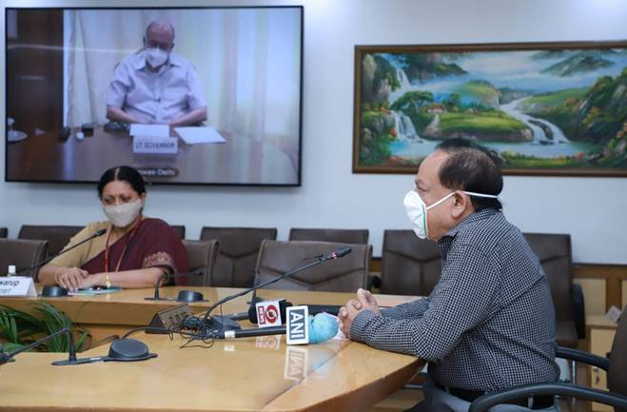

Speaking at the occasion, Dr. Harsh Vardhan said that “this Clean Tech Demo Park would be a good attraction not only for Innovators/ Investors but also for students and common public for awareness and popularization of clean technological solution for waste management”. “The novel indigenous technologies developed for the treatment of sewage and industrial waste waters should be promoted and given wide publicity to ensure their commercialization and adoption for achieving Swachh Bharat and Atmanirbhar Bharat goals”, he added.

Lt. Governer Sh. Anil Baijal welcomed this initiative by DBT and mentioned that Land and water are important natural resources, and affirmed strong support from DDA to this initiative of Department of Biotechnology to ensure that these precious resources are protected.

Dr. Renu Swarup, Secretary, DBT said that, this Clean Technology Waste to Value demonstration Park is an important initiative of the Department of Biotechnology to demonstrate the feasibility of these technologies for scale up and this will encourage partnership with local bodies and other Stakeholders for large scale technology deployment.

The DBT-BIRAC Clean Tech Demo Park will be used to demonstrate innovative Waste-to-Value technologies with support from Department of Biotechnology (DBT), Government of India, and Biotechnology Industry Research Assistance Council (BIRAC), a DBT PSU. This park will be managed by the Clean Energy International Incubation Centre (CEIIC), a public-private-partnership incubator set up jointly by DBT, BIRAC and Tata Power.
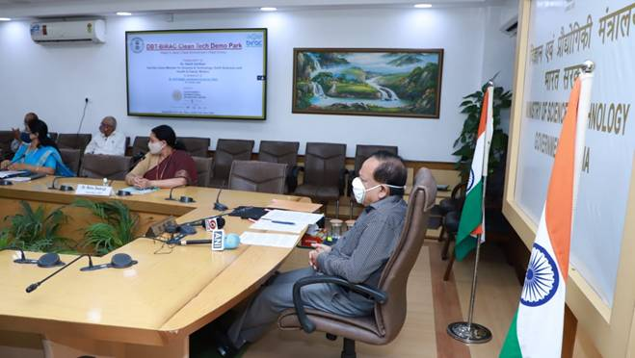

Few other waste treatment technologies with support from DBT & BIRAC that aim to contribute to the vision of Swachha Bharat were demonstrated virtually on the occasion..
DBT has undertaken several initiatives under Swachh Bharat Mission for the development, demonstration and promotion of innovative clean waste-to-value technologies including biomethanation, constructed wetlands, algal treatment and water membrane filtration. The DBT-DESMI project in collaboration with Denmark for cleaning of floating debris from Barapullah nallah, and the LOTUS-HR project in collaboration with Netherlands are already successfully demonstrated at the Barapullah site. Technologies developed by Startups at different locations in the Country will be demonstrated on this site.

Source
Press Information Bureau, 08 October, 2020

