NIF boosts new varieties of Anthurium, a flower with high market value, by lady innovator from Kerala

D Vasini Bai, a women innovator from Thiruvananthapuram, Kerala, has developed ten varieties of Anthurium, a flower with high market value, by cross-pollination. Anthurium (Anthurium spp.) is a vast group of beautiful blooming plants available in a wide range of colors. The plants of the varieties are having high demands due to its use as indoor decorative plants. During the last year, over 8500 plants, as well as the flowers, have been sold to the market of mainly Pune and Thiruvananthapuram. The innovator has been propagating it through cuttings & seeds and supplying some plants and flowers throughout the country, but she was unable to meet the demand due to the time-consuming technique of propagation method.

Therefore, the National Innovation Foundation-India has facilitated mass multiplication and large scale production of four highly demanded varieties through tissue culture technique at the Indian Institute of Horticultural Research (IIHR), Bangalore, for the diffusion of the varieties in similar agroclimatic zones of the country.

Anthurium is one of the best domestic flowering plants in the world. They are beautiful but also purify the surrounding air and remove harmful airborne chemicals like formaldehyde, ammonia, toluene, xylene, and allergens. Its importance of removing toxic substances from the air, NASA has placed it in the list of air purifier plants.Anthurium has larger economic importance because of its eye-catching and beautiful inflorescence and fetches a good market price.
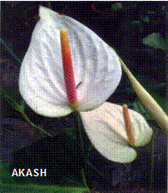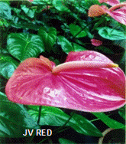
The uniqueness of these varieties developed by D Vasini Baiare large and medium-size flowers with uncommon color combinations of spathe and spadix (viz. light and dark orange, magenta, green and rose color combination, dark red and white colors). She has also developed a new method for raising the seedlings in limited space using corrugated asbestos sheets. For transplanting grown-up seedlings, she uses concrete troughs instead of pots. These methods have helped her in growing more plants in limited space, thus reducing the costs and maintenance and increasing the income at the same time. She sells the Anthurium flowers and plants to local florists as well as in cities like Pune and Mumbai at an average price of rupees 60-75 per flower.

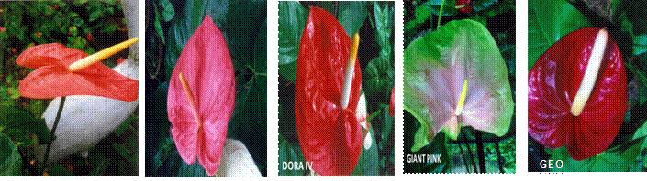

Vasini Bai has received a number of awards and recognition for developing the Anthurium varieties. In March 2017, she was awarded with state award at the Ninth National Biennial competition organized by National Innovation Foundation-India (NIF) by the then President of India Shri Pranab Mukherjee, at Rashtrapati Bhavan, New Delhi.

Her interest in developing new Anthurium variety instigated in the late 1970s when her son brought two plants of Anthurium. She was attracted to the beauty of the plants and wanted to raise more such plants for developing new variety with uncommon color combinations. She started experimenting using various techniques, trials, and errors. In 1980, she manually cross-pollinated for the first time, and after years of experiments in 1985, she developed the first variety of Anthurium- Dora (single plant with 8-10 leaves and multiple flowers with orange-colored spathe). She continued her work, and during 1985–2000, she developed another five varieties viz. Dora- I, Dora –II, Dora –III, Dora –IV and Dora – V. The other five varieties Akash, George, Giant Pink, JV Red, and JV Pink were developed later through manual cross-pollination.

The National Innovation Foundation-India (NIF) facilitated validation trials of Vasini Bai’s varieties along with six parent varieties under the varietal testing programme at Tamil Nadu Agricultural University, Coimbatore. The innovator’s varieties were reported to be healthy, vigorous with prominent and distinguishable characters of spathes and spadix ranging from light pink, pink, red, white, violet and orange. The leaves were found to be shiny, medium-large, and heart-shaped. The flower spathes were bright coloured and had short spadix, and these parameters were comparable with existing commercial varieties.

Salient features of the Anthurium varieties are
- Large beautiful flowers
- Different colors of spathe and spadix
- Long stalks
- Better shelf life
- Good market value

NIF has also facilitated mass multiplication and large scale production of the varieties --Dora, George, JV Pink and JV Red which have significant market value through tissue culture technique at Indian Institute of Horticultural Research (IIHR), Bangalore for diffusion of the varieties in similar agroclimatic zones of the country.

Source
Press Information Bureau, 22 April 2020

