SCTIMST joins hands provide voluntary service in efforts to combat COVID-19

With the COVID-19 virus threat continuing to be a cause for concern, various employee organizations at the Sree Chitra Tirunal Institute of Medical Sciences and Technology (SCTIMST) an autonomous institute of the Department of Science & Technology joined hands to kickstart social service initiatives on a massive scale.

The employee bodies rallied under a single umbrella and initiated a WhatsApp group in a bid to provide the much-needed support to COVID 19 infected staff and those on quarantine, making sure that food, medicine, and groceries were made available to the quarantined staff.

Transportation, to staff working in COVID 19 labs, delivery of HCQ to quarantine staff was also ensured without any hassle. ‘buddies @sctimst,’ a WhatsApp group, took over coordination of volunteer work at all levels. The digital network helped in identifying service requirements for all people, irrespective of designations.

A 15-member core team was in charge of controlling all service-related initiatives, thereby ensuring service delivery and feedback monitoring. A 61-member network, with 15 active members as volunteers, has ensured the availability of services such as counseling, mindful yoga, and meditation, preventive measures, guidance, wellness support through faculties including psychiatrists, naturopathy specialists, Ayurveda physicians, and psychologists. The team has also lend a hand in the activities undertaken by various organisations in maintaining cleanliness and providing food to the needy. Patients and their relatives at the Medical College, SCTIMST, Regional Cancer Centre (RCC), and Sree Avittam Thirunal Hospital for Children (SAT) are being provided support in need like travel, medicine, and food.

The BMS-backed Sree Chitra Employees Sangh distributed food packets to bystanders and poor patients within the Thiruvananthapuram Medical College Campus, and they included those from Regional Cancer Centre, Sree Avittam Thirunal Hospital for Children (SAT), SCTIMST and Medical College Hospital. Further, a blood donation drive by the Employees Sangh members was also initiated on April 16 to be donated to the SCTIMST Blood bank to overcome shortcomings till April 23. Grocery Kits were distributed to those in need at the Institute. The benefactors include cleaning staff, outsourced from an external agency, also. Lunch packets are also being served on a daily basis to those identified among the same group, free of cost.

Around 1000, masks and sanitizers have been distributed among the patients and bystanders during the lock-down period. The Non-Academic Employees & Association at SCTIMST has provided soap and sanitizers in their effort to combat and prevent the spread of the deadly virus.

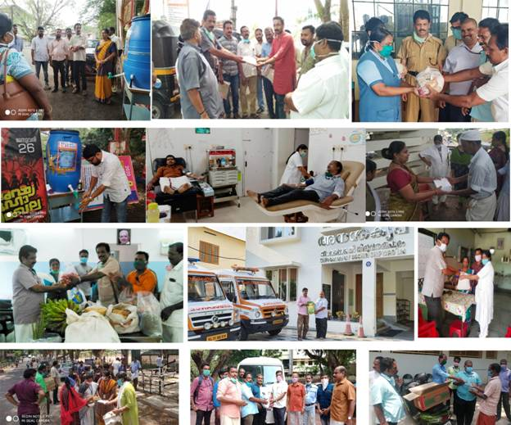
Controlling Measures And Voluntary Activities Done By Staff Members Of SCTIMST From March 25, 2020, To Till Date
(For more details, please contact: Ms. Swapna Vamadevan, PRO, SCTIMST, Mob: 9656815943,
Email: pro@sctimst.ac.in)

Source
Press Information Bureau, 05 June, 2020

