National Supercomputing Mission: a transformative approach in supercomputing
The 2020-21 is an important year for India’s National Supercomputing Mission (NSM). The mission was set up to provide the country with supercomputing infrastructure to meet the increasing computational demands of academia, researchers, MSMEs, and startups by creating the capability design, manufacturing, of supercomputers indigenously in India.
A first of its kind attempt to boost the country’s computing power, the National Super Computing Mission is steered jointly by the Ministry of Electronics and IT (MeitY) and Department of Science and Technology (DST) and implemented by the Centre for Development of Advanced Computing (C-DAC), Pune and the Indian Institute of Science (IISc), Bengaluru.
The target of the mission was set to establish a network of supercomputers ranging from a few Tera Flops (TF) to Hundreds of Tera Flops (TF) and three systems with greater than or equal to 3 Peta Flops (PF) in academic and research institutions of National importance across the country by 2022. This network of Supercomputers envisaging a total of 15-20 PF was approved in 2015 and was later revised to a total of 45 PF (45000 TFs), a jump of 6 times more compute power within the same cost and capable of solving large and complex computational problems.
With the revised plan in place, the first supercomputer assembled indigenously, called Param Shivay, was installed in IIT (BHU) and was inaugurated by the Prime Minister. Similar systems Param Shakti and Param Brahma were installed at IIT-Kharagpur and IISER, Pune. They are equipped with applications from domains like Weather and Climate, Computational Fluid Dynamics, Bioinformatics, and Material science.
Plans are afoot to install three more supercomputers by April 2020, one each at IIT-Kanpur, JN Centre for Advanced Scientific Research, Bengaluru, and IIT-Hyderabad. This will ramp up the supercomputing facility to 6 PF.
11 new systems are likely to be set up in different IITs, NITs, National Labs, and IISERs across India by December this year, which will have many sub-systems manufactured and microprocessors designed in India which will bring in a cumulative capacity of 10.4 petaflops.
Spreading out the reach to the North-East region of the country, 8 systems with a total Compute Power of 16 PF are being commissioned. 5 indigenously designed systems with three 3 PF computing power will be installed at IIT-Mumbai, IIT-Chennai and Inter-University Accelerator Centre (IUAC) at Delhi with NKN as its backbone. It also includes an indigenously build 20 PF system at C-DAC, Pune, and a 100 PF Artificial Intelligence supercomputing system. One midlevel 650 TFs system is also to be installed at C-DAC Bengaluru to provide consultancy to Start-ups, SSIs & MSMEs.
Geared to provide Supercomputing facility to about 60-70 institutions Nation-wide and more than thousands of active Researchers, Academicians, and so on, NSM has gathered momentum and is moving fast not only towards creating a computer infrastructure for the country but also to build capacity of the country to develop the next generation of supercomputer experts.

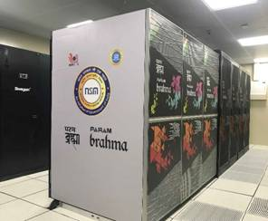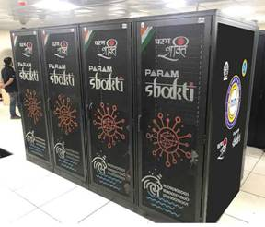

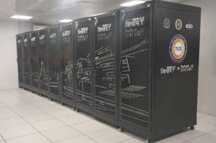

Source
Press Information Bureau, 23 March 2020

