DST supported healthcare startup developing rapid test for detection of COVID-19

The Department of Science & Technology has funded ‘Module Innovations”, a Pune based healthcare startup working on point of care diagnostics to build up on its platform technology for rapid diagnosis of diseases to develop a product for detecting COVID 19 with a 10 to 15 minute test.
Using the proven concept from its flagship product USense, Module is now developing nCoVSENSEs (TM) which is a rapid test device for detection of antibodies that have been generated against the COVID 19 in the human body.
With the current stage that India is in, doing a mass screening is of extreme importance. With the rapid test device it will be possible to confirm infection in patients and also determine whether an infected patent has recovered and also identify the stage of infection in the patients.
The current confirmatory method of Real-TimeReverse Transcription Polymerase Chain Reaction (RT-PCR) though a gold standard is costly, takes longer time and needs trained manpower. This new rapid test will help manage the problem in a more efficient way at a lesser cost.
"While not being a substitute for the PCRbased confirmatory technique, the tests based on the detection of antibodies are being deployed globally for the purposes of rapid mass screenings that take some of the burden off from limited number of PCR machines, and help in the formulation of strategies and decision making, among other things", said Professor Ashutosh Sharma, Secretary, Department of Science & Technology.

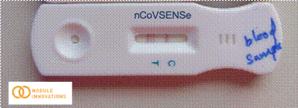

The nCoVSENSe test is aimed at detecting the IgG and IgM antibodies generated in the human body upon the onset of viral infection and is targeted against the Spike proteins making it specific for COVID 19.

The startup is planning to deploy the test in a time of 2-3 months after due validation with national agencies. This in future will also help determine people who have recovered and assign them front line jobs. The test could also be used to screen patients and passengers at airports, railway stations, hospitals and many such settings thus safeguarding us for any future outbreak as well.

While the feasibility of the technology has been proved, the Proof of concept (PoC) and Prototype illustrating functionality of product are to be demonstrated.

(For further details contact
Sachin Dubey
sachin@moduleinnovations.com
7350840295)

Source

Press Information Bureau, 06 April, 2020

