In recent years CSIR has been putting in places processes to have more representation of women in the system: Dr. Shekhar C Mande, Director-General, CSIR

AcSIR and CSIR launch Vigyangranth- the PhD Thesis Repository portal, aimed at giving a holistic view of R&D initiated and carried out by Indian research scholars
A webinar on "CSIR Women Researchers at the forefront of the fight against COVID-19" organized

Vigyangranth- the PhD Thesis Repositoryhas been launched which is a joint initiative of Academy of Scientific and Innovative Research, India (AcSIR) and Council of Scientific and Industrial Research, India (CSIR). The portal is aimed to give a holistic view of R&D initiated and carried out by Indian research scholars in the areas of Science, Technology, Engineering and Mathematics (STEM) with respect to their relevance to (i) Broad Heads of Research (targets for societal needs), (ii) Sustainable Development Goals (SDGs) set by United Nations, (iii) National Thrust Areas of Research, (iv) Disciplines, in addition to value of the contributions as deep discoveries in science and frontline advancements in technological space.

The portal was launched by the Chief Guest Lt. General (Dr.) Madhuri Kanitkar, Deputy Chief of Integrated Defence Staff (Medical). At the online event organized by CSIR to mark the United Nations International Day of Women and Girls in Science, Dr. Kanitkar pointed out that theses repository is a valuable contribution to make the information and knowledge accessible to the world at large and also called upon the women scientists to follow their passion in science.

Speaking about Vigyangranth, Dr. R S Sangwan, Director, AcSIR said that the portal has been developed on the suggestion of the PM who, while Presiding over the Society Meeting of CSIR in 2020, emphasized the need and significance of a databank of researchers pursuing PhD in the country and of a Portal reflecting research work and topics directly relevant to national problems, needs and demands. He informed that close to 7000 thesis abstracts are available currently which are searchable by key words and discipline.

Earlier, welcoming the audience, Dr. Shekhar C Mande, Director-General, CSIR said that in the recent years CSIR is putting in places processes to have more representation of women in the system.

A webinar on "CSIR Women Researchers at the forefront of the fight against COVID-19" was organized on the occasion. Five women research students belonging to various CSIR laboratories shared their research work related to PPEs, COVID-19 drugs, viral sequencing, disinfection systems and so on which were taken up as a part of CSIRs fight against Covid-19.

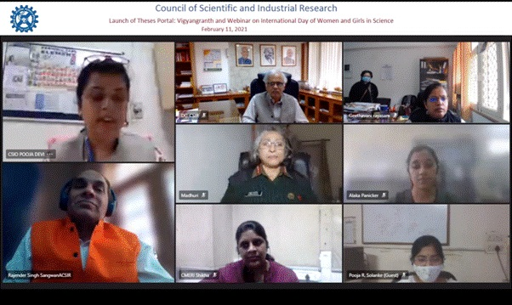

Source
Press Information Bureau, 12 February, 2021

