Dr. Harsh Vardhan along with Shri. Narendra Singh Tomar release ‘Guidelines for Evaluation of Nano-based Agri-input and food products in India’

“These ‘Guidelines’ would help policy makers and regulators to frame effective provisions for future novel nano-based products in the agri-input and food sectors of India”: Dr. Harsh Vardhan
“This is an excellent initiative, which has bought on board all the Departments and Ministries dealing with Nanotechnology, and nano based products”: Narendra Singh Tomar
The Guidelines have been prepared jointly by DBT, M/o S&T, M/o A&FW,FSSA, M/o H&FW through concerted Inter-Ministerial efforts coordinated by DBT
Dr. Harsh Vardhan, Minister for Science & Technology, Health & Family Welfare and Earth Sciences and Shri. Narendra Singh Tomar, Minister of Agriculture & Farmers Welfare and Rural Development & Panchayati Raj released through video-link the ‘Guidelines for Evaluation of Nano-based Agri-input and food products in India’ here today. The Guidelines have been prepared jointly by Department of Biotechnology (DBT), Ministry of Science and Technology, Ministry of Agriculture and Farmers’ Welfare (M/o A&FW) and Food Safety and Standards Authority of India (FSSAI), Ministry of Health and Family Welfare through concerted Inter-Ministerial efforts coordinated by DBT. Present on the occasion were Shri Parshottam Khodabhai Rupala, Union Minister of State for Panchayati Raj, Agriculture and Farmers Welfare,Dr Renu Swarup, Secretary, Department of Biotechnology; Shri Sanjay Agarwal, Secretary, Department of Agriculture, Cooperation & Farmers Welfare; Shri Arun Singhal, CEO, FSSAI and senior officials and experts from the Government, Research Institutes and University.
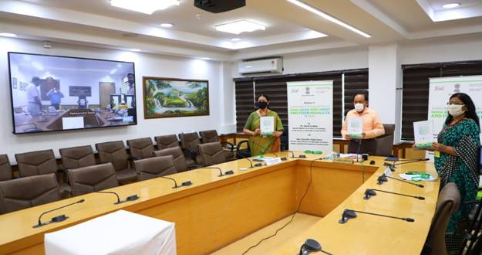

Speaking on the occasion, Dr. Harsh Vardhan said, “Nanobiotechnology has the potential to improve agricultural systems through increase in plant productivity and better crop protection for meeting the changing needs and requirement of providing food to the growing population”. He said, “Compared to bulk form of chemical inputs in crops, use of nano-nutrients can reduce nutrient run-off into ground and surface water and thus can reduce environmental pollution.”“Indian government departments and agencies have been supporting various programmes on nanotechnology”, he added. Congratulating scientists, Dr. Harsh Vardhan said, “These guidelines are aimed at assisting in making policy decisions by providing information on the existing regulations for nano-based products in agriculture and food and also to ensure quality, safety and efficacy of the targeted products”. The Science & Technology Minister said, “These ‘Guidelines’ would help policy makers and regulators to frame effective provisions for future novel nano-based products in the agri-input and food sectors of India. They will also encourage the Indian innovators and industries to develop and commercialize new nano-based formulations and products in these sectors”.

Shri. Narendra Singh Tomar, highlighted that “The formulation of these ‘Guidelines’ is one of the most important steps for delineating quality, safety and efficacy assessment of the novel nano-formulations which can be commercialized here”. He said, “These guidelines are also intended to provide transparent, consistent and predictable regulatory pathways for nano-based agri-input and food products in India”. The Minister said, “This is an excellent initiative, which has bought on board all the Departments and Ministries dealing with Nanotechnology, and nano based products”. He added that “The ‘Guidelines for Evaluation of Nano-based Agri-input and food products in India’ will pave the way for significant benefits for our mission on ‘Doubling Farming Income by 2022’ and ‘National Mission on Sustainable Agriculture’.”

The present ‘Guidelines’ apply to nano-agri-input products (NAIPs) and nano-agri products (NAPs). These ‘Guidelines’ also apply to nano composites and sensors made from NMs and those that require direct contact with crops, food and feed for data acquisitions.

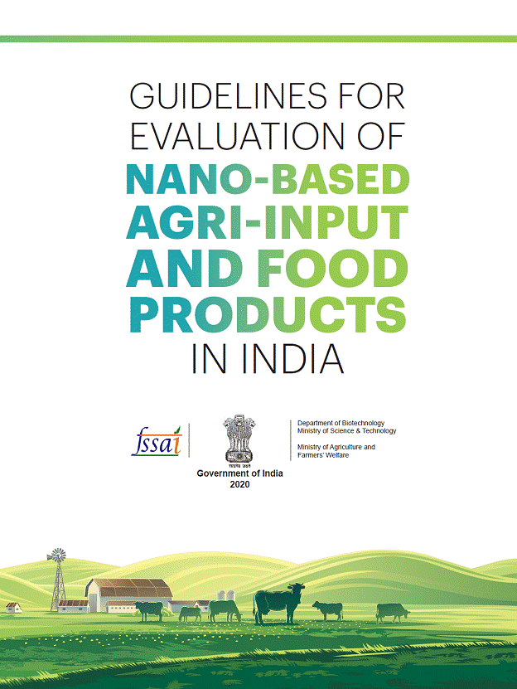

For detailed Guidelines, please click here. (Attachment)

Source
Press Information Bureau, 07 July 2020

