Scaling up of COVID testing centres (Hub and spoke model) in National research laboratories and Universities
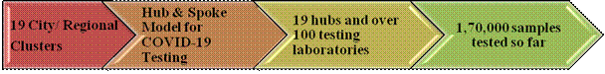

To scale up testing and enhance the reach across the countryCity /Regional clusters have been established in a Hub and Spoke Model to scale-up testing of COVID-19 samples in government institutions across the country. Institutes and Laboratories which have the capacity and expertise for both sample collection, handling/processing (BSL-2 facility) and testing (RT-PCR) serve as the hubs and they involve a number of laboratories which have RT PCR machines and the requisite manpower as their extended Testing facilities.

The Hubs are Government laboratories approved by respective Ministries /Departments (DBT, DST, CSIR, DAE, DRDO, ICAR etc) as per ICMR guidelines. So far 19 City /Regional clusters have been established in Bangalore, Delhi/NCR, Hyderabad, Thiruvananthapuram, Chandigarh/Mohali, Bhubaneshwar, Nagpur, Pune, Mumbai, Lucknow, Chennai, Kolkata, North Eastern Region, Jammu & Kashmir, Ahmedabad, Madhya Pradesh, Rajasthan, Banaras, Palampur and Delhi city.

About 100 institutions have been involved and over 1,60,000 samples tested. Seven DBT Autonomous institutes have been approved as hubs by ICMR and they are performing testing for diagnosis of COVID-19 (RGCB, THSTI, ILS, inStem, NCCS, CDFD, NIBMG).

They are also functioning as hubs in the respective Cities/Regions and coordinating the efforts with a number of other premier Central and State Government institutions. In addition, they are working closely with the respective State Governments in obtaining samples for testing and are reporting every day to ICMR on their testing results. Collectively in about 4 weeks, these clusters have done nearly 1,70,000 tests. These clusters will now be scaled to nearly 50 in next 4 weeks and reach remote corners of the country.

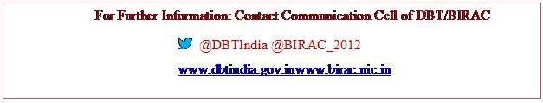

Source
Press Information Bureau, 30 May, 2020

