Professor K Vijay Raghavan:“Regulatory system need to be reformed and the CSR mechanism broadened to leverage it in R&D activities.”
Prof Ashutosh Sharma:“Need for a robust policy for the long term & also for identifying weak links to connect knowledge generators with knowledge consumers.”
High-level Industry consultation roundtable for formulation of STIP 2020 discusses ways to encourage industry to fund R&D
Also discussed on the ways to use CSR funds to create a culture in industry, academia, and government for indigenous technology development and move towards self-reliance
Posted On: 05 JUL 2020 3:15PM by PIB Delhi
About 30 industry stalwarts, who are CII members participated in the two-day roundtable meeting and shared their views and suggestions for the new STIP 2020 and discussed how to create an R&D ecosystem in a sustainable way to solve social problems. The industry captains stressed on the need for more collaboration between industry & academia and also need to increase the investment in R&D as a percentage of GDP.

The deliberations focused on the need for more incentives and recognition to encourage industry to fund R&D and ways to leverage the use of CSR funds for the purpose. In the meeting, the industry leaders also discussed on the ways to use CSR funds to create a culture in industry, academia, and government for indigenous technology development and move towards self-reliance.

On the 2nd day of the high-level Industry consultation roundtable for the formulation of the new Science, Technology & Innovation Policy STIP 2020, Principal Scientific Advisor to the Government of India, Professor K VijayRaghavan and DST Secretary Professor Ashutosh Sharma, focused on the need for more incentives and recognition to encourage industry to fund R&D and ways to leverage the use of CSR funds for the purpose.
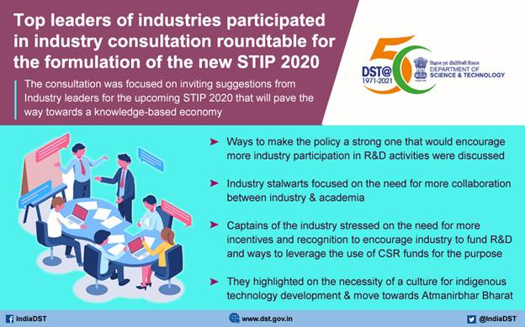

In his introductory address, Professor K VijayRaghavan highlighted that the regulatory system need to be reformed and the CSR mechanism broadened to leverage it in R&D activities.

Prof Ashutosh Sharma emphasised on need for a robust policy for the long term, which could attract industry investment in R&D & also for identifying weak links to connect knowledge generators with knowledge consumers.

In his opening remarks, Mr. Chandrajit Banerjee, Director General, Confederation of Indian Industry (CII), re-emphasized the critical facets of R&D that needs to be immediately strengthened such as importance of public funded research in academic system, focused R&D programmes, unlocking entrepreneurial ecosystem, IP valuation, cross-collaboration, and effective translational research amongst others.

The two-day roundtable meeting was heldover a virtual platform by theSTIP 2020 Secretariat in partnership with Confederation of Indian Industry (CII) and Science Policy Forum. The consultation was focused on inviting suggestions from Industry leaders for the upcoming STIP 2020 that will pave the way towards a knowledge-based economy.

This is the first-ever high-level industry consultation for the formulation of a Science, Technology, and Innovation Policy, which by way of its decentralized, bottom-up, and inclusive design process, aims to re-strategize priorities, sectoral focus, and methods of research and technology development for larger socio-economic welfare.

Top leaders from industry like Mr. Salil Singhal, Chairman & MD, PI Industries Limited; Dr. BVR Mohan Reddy, Executive Chairman, Cyient Limited; Mr. B Thiagarajan, Managing Director, Blue Star Limited; Mr. Deep Kapuria, Chairman, Hi Tech Group; Mr. MS Unnikrishnan, Managing Director and CEO, Thermax; Mr. Kunal Bahl, Founder & CEO, Snapdeal; Mr. Ashank Desai, Founder & Former Chairman, Mastek Limited; Mr. Sanjay Nayak, CEO & Managing Director, Tejas Networks Ltd; Mr. Anand Deshpande, Chairman, Persistent; Mr. Palaniappan P, CEO, Mahindra- Waste to Energy Solutions Ltd; Mr. K Anant Krishnan, CTO, TCS; Mr. AjitSapre, Group President, Reliance; Dr. Badri Gomatam, Group CTO, Sterlite Technologies Limited; and Mr. KK Kaul, Director, DCM Shriram, shared their insights and expectation on the STIP 2020.

Head of STIP 2020 Secretariat & Advisor, DST, Dr. Akhilesh Gupta, presented an outline of the STIP2020 formulation process from Track 1 to Track 4 initiated by STIP 2020 secretariat. He also placed before the industry captains some of key expectations of government.

The STIP 2020 Secretariat has been established jointly by the Office of Principal Scientific Adviser (PSA) and Department of Science and Technology (DST) to coordinate and execute the entire STIP 2020 policy-making process.

The Science, Technology, and Innovation Policy (STIP 2020) was flagged off jointly by the (Office of PSA), and DST as India and the world reorient in the wake of the COVID-19 crisis. The new policy is expected to be released later this year, replacing the existing policy, which was formulated in 2013.

The STIP 2020 formulation process is organised into 4 highly interlinked tracks, which will reach out to around 15,000 stakeholders for consultation in the policy formulation. Track I involves an extensive public and expert consultation process through Science Policy Forum - a dedicated platform for soliciting inputs from larger public and expert pool during and after the policy drafting process. Track II comprises experts-driven thematic consultations to feed evidence-informed recommendations into the policy drafting process. Twenty-one (21) focused thematic groups have been constituted for this purpose. Track III involves consultations with Ministries and States, while Track IV constitutes apex level multi-stakeholder consultation.

Source
Press Information Bureau, 05 July 2020

