Power-packed Apex Committee meeting provides suggestions for finalization of draft STIP 2020
A power-packed Apex Committee meeting of the new Science, Technology & Innovation Policy STIP 2020 discussed various suggestions for the upcoming policy that will pave the way towards a knowledge-based economy.

The meeting on virtual mode chaired by Professor K Vijay Raghavan, Principal Scientific Adviser to the Government of India, and co-chaired by Dr. V K Saraswat, Member Science, NITI Aayog and Professor Ashutosh Sharma, Secretary, Department of Science and Technology, Government of India, was held on November 26, 2020.

The draft STIP2020 policy was presented in the meeting. The distinguished thought leaders deliberated upon some big ideas and suggestions to be incorporated in the draft policy.

STIP 2020, India’s fifth National Policy for Science, Technology, and Innovation, aims to capture the aspirations of the entire nation through a decentralized, bottom-up, and inclusive approach. From open science to funding priorities; critical human capital to equity and inclusion; strategic technologies to traditional knowledge systems; science diplomacy to science communication – this policy promises a renewed STI ecosystem for an Atmanirbhar Bharat.

The STIP 2020 Secretariat has been established jointly by the Office of Principal Scientific Adviser (PSA) and the Department of Science and Technology (DST) to coordinate and execute the entire STIP 2020 policy-making process.

Secretaries of all science and several line ministries -- Secretary, Ministry of Earth Sciences; Dr. M Rajeevan, Secretary, Department of Atomic Energy (DAE) Shri K. N. Vyas; Director-General Council for Scientific & Industrial Research (CSIR) Dr. Shekhar Mande; Secretary, Department of Biotechnology (DBT) Dr. Renu Swarup; Secretary, Department of Space, Dr. K. Sivan; Secretary, Science, and Engineering Research Board (SERB) Prof. Sandeep Verma; Secretary, Ministry of AYUSH, Shri Vaidya Rajesh and Scientific Secretary, O/o Principal Scientific Adviser to GoI Dr. Arabinda Mitra participated and shared their insights and expectationsfrom the STIP 2020.

Heads of several national-level S&T institutions like Prof. Govindan Rangarajan, Director, IISc Bangalore; Prof. Subhasis Chaudhuri, Director, IIT Bombay; Prof. Bhaskar Ramamurthi, Director, IIT Madras; Prof. V Ramgopal Rao, Director, IIT Delhi; Prof. Jagdesh Kumar, VC, JNU; Prof. Umapathy, Director, IISER Bhopal; Dr. Sudhir K. Jain, Director, IIT Gandhinagar; Prof. T. G. Sitharam, Director, IIT Guwahati; Dr. Chandrima Shaha, President, INSA; Dr. Shailesh Nayak, Director, National Institute of Advanced Studies, Bangalore; Dr. Suresh, President, ISBA and from industry associations CEO, Invest India, Shri Deepak Bagla; S Raghupathy, Deputy Director General & In charge of Technology Department, CII & Mr. Dilip Chenoy, Secretary-General, FICCI along with other nominated members from various knowledge organizations provided their inputs to strengthen the new policy.

Dr Akhilesh Gupta, Head, STIP-2020 Secretariat made a presentation on policy formulation process and major recommendations contained in the draft policy document.

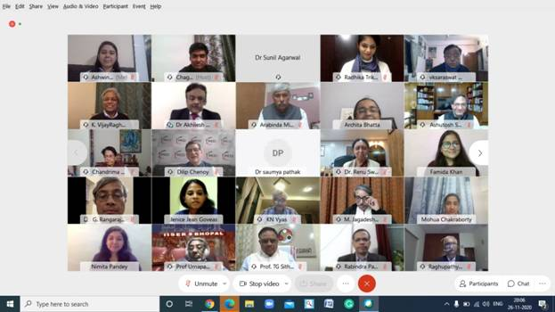

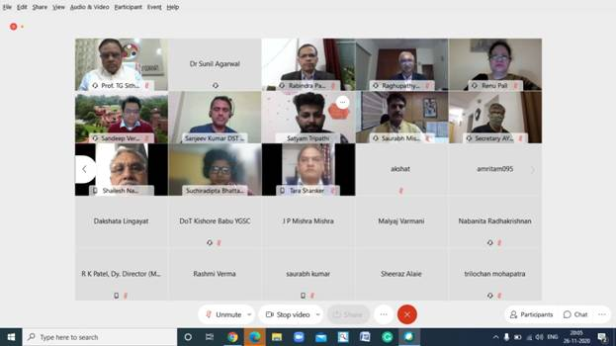

Source
Press Information Bureau, 28 November, 2020

