Curtain Raiser of 26th DST–CII Technology Summit 2020 between India and Portugal takes place

The 400-yr old partnership between India & Portugal in shared culture, history, and kinship is now turning modern with partnerships in science & technology: Mrs. K. Nandini Singla, Ambassador of India to Portugal
Summit will establish bilateral research networks, enhance research cooperation, and promote the exchange of knowledge between Indian and Portuguese scientists: Professor Ashutosh Sharma, Secretary, DST
We are now engaged in several areas, and we can hope for many joint collaborative projects to start soon: Prof. Helena Pereira, President, Foundation of Science and Technology, Portugal
The Department of Science and Technology (DST) with the Confederation of Indian Industry (CII) held the Curtain Raiser to announce the 26th edition of Technology Summit 2020 on December 1, 2020. Portugal is the partner country this year.

Professor Ashutosh Sharma, Secretary, Department of Science & Technology said that this is an important year in which we are celebrating our research partnership with Portugal amidst the unprecedented crisis. He welcomed Prof. Helena Pereira, President; Prof. José Paulo Esperança, Vice President, the Foundation of Science and Technology, Portugal; Mrs. K. Nandini Singla, Ambassador of India to Portugal; Mr. Carlos Pereira Marques, Ambassador of Portugal to India; Mr. Vipin Sondhi Chairman, and Mr. Alok Nanda, Vice Chairman, CII National Committee on R&D and Innovation and Chairman, Technology Summit.

Prof. Sharma wholeheartedly congratulates CII to continuously work with DST, not only for Tech Summit but for many other initiatives. He further emphasized that there has been successful bilateral research cooperation between India's Department of Science and Technology (DST), with the Foundation for Science and Technology (FCT) of Portugal. Both organizations have planned to structure their cooperation in sectors such as water, healthcare, agriculture, IT/ ICT, clean technologies etc. He shared that a total of approximately 450 proposals have been received against the recently announced India-Portugal joint call. He also mentioned that both governments are poised to support the development of scientific and technological cooperation between Indian and Portuguese researchers and to strengthen the scientific partnership between research groups from each country by establishing bilateral research networks, enhancing research cooperation, and promoting the exchange of knowledge between Indian and Portuguese scientists. He stated that this Summit will sign several MoUs and agreements which will increase bilateral trade between the two countries. He also encouraged the delegates to engage and take advantage of the B2B networking opportunities.

Mr. Sondhi stated that there is immense scope of collaborations between India and Portugal in different sectors. Indian industry would be happy to be the growth engine between the two.
Mr. Nanda also revealed that time has reached that India-Portugal ties to move forward. The summit is the right platform for the same to forge partnerships in in different sectors like WaterTech, Agritech, and Cleantech.

Prof. Esperança also highlighted the importance of India-Portugal bilateral S&T Cooperation. He stated that the three days of the summit will witness the highest ever online participation of research and development community of Portugal. Top national research centers, enterprises, private industries, startups, innovators, academic and research institutions, all geared at creating economic and social value will be online during the summit He invited everyone to be a part of our scientific exhibitions.

Professor Pereira delivered the special address and highlighted that science and technology is the oldest cooperation between India and Portugal. She stated that India-Portugal shares long historic ties, and now it is being enhanced in the space of Science & technology. FCT & DST earlier launched a joint call in research with a budget of approximately 2M Euros. We are now engaged in several areas, and we can hope for many joint collaborative projects to start soon.

She also mentioned that India was the country guest-of-honour in our flagship science event in 2017, and it establishes our close ties in politics, research as well as in Science.

Mrs. Singla shared that Portugal was the first country to launch collaborative S&T projects with India. This shows that the S&T relations with India and Portugal are very old. The 400-yr old partnership between India & Portugal in shared culture, history, and kinship is now turning modern with partnerships in science & technology. She stated that India-Portugal recently added 20 new agreements in the last 4 years, in areas such as marine research, robotics, waterway management, cleantech, and many other areas. India-Portugal trade crossed 1B$ mark in 2019 and Indian investments has crossed 350M. Looking at the COVID 19 vaccines on the horizon, our collaborations are all the more important.

In his closing address, Mr. S K Varshney, Head, International Cooperation, Department of Science & Technology, Government of India revealed that India-Portugal sharing long cooperation since December 1998. DST in collaboration with the FCT is organizing joint research and development projects, held bilateral workshops, and facilitated the exchange visits for young researchers. Recently, a 4 million Euro Memorandum of Understanding (MoU) was concluded on March 1, 2019, to foster partnerships between Research and Development organisations and institutions from India and Portugal. He emphasized that this summit may act as a platform for further networking and future avenues between Indian and Portuguese researchers and industries. He expressed his views to convert the knowledge into hi-tech affordable products.

The 26th edition of India-Portugal Technology Summit 2020 will be held over a digital platform from 7th – 9th December 2020.

Over the past 26 years, DST has been co-organizing the Technology Summit in partnership with CII.
The summit has benefitted immensely the Indian industry and academic & research institutions by forging partnerships, stimulating innovation, investment & trade and facilitating technology transfers, joint projects, and market access.

The Focus sectors of the summit for this year are Watertech, Agritech, Healthtech, Energy, Climate change, Cleantech, IT, ICT, Advanced technologies, and Space- Ocean Interactions.

Dr. Harsh Vardhan, Union Minister of Science & Technology, Health and Family Welfare and Earth Sciences, Government of India jointly with Prof. Manuel Heitor, Minister of Science, Technology and Higher Education, Government of Portugal will inaugurate the summit and the digital exhibition on 7th December 2020.

The summit will bring together experts from India and Portugal to deliberate on their country expertise in the focus sectors and to explore opportunities for future collaboration. Other Highlights of the summit shall include technology leadership plenaries, tech talks, business presentations, high technology virtual expo and B2B networking opportunities with Indian and Portugal delegates.
The event will be hosted on CII HIVE, its dedicated multi-feature, virtual online exhibition and conferencing platform with 24X7 helpdesk with a digital B2B lounge.

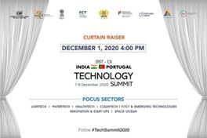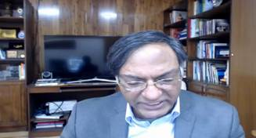
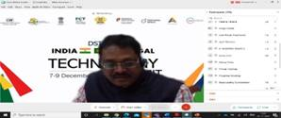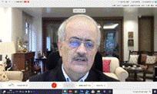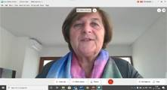
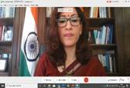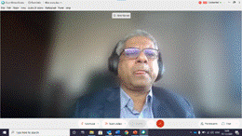
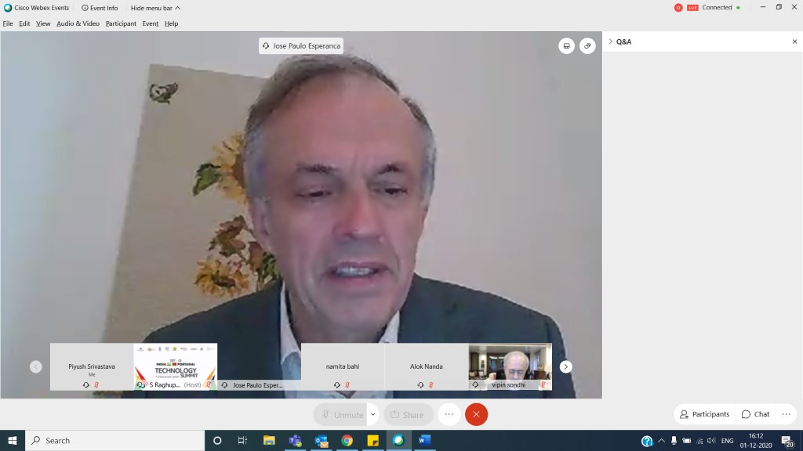

Source
Press Information Bureau, 1 December, 2020

