NIPER-Guwahati designs innovative 3D products to fight COVID-19
Researchers at the National Institute of Pharmaceutical Education and Research - Guwahati (NIPER-G) have come out with two products that promise to be of great help in the fight against the current pandemic outbreak of COVID-19 infection in the world.

The first product is a 3D-printed hands-free object that could be used to help open or close doors, windows, drawers (both vertical and horizontal), and refrigerator handle, or press elevator buttons, and laptop/desktop keyboards, including turning the switch buttons on/off.

Doors, windows, switch buttons, elevator buttons, drawers handle, refrigerator handle, and laptop/desktop keyboards are some of the most germ-infested objects in houses, hospitals, factories, companies, institutes, organizations, and other buildings. In this current situation of pandemic outbreak of COVID-19, this aspect may play a key role in transmitting infection from one person to another through bare hand contacts or contaminated surface source.

The researchers came up with the design for the fabrication of the 3D-printed object after a detailed analyses of several resources for risk measurement and on how viruses spread through bare hands.

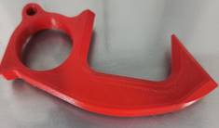
Dr. U.S.N Murty, Director, NIPER-G , noted that the product was easy to design, and was amenable to rapid development of prototypes. It was also handy, user friendly, non-fragile and easy to clean with the existing sanitizers or any alcoholic disinfectant.

The second product is a 3D-printed antimicrobial face-shield to control the spread of novel coronavirus. It was designed after a thorough study to understand how viruses spread through oral, ophthalmic, olfactory and other body cavities.
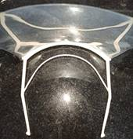
The face shield is also easy to design and it is possible to have rapid development of prototypes. It is also low cost, easy to wear, has good chemical stability, non-fragile and is easy to clean with the existing sanitizers or any alcoholic disinfectant.
Dr. Murty noted that being a premier institute of national importance, NIPER-G endeavoured to help the country in fighting coronavirus through quick validated prototype/product development and deployment. “NIPER-G is committed to provide useful contributions cum solutions”.

Source
Press Information Bureau, 11 April 2020

