NIF invite innovative citizens to participate in Challenge COVID-19 Competition (C3)

Ideas are also invited for gainful engagement of people at home, healthy food for nutrition and boosting immunity specially at the time of lockdown
“The initiative will not only create awareness, but will intimately engage a wide cross-section of society with diverse backgrounds in providing and implementing solutions"-- Professor Ashutosh Sharma, Secretary, DST

At a time when the country is facing a great crisis due to the Corona pandemic, National Innovation Foundation – India (NIF), an autonomous institute under the Department of Science and Technology, Govt. of India has come up with a call inviting innovative citizens to participate in its Challenge Covid-19 Competition (C3).
All interested innovators are welcome to participate with their creative ideas and innovations for problems or issues like reducing transmission of Corona virus through original creative ideas, innovations, which can supplement the efforts of the government in slowing or eliminating the spread further, innovative ideas which can make activities like sanitising one’s hands, body, home items, and home, public places wherever required more interesting and effective, supply and distribution of essential items to people specially the elderly living alone like ideas for the door-to-door supply of essential products and services which obliterate the need to move out of the home.
Ideas are also invited for gainful engagement of people at home, healthy food for nutrition and boosting immunity specially at the time of lockdown when raw materials are limited, (Personal Protective Equipment) PPE’s and rapid diagnostic testing facilities for capacity building of healthcare, rethinking contactless devices for the post-Corona implementation, varying needs of the different segment of the population during COVID-19 like differently-abled, people with special needs and mentally challenged population.
Professor Ashutosh Sharma, Secretary, Department of Science & Technology said, "NIF is a rather unique institution with a strong focus and experience in scouting and facilitating inclusive and grass-roots innovations driven by citizens. The initiative being launched will not only create awareness, but will intimately engage a wide cross-section of society with diverse backgrounds in providing and implementing solutions."
The selected technological ideas and innovations will be supported for incubation and dissemination. The details of ideas and innovations may be sent to campaign@nifindia.org & http://nif.org.in/challenge-covid-19-competition with complete details about the person (Name, Age, Education, Occupation, Address, Contact Number, Email) and details about the idea/ innovation (including photo and video, if any). The C³ announced on March 31, 2020, will accept entries on a rolling basis until further notification..

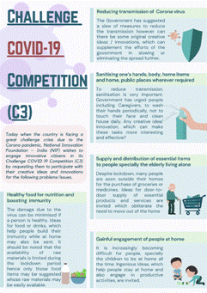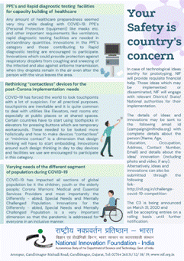

(For further details, contact Mr. Tushar Garg, tusharg@nifindia.org, Mob: 9632776780)

Source

Press Information Bureau, 04 April, 2020

