8th BRICS STI Ministerial Meeting held on Friday

The Meeting unanimously adopts BRICS STI Declaration 2020 and Calendar of BRICS STI Activities 2020-21
“The COVID 19 pandemic has been a test, demonstrating that multilateral cooperation is the key to overcoming such global challenges”: Dr. Harsh Vardhan
“We recognize the importance of engaging with BRICS countries in order to foster dialogue and mutual knowledge sharing, capacity building, cross-incubation with a broad view to advancing BRICS systems of innovation”: Dr. Harsh Vardhan
BRICS Members applauded India’s scheme ‘SERB–POWER’ (Promoting Opportunities For Women in Exploratory Research) to encourage and support emerging as well as eminent women researchers to undertake R&D activities in frontier areas of science and engineering.
The Science, Technology and Innovation Ministers of the BRICS grouping (Brazil, Russia, India, China and South Africa) met on November 13 evening through a virtual platform to discuss S & T cooperation among the member countries. The Ministry of Science and Higher Education of Russia organized the meeting, Russian Federation being the Chair for 12th BRICS Summit.

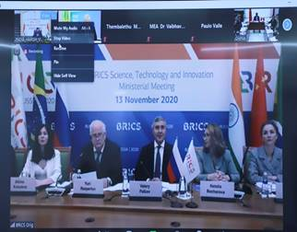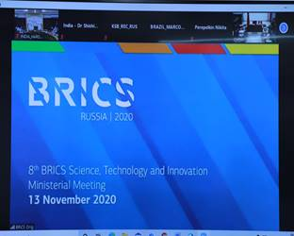

Speaking at the meeting, Union Minister for Science & Technology, Earth Sciences and Health & Family Welfare, Dr Harsh Vardhan congratulated the participating dignitaries at the concluding session for, “The BRICS STI Declaration 2020 and Calendar of BRICS STI Activities 2020-21 which will act as a roadmap to take our cooperation forward”. The BRICS STI Declaration 2020 was unanimously adopted at the meeting.
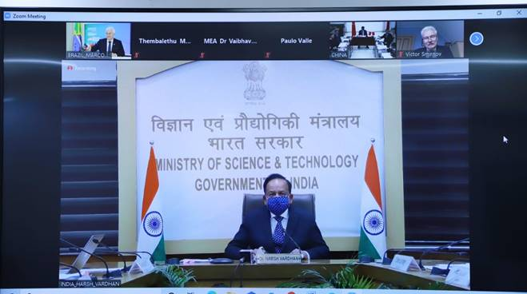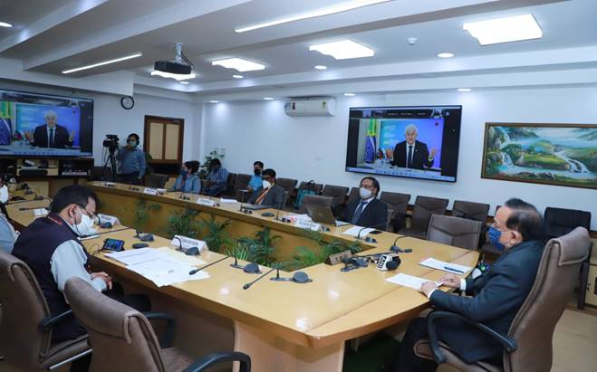
During the meeting, Dr. Harsh Vardhan highlighted that “The COVID 19 pandemic has been a test, demonstrating that multilateral cooperation is the key to overcoming such global challenges”. He said, “Since we are one of the most affected population from this pandemic, it provides for greater cooperation opportunity among BRICS countries to combat this pandemic”.
The Union Minister informed that “India has initiated an integrated response to overcome this unprecedented COVID-19 pandemic. From the development of indigenous vaccines, novel point-of-care diagnostics and therapeutic formulations based on traditional knowledge, to establish research resources and offering services, Indian R&D entities both public and private, are working relentlessly to develop effective interventions for combating the pandemic. Hundreds of projects are being supported. More than 100 startups have developed innovative products for COVID-19”.
Pointing out that “Innovation for inclusive development finds significant mention in the Declaration”, Dr. Harsh Vardhan said, “ We recognize the importance of engaging with BRICS countries in order to foster dialogue and mutual knowledge sharing, capacity building, cross-incubation with a broad view to advancing BRICS systems of innovation”.
The BRICS Member leaders applauded India for what Dr. Harsh Vardhan said, “We have recently launched a scheme ‘SERB–POWER’ (Promoting Opportunities For Women in Exploratory Research) to encourage and support emerging as well as eminent women researchers to undertake R&D activities in frontier areas of science and engineering. We may think of networking BRICS women scientists through a dedicated platform and mechanism”.
He reiterated that “India will actively contribute in implementation of BRICS STI Calendar of Activities 2020-21 and supports continuation scientific activities under BRICS MOU on Science, Technology and Innovation”.
Participating in the 2nd Session on ‘Report of Working Group’ Meetings in 2019-2020 (including COVID-19 pandemic coordinated call, results of the BRICS STI Steering Committee activity) and the results of the 5-year implementation of MoU on STI’, Professor Ashutosh Sharma, Secretary, Department of Science & Technology, India emphasised that “We need to streamline and make BRICS STI initiatives more efficient, focussed and result oriented”. He appreciated that “I am glad to know that BRICS countries especially scientific ministries have been quick to join hands for addressing the current global COVID-19 pandemics”.
Shri Valery Falkov, Minister of Science and Higher Education, Russian Federation; Shri Marcos Pontes, Minister of Science, Technology and Innovation, Federative Republic of Brazil; Shri Huang Wei, First Vice Minister of Science and Technology, People’s Republic of China; Dr. Bonginkosi Emmanuel Nzimande, Minister of Higher Education, Science and Technology, Republic of South Africa and several other dignitaries from member countries participated in the meeting.
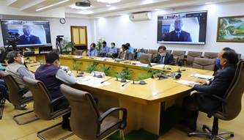
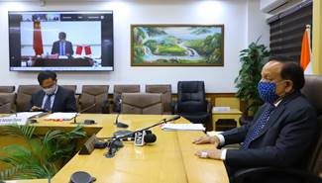
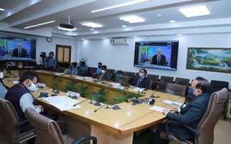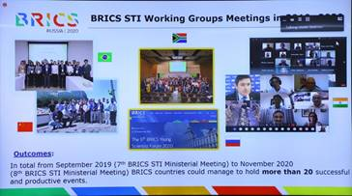

Click here for Opening remarks of Dr. Harsh Vardhan.
Click here for the main speech of Dr. Harsh Vardhan, at the Meeting.
Click here for the speech of Dr. Harsh Vardhan, at the concluding session.

Source
Press Information Bureau, 14 November, 2020

