CSIR-CMERI Conducts Skill Development Programme on Integrated Municipal Solid Waste Management for Zero Waste Solutions

Institute Designs Mechanized Segregation of Municipal Solid Waste and Disposes Bio-degradable Wastes

CSIR-Central Mechanical Engineering Research Institute, Durgapur conducted a three-day residential training programme on "Integrated Municipal Solid Waste Management: Zero Waste Solutions" from March 16, 2020 till date where 25 participants including students and officials from Urban Water Supply & Sanitation Services Advisory Network (host organization: Pragati Bio And Renewable Energy), Bihar participated.
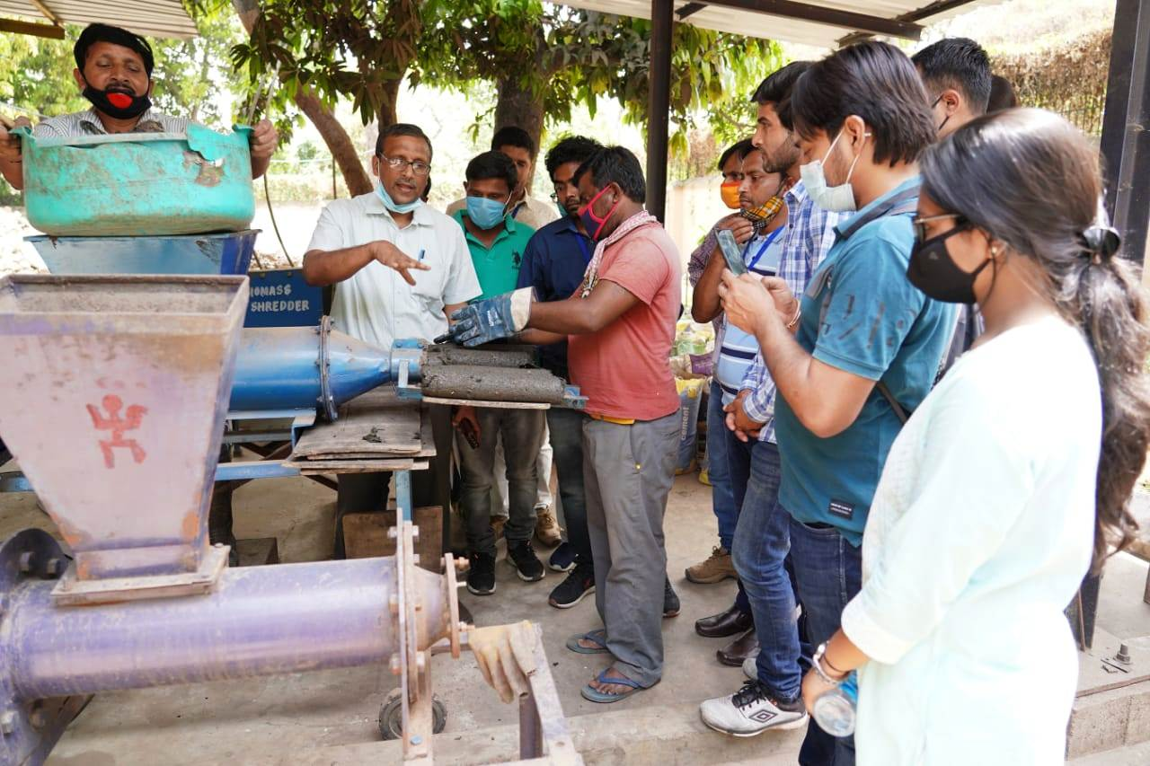
In the concluding session Prof. (Dr.) Harish Hirani, Director, CSIR-CMERI stated that the people in our society more rely on the imported technologies rather than the indigenously developed ones. He added, CSIR-CMERI is working hard to develop the indigenous technologies. The Institute is also giving its efforts for the awareness of these technologies amongst the masses through skill development programmes and improving the knowledge.
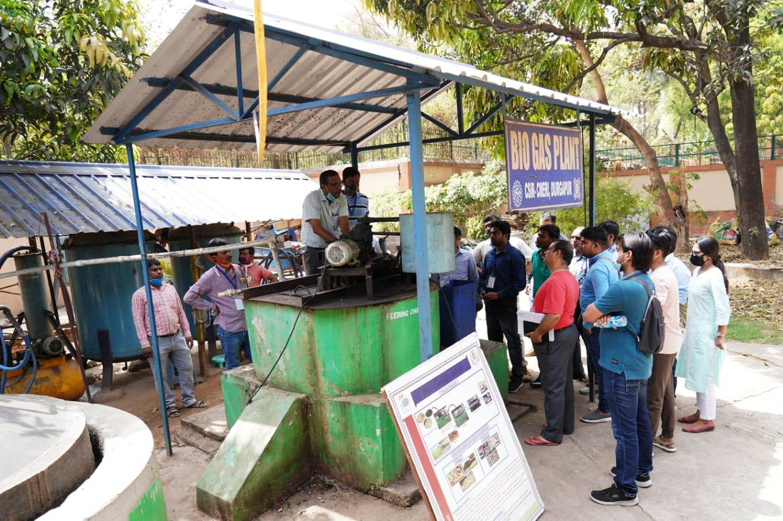
Prof. Hirani also remarked that our country produces huge quantities of waste annually which occupies a large volume of limited land, and contributes to severe contamination and environmental pollution. With the gradual growth of the population the problem is getting worse. To tackle the situation scientifically, the Institute has designed & developed a unique technology for integrated Municipal Solid Waste management. The developed system includes mechanized segregation of municipal solid waste, practicing the contactless operation and disposal of every type of bio-degradable waste including garden waste and non-biodegradable polymer waste. The daily waste generated from the residential campus is being processed in an environment friendly way to achieve a ZERO landfill residential campus. This kind of decentralized municipal solid waste disposal system is very useful in breaking the chain to prevent the pathogens including spread of Covid-19 virus through solid waste management route. Moreover, the developed system is easy to operate and maintain and self-sustainable in terms of operational energy requirement. CSIR-CMERI will always be supporting the MSMEs in every manner possible.
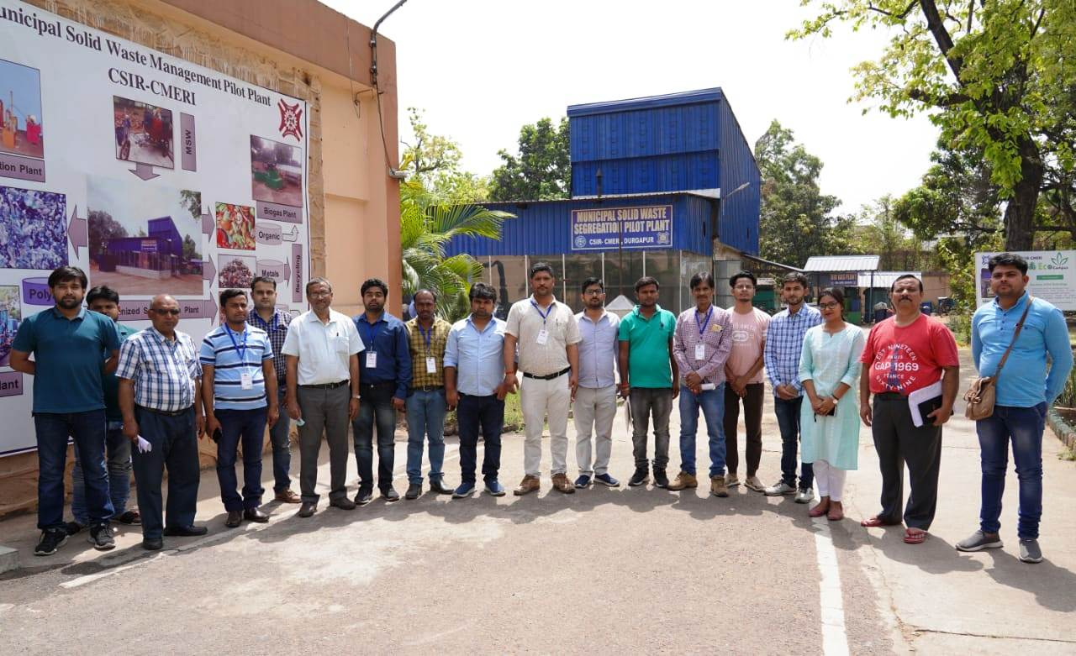
The participating students expressed their sincere gratitude to the institute for organizing such a program, as there is a huge vacuum in this domain. The students were amazed to see the functioning of CSIR-CMERI Integrated Waste Management processes system on ground. They also shared that there is a huge potential for job & business opportunity in the sector due to shortage of skilled manpower in the waste management. They also requested for such skilling initiatives on a more frequent basis.

Prof. Hirani also handed over the certificates to the students participating in the said skill development programme and assured of cooperation from CSIR-CMERI.

Source
Press Information Bureau, 18 March, 2021

